# 1. Create access from Dell OME server to these servers (tuffin and network admis).
# 2. In Dell OME find and discovery servers.
# 2.1. Update firmware on servers.
# 2.2. Apply common configuration for iDRAC (access via domain authorization).
# 2.3. Change root password for iDRAC.
# 2.4. Create raid array configuration.
# 3. Find free ip-addresses via vm-pinger and fix it for defined serves.
# 3.1. Create task to write DNS names for A and PTR zones for choosen ip-addresses.
# 4. Create Service Desk task for network admins to configure switch for appropriate ports and give vlan's.
# 5. Run deployment tool "F10" and start manual installation.
# 6. Login on installed server with its console as root and test and add network configs.
# 7. Login on serves via ssh and disable firewald.
# 8. Add repositories. Configure it to work.
# 9. Install puppet.
# 10. Add servers into puppet. Apply manifests.
# 11. Create users, that will use this server (lzn and other).
# 12. Install software for monitoring (idrac and so on).
# 13. Nagios monitoring configure.
# 14. Update information in racktables about servers.

# How to change root password on iDRAC on Dell servers.

[support@centos00 ~]$ while read -p "Enter service tag: " var1_servicetag ; do var2_username="$( SSHPASS="$(pass common/windows-current)" sshpass -e ssh -t -oStrictHostKeyChecking=no tcsbank.ru\\s.belogrud@${var1_servicetag}.mgmt.tcsbank.ru racadm get idrac.users.2.username | grep UserName | cut -d "=" -f2 | tr -d '\r' )" ; if [ "${var2_username}" = "root" ] ; then echo -e "Service tag: ${var1_servicetag}\nServer: ${var1_servicetag}.mgmt.tcsbank.ru\nUser: ${var2_username}" ; var3_newpassword="$(pwgen -c -n -s -C 10 1)" ; echo "Password: ${var3_newpassword}" ; SSHPASS="$(pass common/windows-current)" sshpass -e ssh -t -oStrictHostKeyChecking=no tcsbank.ru\\s.belogrud@${var1_servicetag}.mgmt.tcsbank.ru racadm set idrac.users.2.password "${var3_newpassword}" | tee -a ./$(date +%Y%m%d- %H%M).racadm.set.${var1_servicetag}.txt ; else echo "No, we mightn't change pasword for user: ${var2_username}." ; fi ; done
Enter service tag: D2CFRG2
Warning: Permanently added 'd2cfrg2.mgmt.tcsbank.ru,10.219.11.137' (RSA) to the list of known hosts.
Connection to D2CFRG2.mgmt.tcsbank.ru closed.
Service tag: D2CFRG2
Server: D2CFRG2.mgmt.tcsbank.ru
User: root
Password: KhWAlg2ZCo
[Key=idrac.Embedded.1#Users.2]
Object value modified successfully
Connection to D2CFRG2.mgmt.tcsbank.ru closed.
Enter service tag: ^C
[support@centos00 ~]$

*. Configure iDRAC on server.
# Ip addresses could be obtained here http://vm-pinger/
# See commutations in racktables.
# Ask for network administrators appropriate management vlan.
# Finding network with this vlan here. Click mouse on choosed row.
# See what ip address is green - assign this address to idrac of these servers.
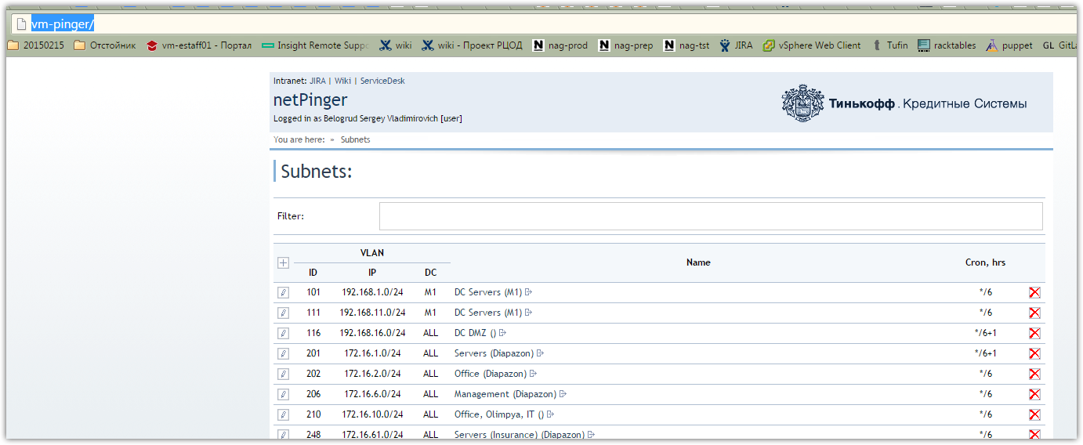

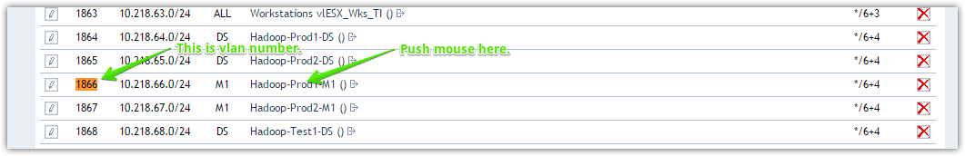
# See, that several ip addresses are using. Other green are free.
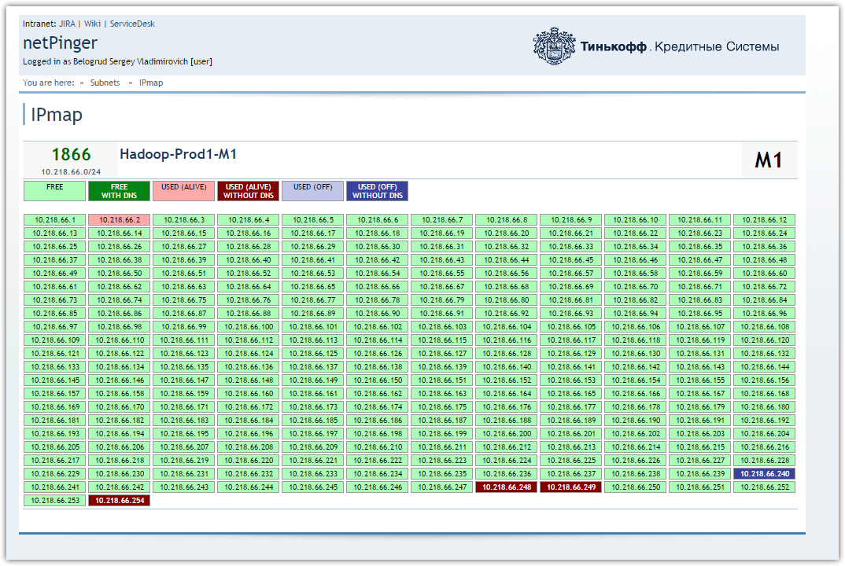

*. Ask for network administrators to grant appropreate vlans for this server.
# This is for interfaces ot this server, that will be used for work.

*. Ask for windows administrators to assing into dns new ip addresses for this server.

*. This step for Gen8 or later generation of HP servers.
If we want, we can update HP Intelligent Porovisioninig that embedded into server's BIOS and available as a feature at server restart.
http://repo-linux.tcsbank.ru/others/hp.com/hpip/current_hp_ip.iso
# After we configured iDRAC, we can include this server into Dell Open Manage Essentials software and update all firmware on it and apply good configuration from my template.

*. During server's boot, disable FCoE for QLogic CN1000Q 10Gbps network cards, if they have been installed at server.
Of course we do it, if we have no plans to use FCoE in future on this server.
# This is good point if used network card like described.
# But I see, that on Dell servers we have follow 10Gbps cards.
[root@ds-ms-mongo01p ~]# lspci
...
04:00.0 Ethernet controller: Emulex Corporation OneConnect NIC (Skyhawk) (rev 10)
04:00.1 Ethernet controller: Emulex Corporation OneConnect NIC (Skyhawk) (rev 10)
...

*. Test server's hardware for errors with HP Insight Diagnostics.
To execute this diagnostics, we can use HP SPP iso image or native BIOS opportunity if server's generation equal or greater then Gen8.
http://repo-linux.tcsbank.ru/others/hp.com/spp/current_hp_spp.iso
# This is good idea.
# Gnitiev had troubel with one server, for example, after this diagnostic.
From: Gnitiev Viktor
Sent: Wednesday, June 29, 2016 12:27 PM
To: admins
Subject: Новые серверы Dell

Коллеги,
Перед началом работы с серверами Dell рекомендую делать полный цикл Hardware Diagnostic из утилиты Lifecycle Controller (который делается после краткой диагностики в этом же разделе).
Чтобы он успешно прошел, должны быть собраны и инициализированы RAID-массивы и в iDRAC-разделе логов (на картинке ниже) не должно быть ошибок (нажимайте кнопку Clear Log).

У меня на одном сервере во время теста диск уже вывалился.
Кейс заведен, ждем замены.

*. If we want to use GUI to configure raid controller, we should use it at this moment.
If we use HP STK (Scripting Toolkit) iso image, we will do it later, exactly after firmware will have been updated with HP SPP iso image.
http://repo-linux.tcsbank.ru/others/hp.com/hpstk/20150324-1449.hp-scripting-toolkit-linux-9.60.iso
# Configure raid with iDRAC or with native raid-bios utility.

*. Update server's Firmware with the latest HP SPP iso image.

*. At this moment we should boot with HP STK iso image and configure raid controller, if we didn't do it before within GUI raid configuration utility.
*.*. As a substep we can reset BIOS setting on server, then reboot will be required.
*.*.*. After server boot with HP STK iso image, fit for us optimal BIOS configuration should be applied. We assing server name in BIOS configuration file and other tunes, like power performance, low latency recomendation settings.
*.*.*. Here we can rollup HP MSB (Maintenance Supplement Bundle) with hpsum command line utility. But it should be previously prepared - we shoud place distributive of updates into iso image. Or we can do it later, after OS will be installed.

*. Prepare Anaconda kickstart file for unattended server installation.

*. Install operation system from it's iso dvd distributive. To automate installation process we use previously created floppy image that contains ks.cfg file.
http://repo-linux.tcsbank.ru/others/redhat.ks/floppy.img
http://repo-linux.tcsbank.ru/others/distr/rhel/rhel66.iso

*. After server's OS successfully boot, we will be configuring network interfaces to access to server via ssh.
Next steps are use ssh connection to this server.

*. Check that selinux is disabled on this server.

*. Create repository configuration files into /etc/yum.repos.d/
curl http://repo-linux.tcsbank.ru/tcs-common.repo.sh | sh

*. Correct date and time on server.

*. Check and configure if it needs server's timezone.

*. Check ip addresses of our dns servers into file /etc/resolv.conf.
*. Add search suffix and domain suffix into file /etc/resolv.conf.
echo -e "search tcsbank.ru\ndomain tcsbank.ru" >> /etc/resolv.conf

*. Disabling ip6v protocol at several places.

*. Correct sudo access for wheel group.
[root@ds-sas-ods01t yum.repos.d]# visudo
...
## Allows people in group wheel to run all commands
%wheel ALL=(ALL) ALL
...

*. Create administrators accounts and grant them access to server.
We can do it later and automate it via puppet, but if we want to get access to server immediately, we should do it here.

*. Install HP utilities on server.
It place before puppet install, because our modern puppet doesn't work if hpacucli utility had not been installed before.
yum install hp-ams hp-fc-enablement hp-health hp-smh-templates hp-snmp-agents hpacucli hpdiags hponcfg hpsmh hpvca hpssa hpssacli

*. Install puppet agent. Register host into puppet and rollup on it basic manifests ( include server into all-server group, that allow to create administrators accounts and other rules).
yum install puppet facter ruby

*. At this moment we can rollup servers firmware updates with HP MSB, if it had have not rolled up before.

*. Check to ntpd service works correctly.
See that ntp servers are present.

*. Install software to use nagios check well. Turn on nrpe service.
yum install nagios-plugins nagios-plugins-disk nagios-plugins-load nagios-plugins-nrpe nagios-plugins-procs nagios-plugins-users nagios-plugins-load nagios-plugins-swap nrpe

*. Install software to use snmp service.

*. Install Zabbix agent.

*. Check and add if it needs, time stamp to history file for root user.

*. Increase number UID and GID for new created users.

*. Turn off iptables service.

*. Install lldpcli package.

*. Configure network at server as it should be. Here we create bonding and other tune.

*. Configure kdump service to store only used memory to hard drive.

*. Rollup security updates on server.
Previously it sould be registered into RHN.

*. Add host to nagios monitoring.

*. Add server to ossec monitoring if it needs.

*. Create task for storage admins to tune backups for this server.

*. Add server to our HP IRS server.
https://m1-irs:7906/

# 20170705
# Follow command reboot server (safely shutdown operation system). And then start diagnostics. It takes more than 30 minutes.
# And we don’t know how to receive results of this diagnostic.
# Details about it could be found here: http://www.dell.com/support/manuals/ru/ru/rubsdc/integrated-dell-remote-access-cntrllr-8-with-lifecycle-controller-v2.00.00.00/racadm_idrac_pub-v1/diagnostics?guid=GUID-54DF65F6-7C95-49C4-9AE4-9FBFB1F4ED2F&lang=en-us

[root@m1-2-gp-prd-mdw ~]# for var1_host in m1-2-gp-prd-sdw{2..36} ; do ssh -t root@${var1_host} '( echo ; hostname ; racadm diagnostics run -m 1 -r forced -s 20170629193000 -e TIME_NA )' ; done

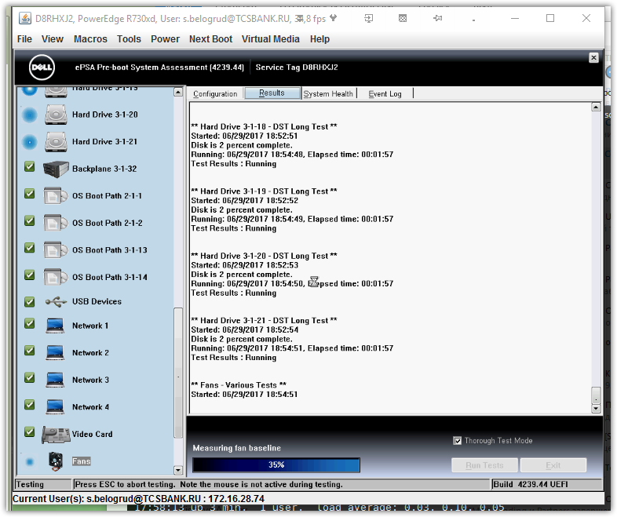

# This is steps of installation of RedHat 7.2 on hardware Dell server.
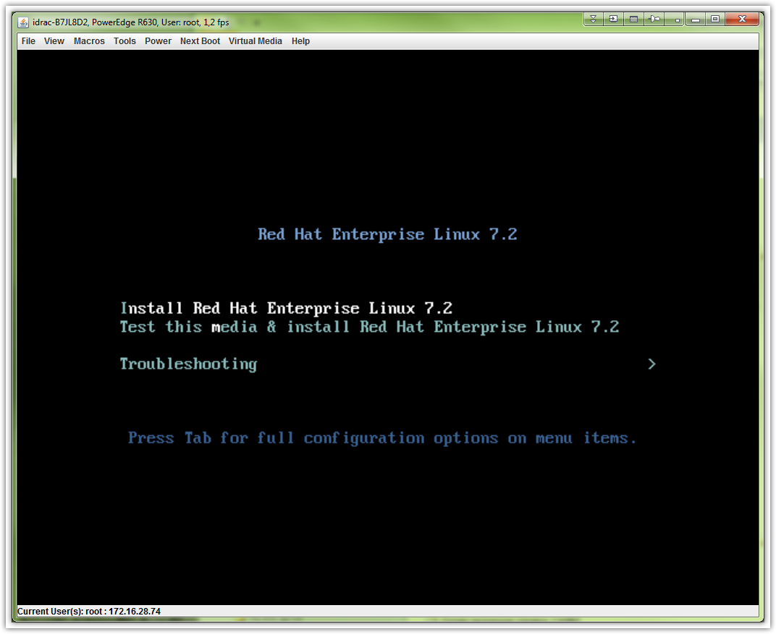

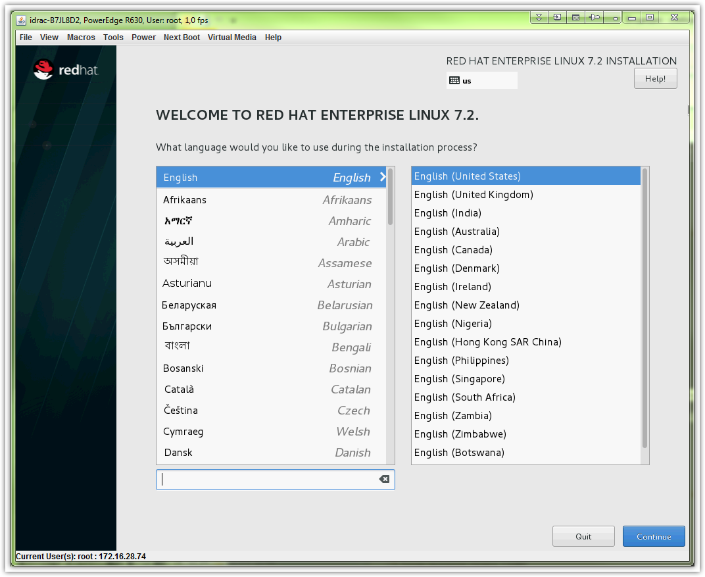

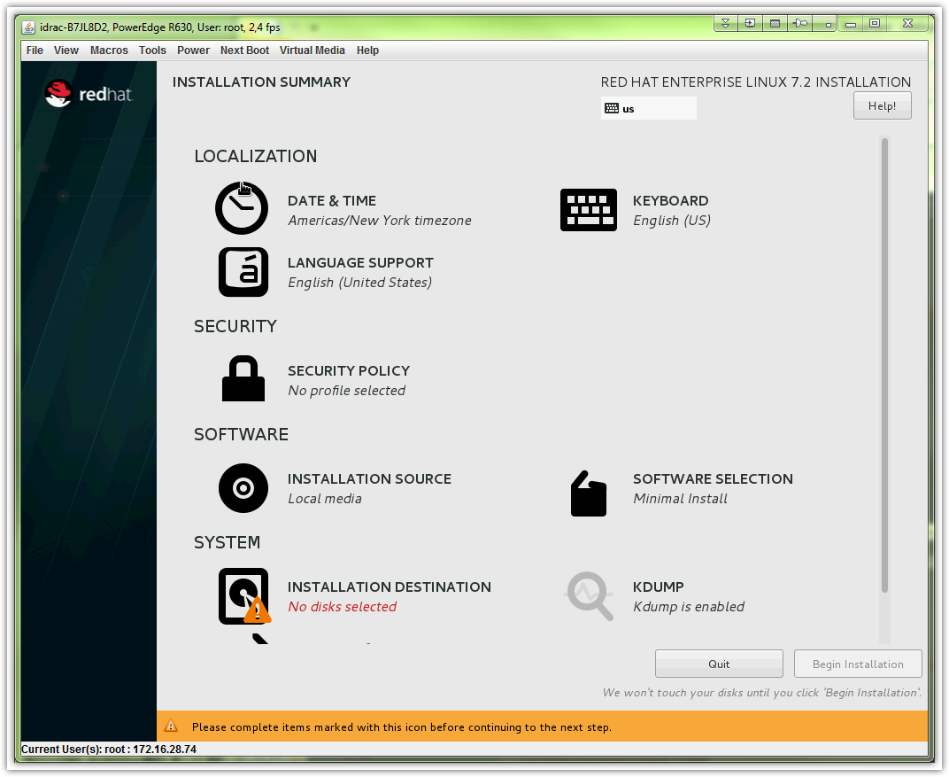

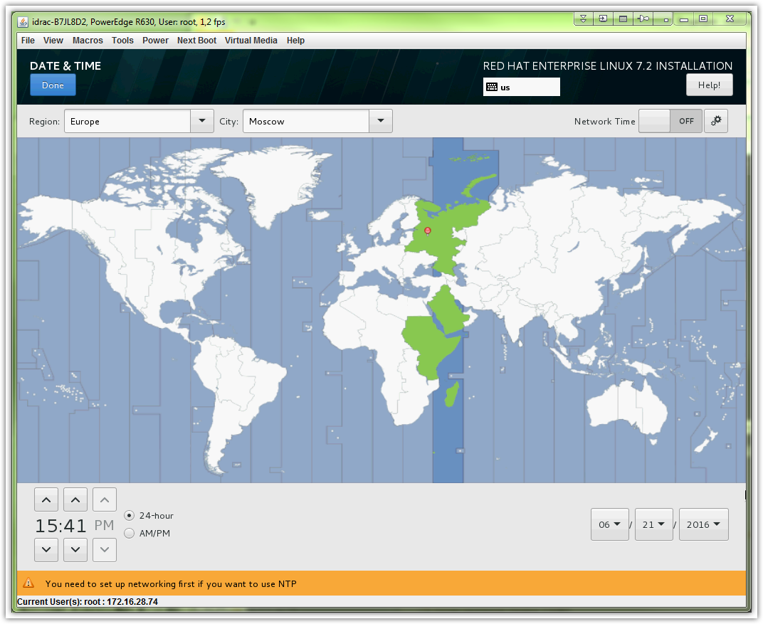

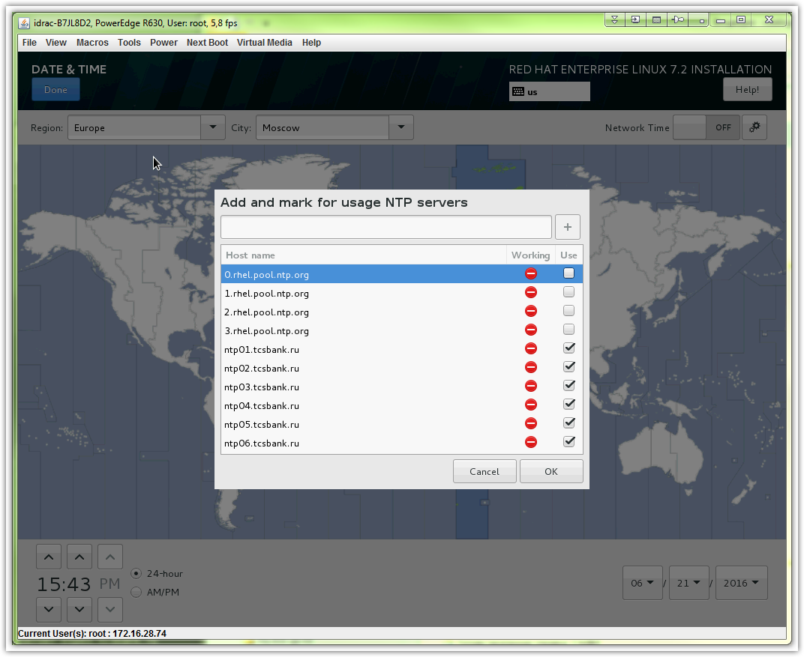

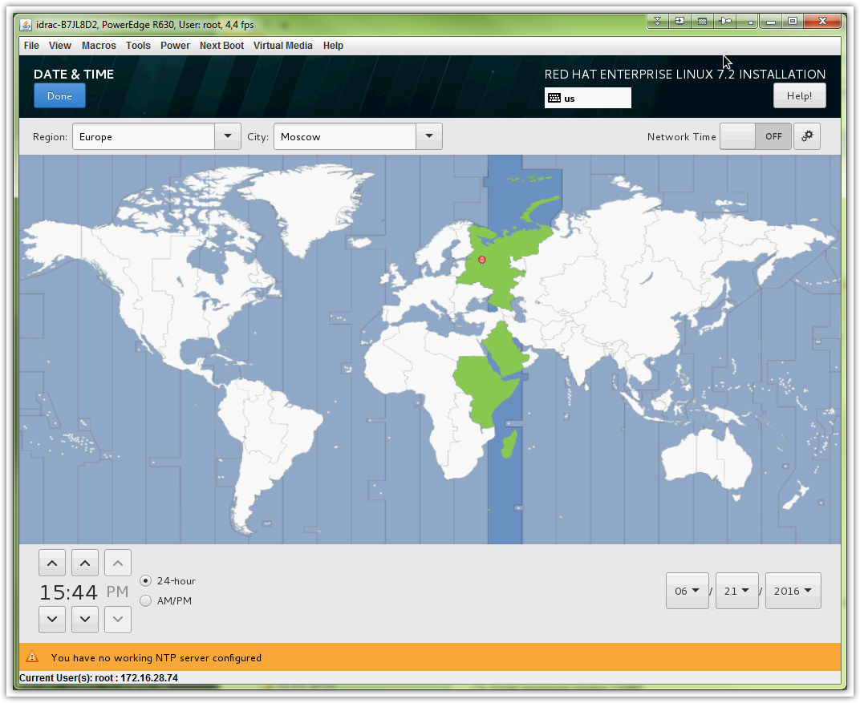

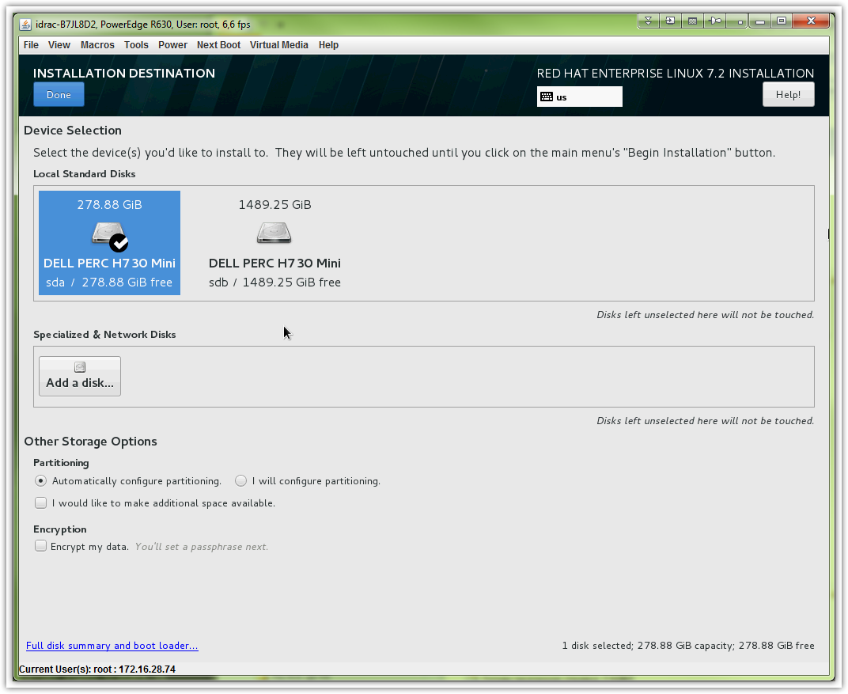

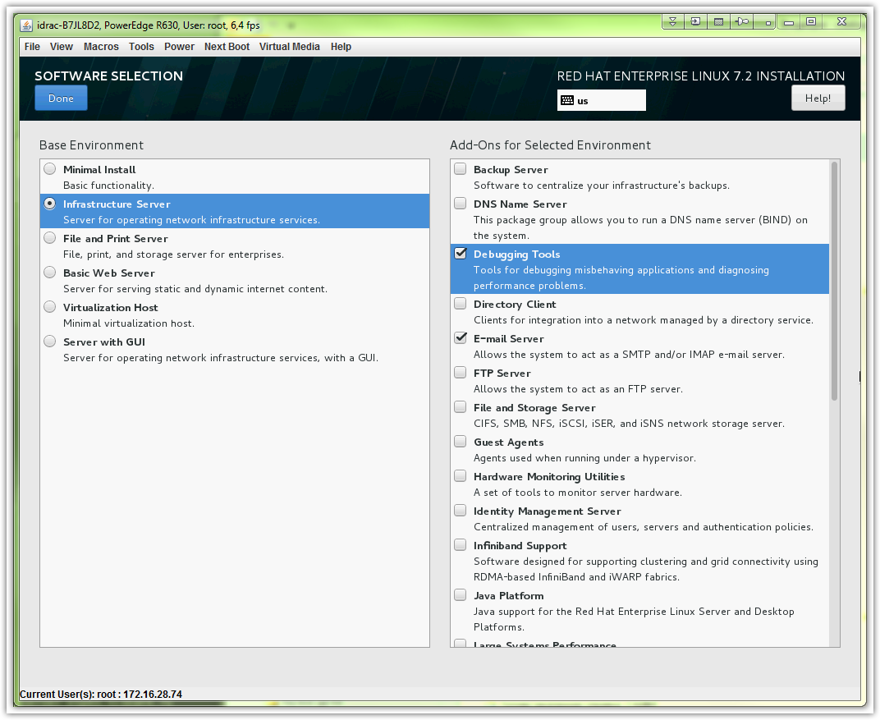

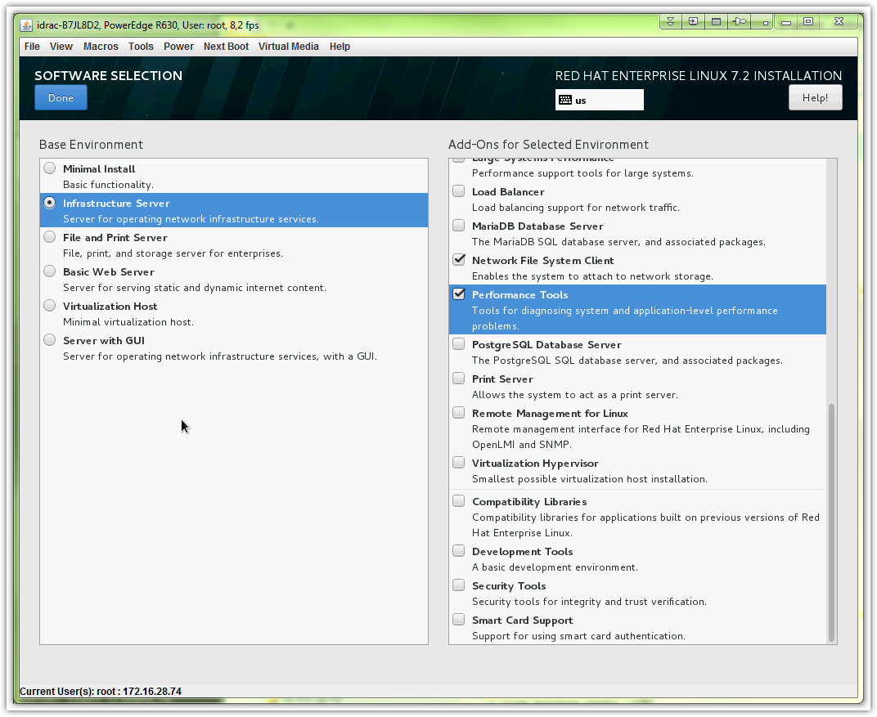
# Here is wrong ip address of dns server.
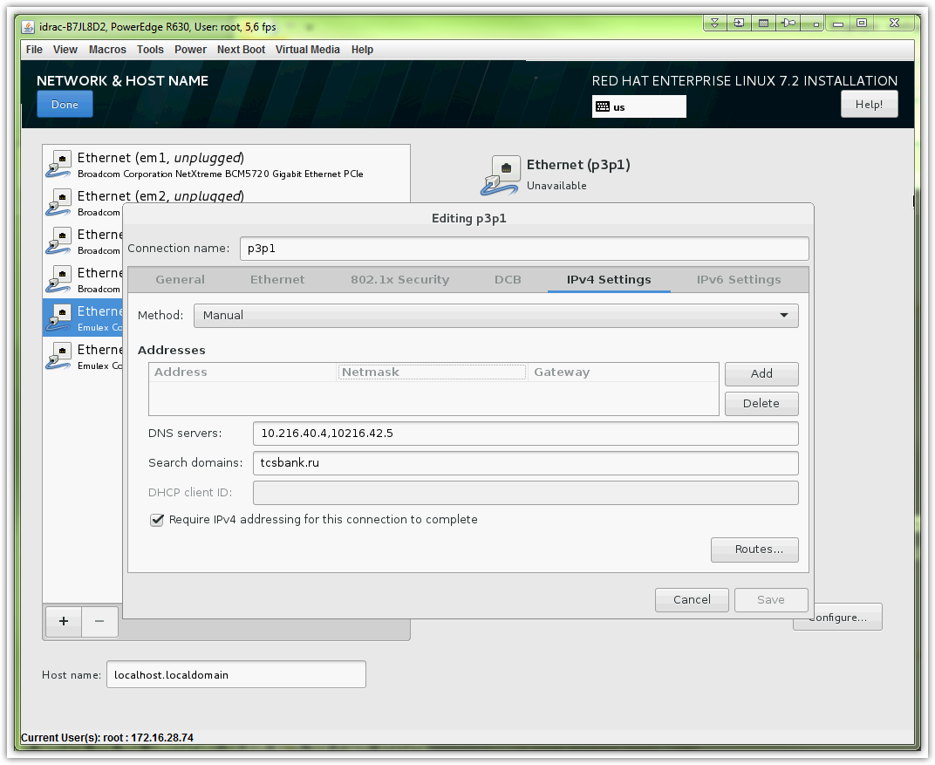
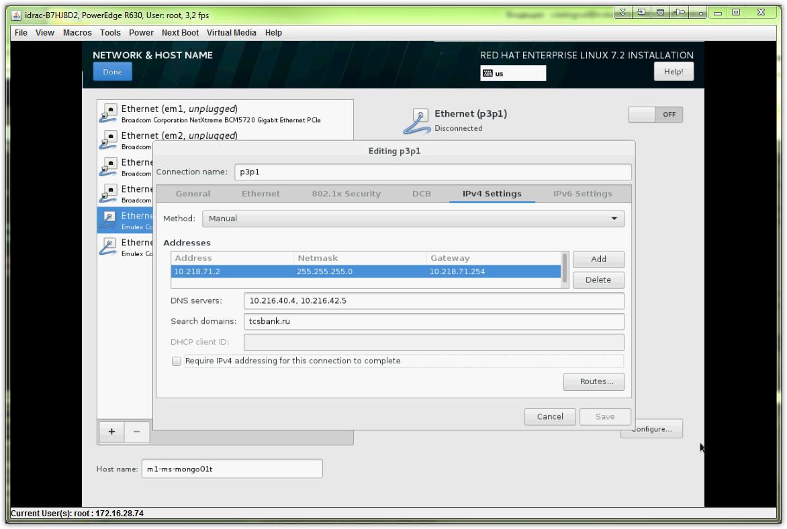

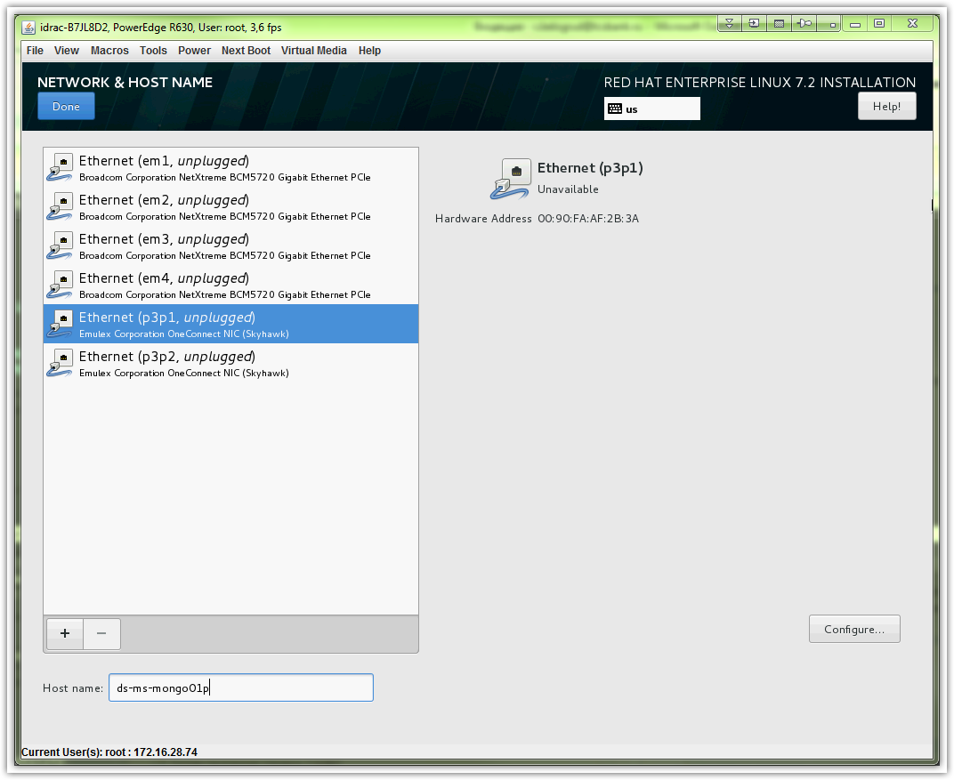

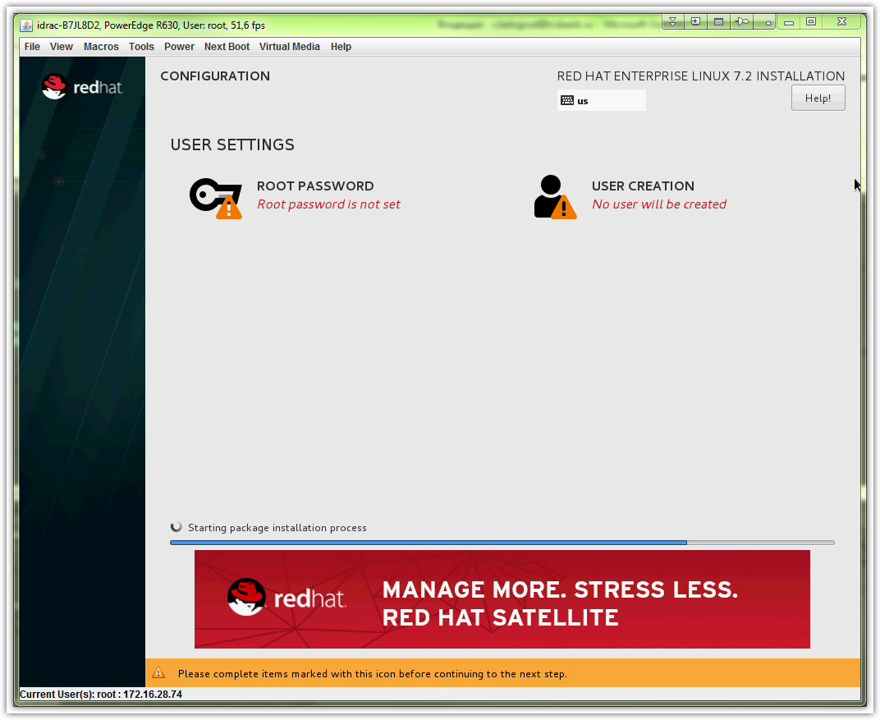

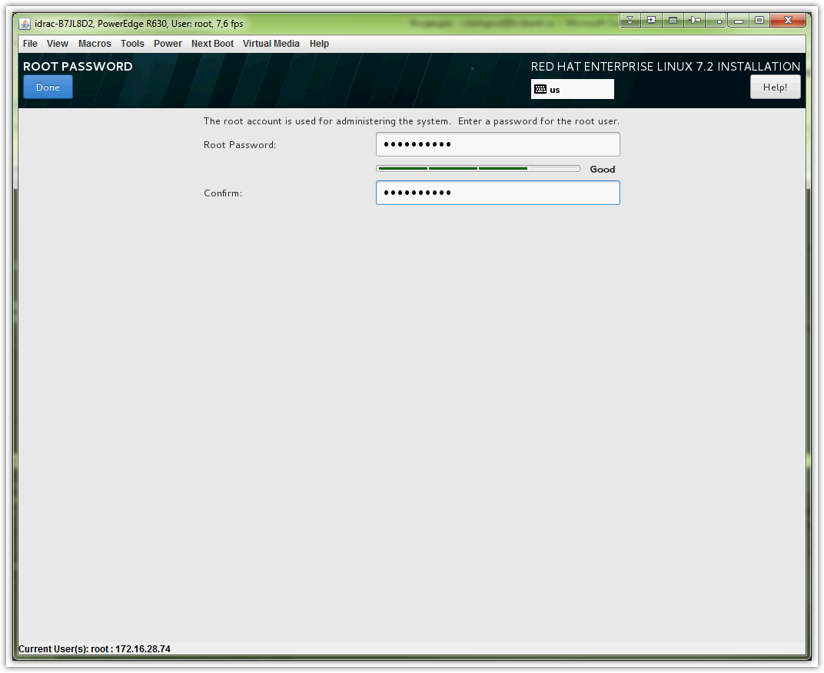

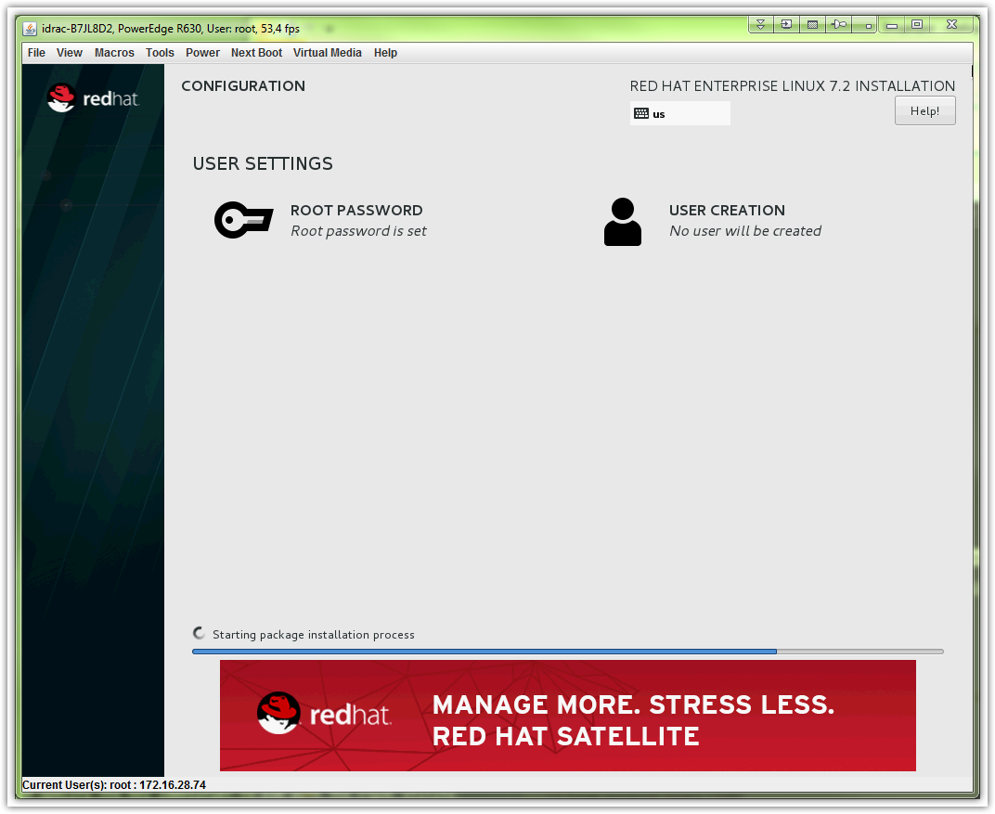

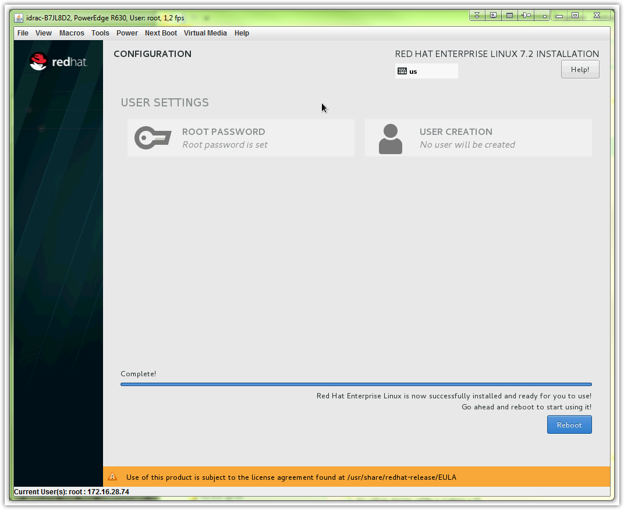

# Here is an example how to created and configure partition and filesystem and mount point for application data.

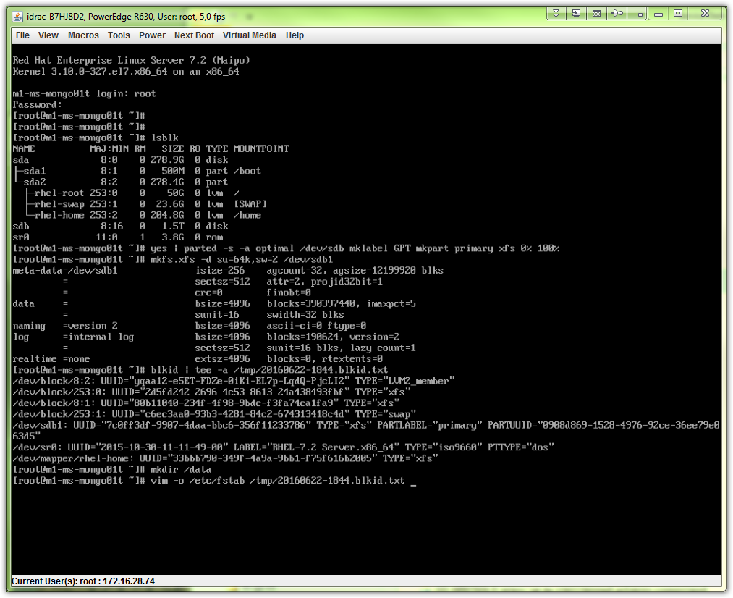

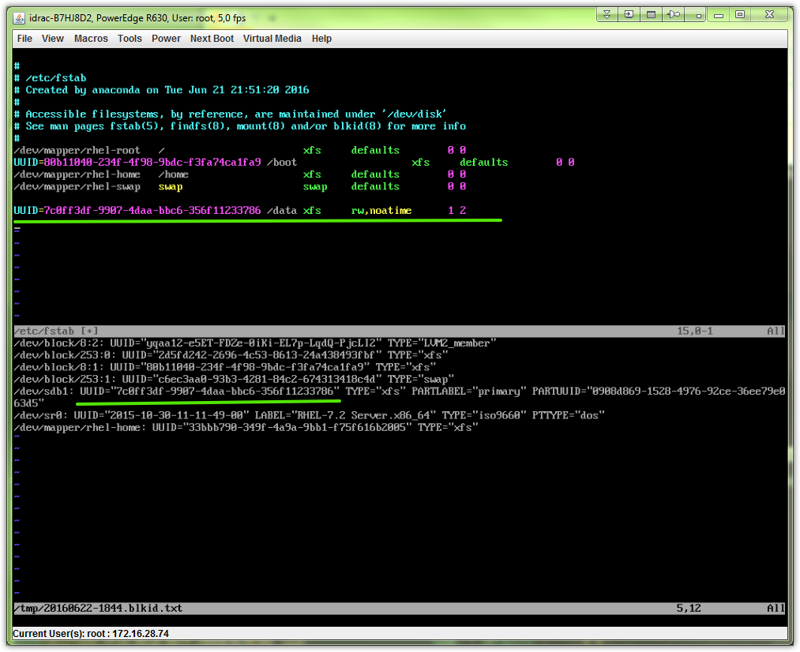

# This is my attempt to configure network after server with rhel 7.2 was installed.
# I try to use teaming instead bonding.
# And use tagged interface (vlans).
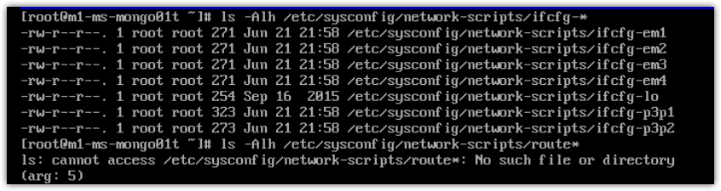
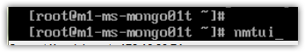
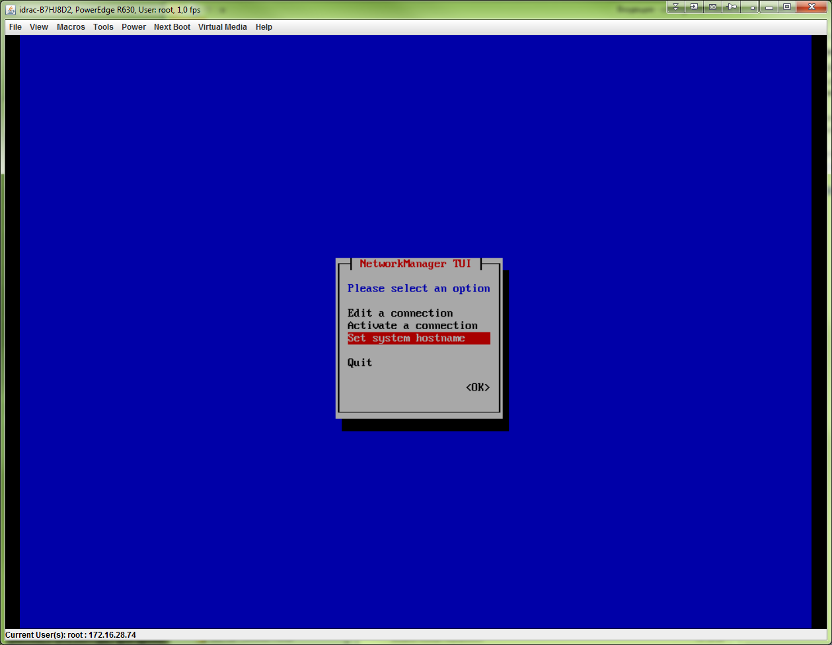

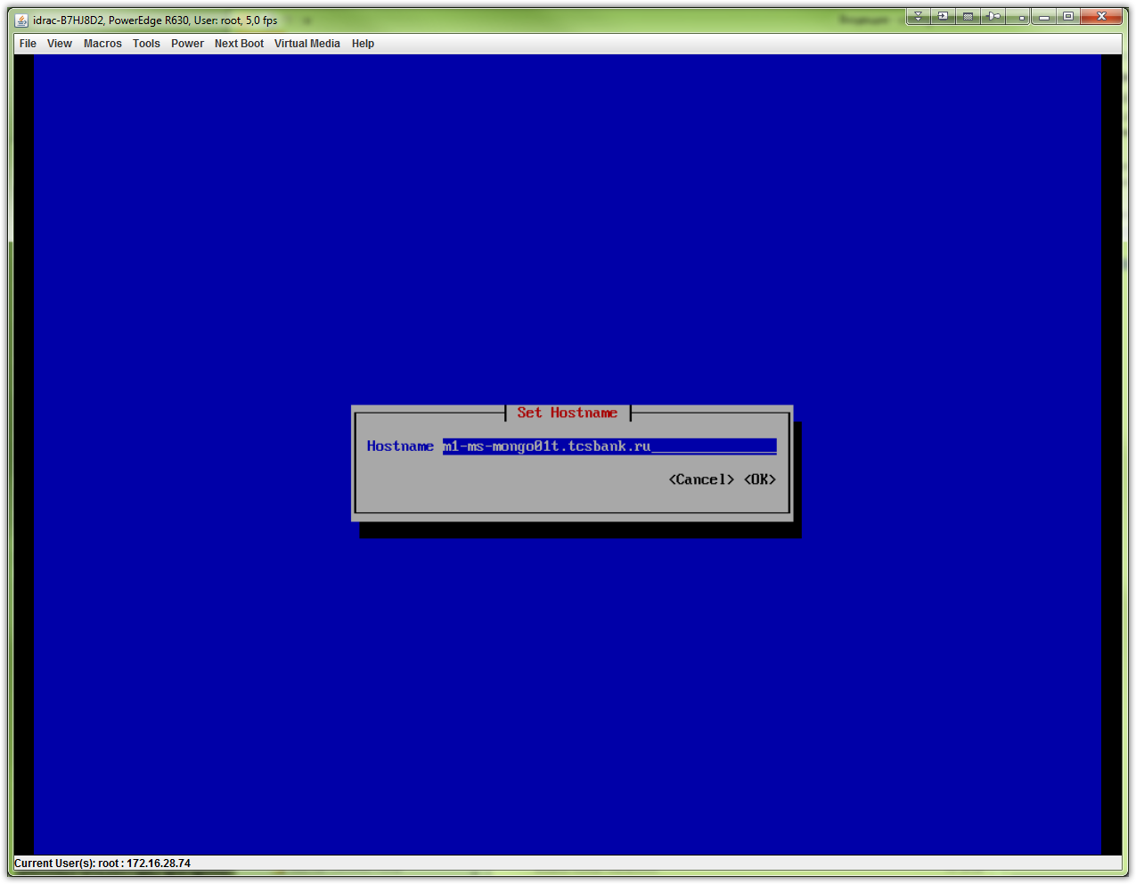

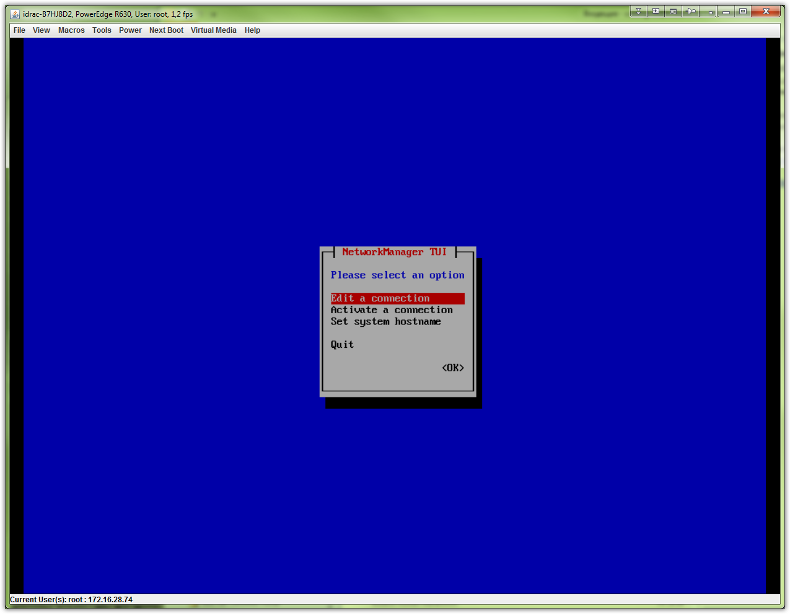
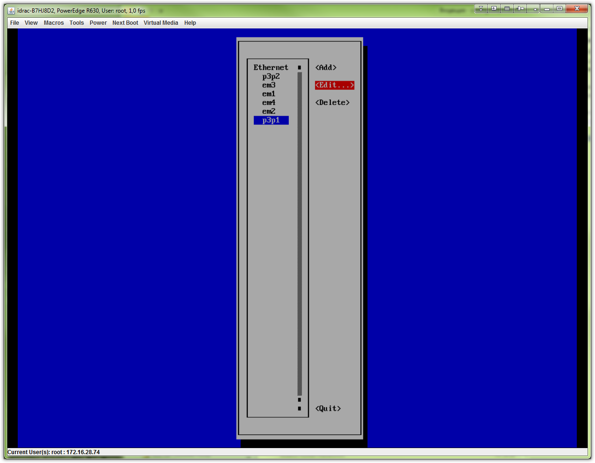
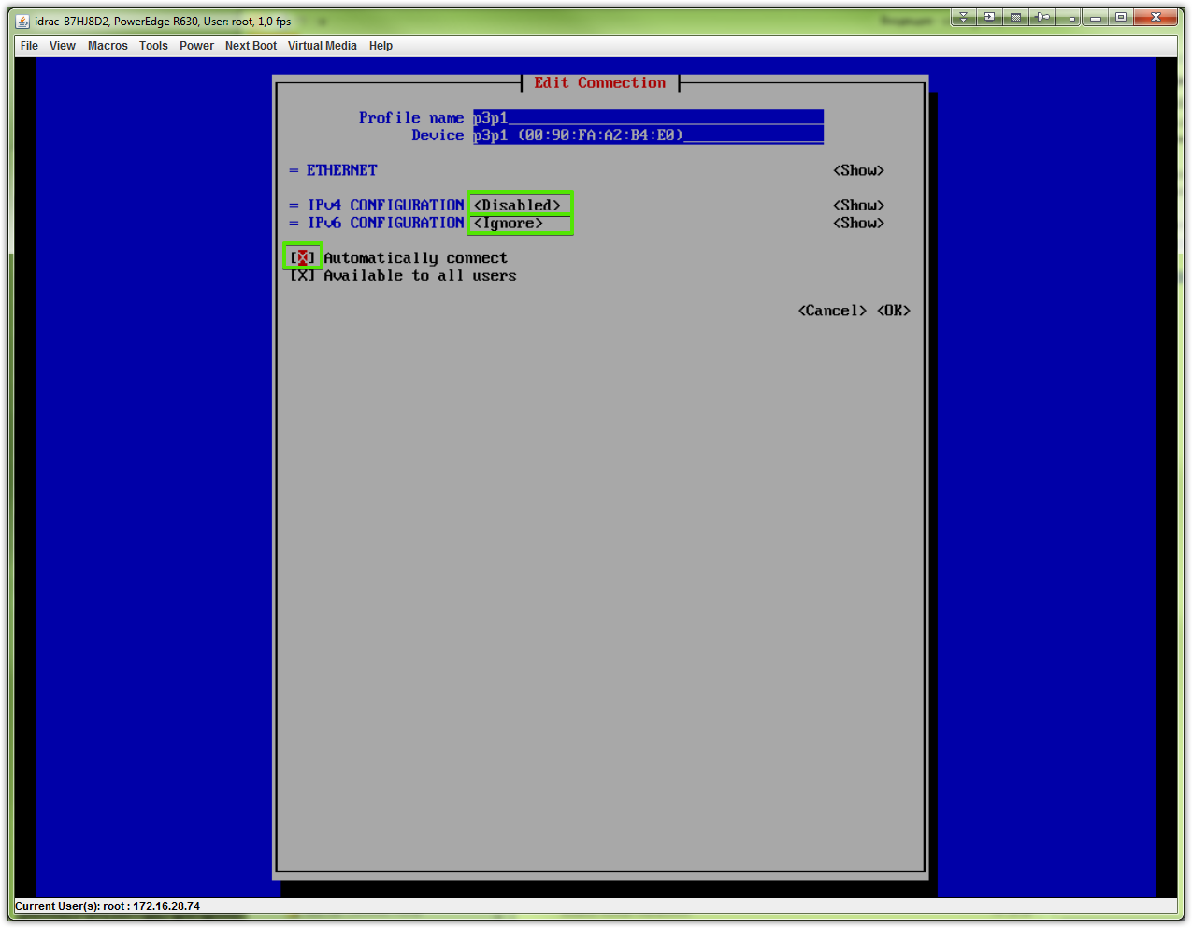
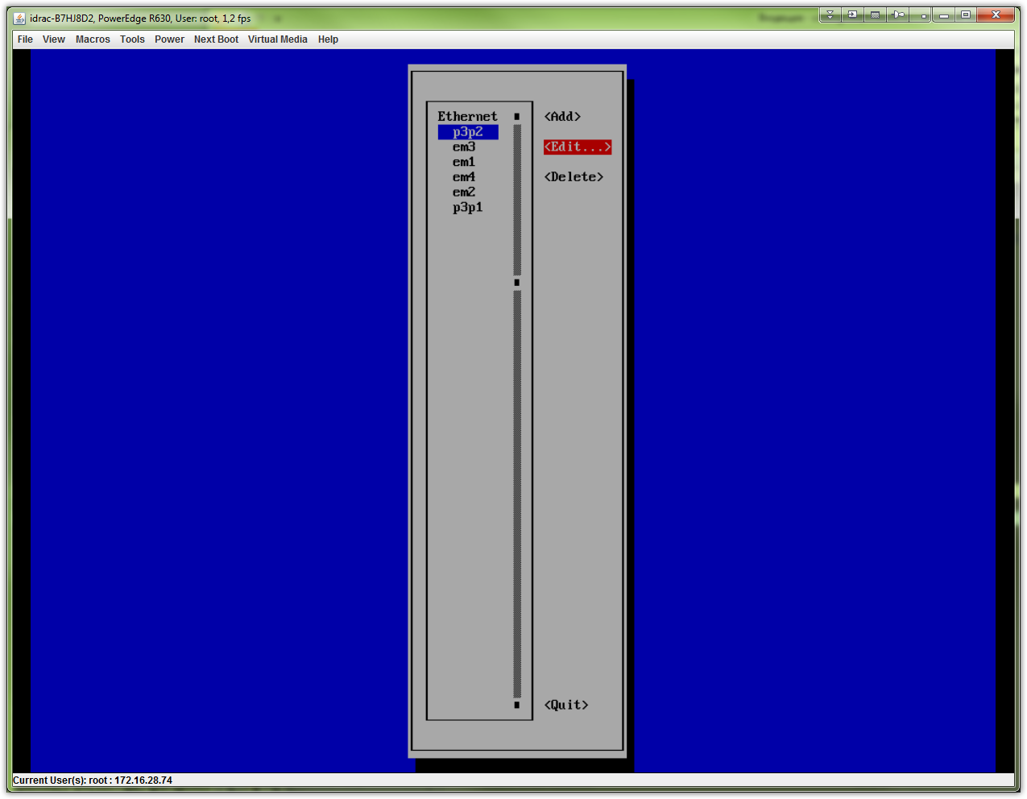
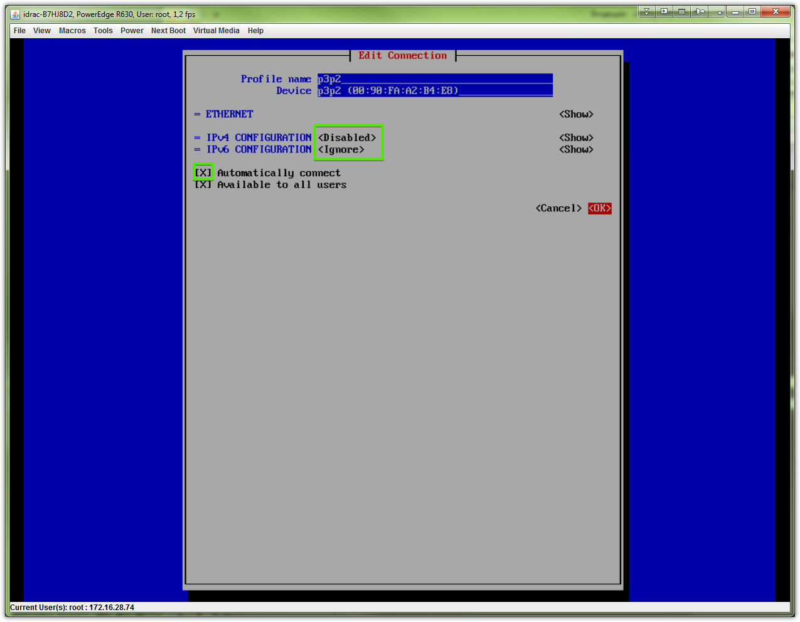

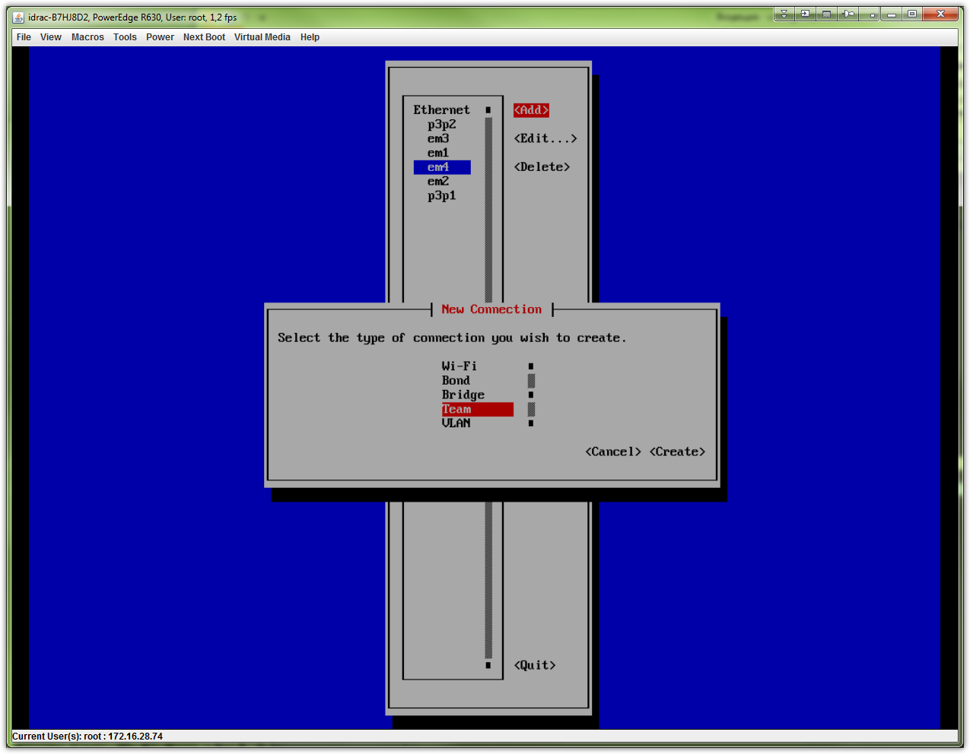
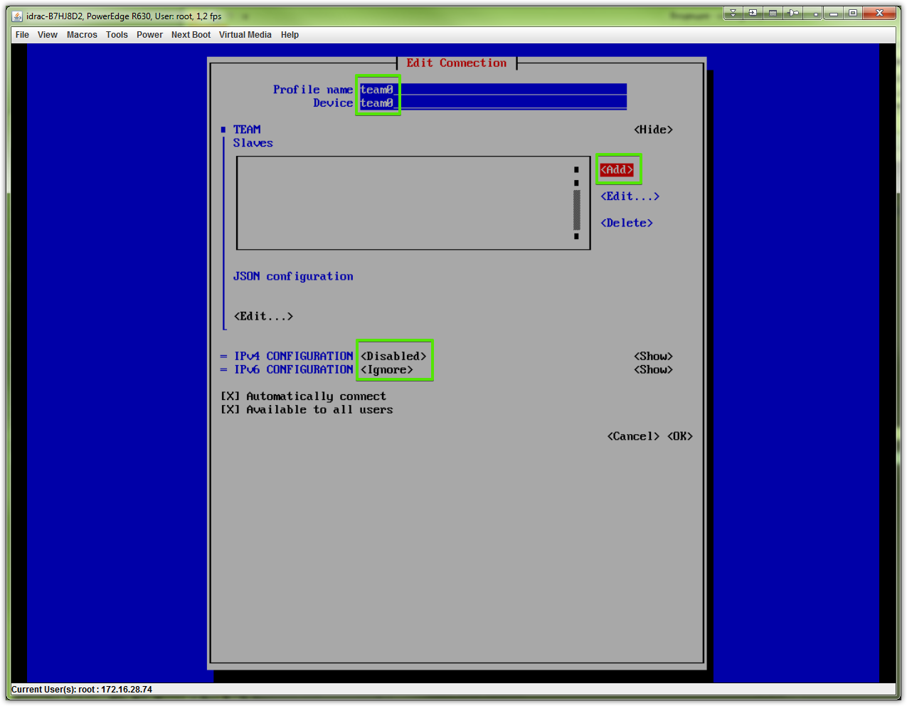

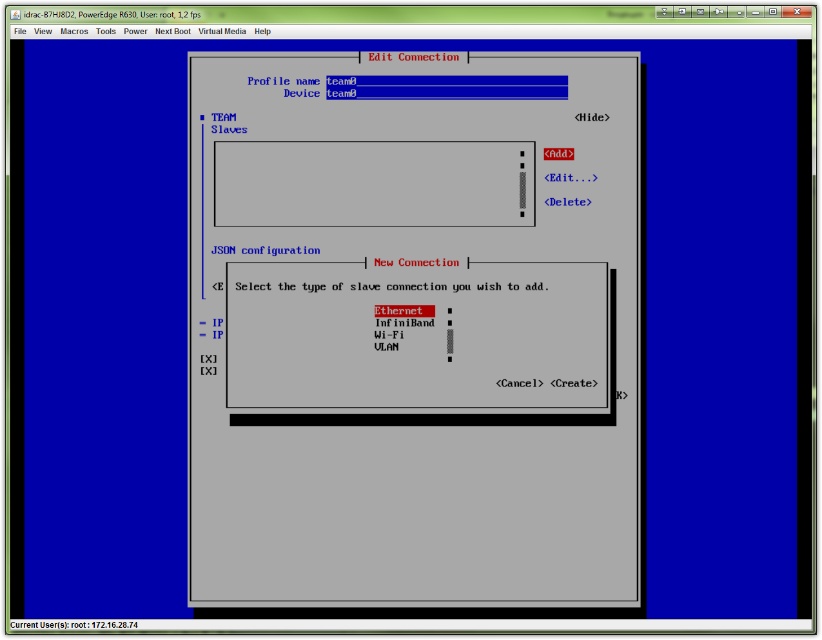

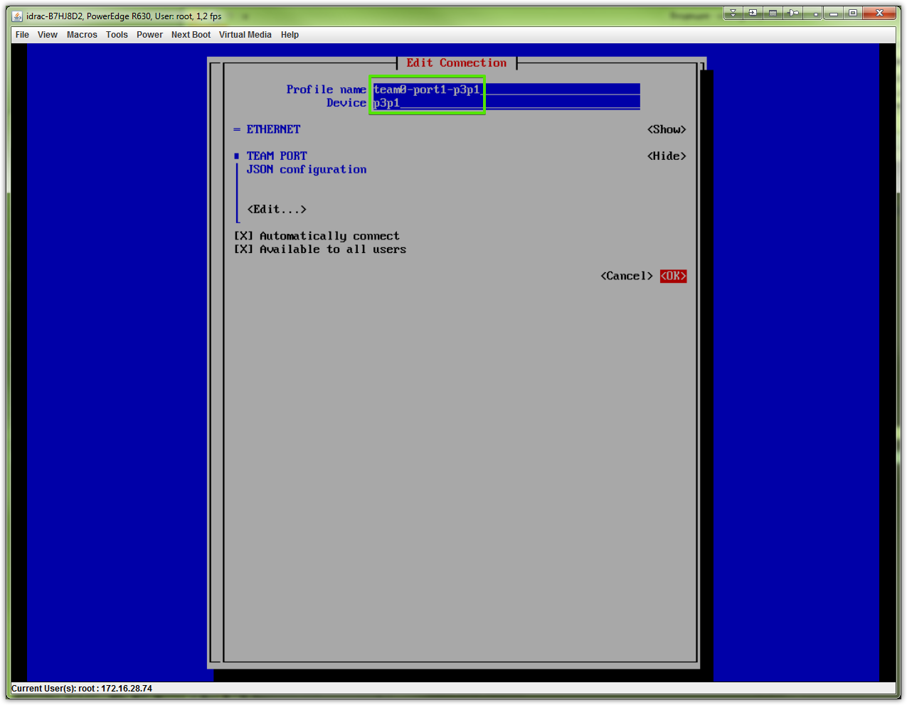
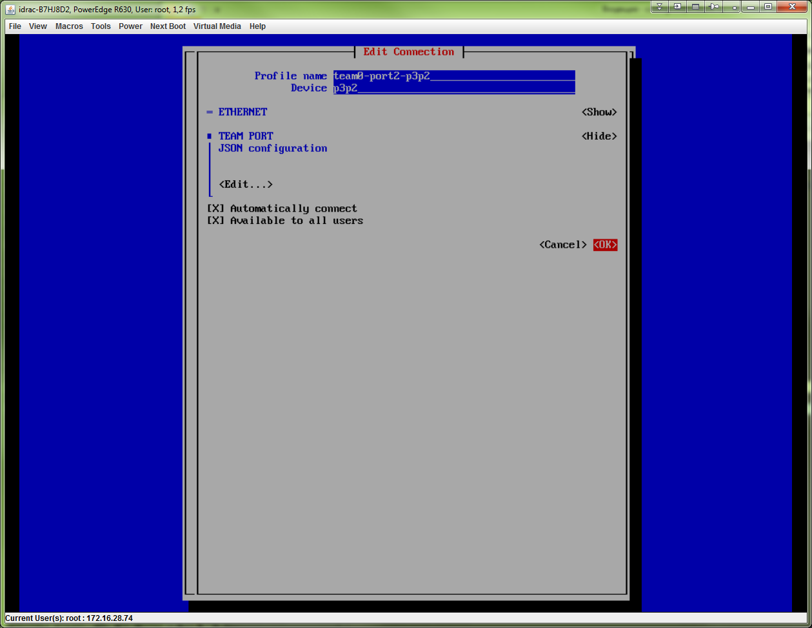

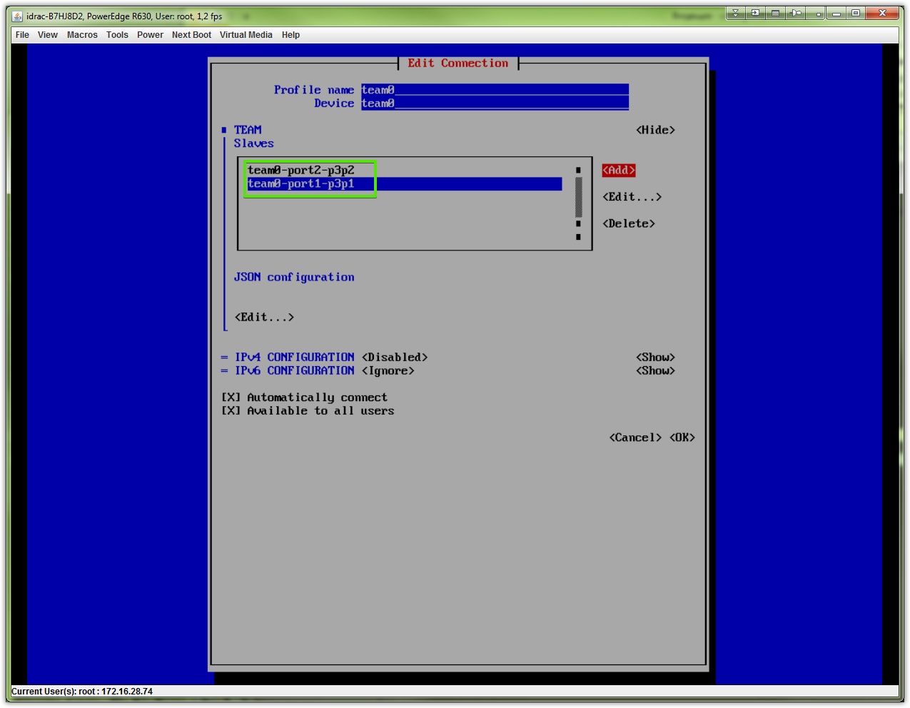

# It’s better to avoid to write “runner” statment here. I’m not sure, but this could bring me troubles, that looks like not working teaming at all. So I had reinstall OS at all.
# Better and tested way is write “runner’ string directly to file ifcfg-team0 after all interfaces will be configured with nmtui.
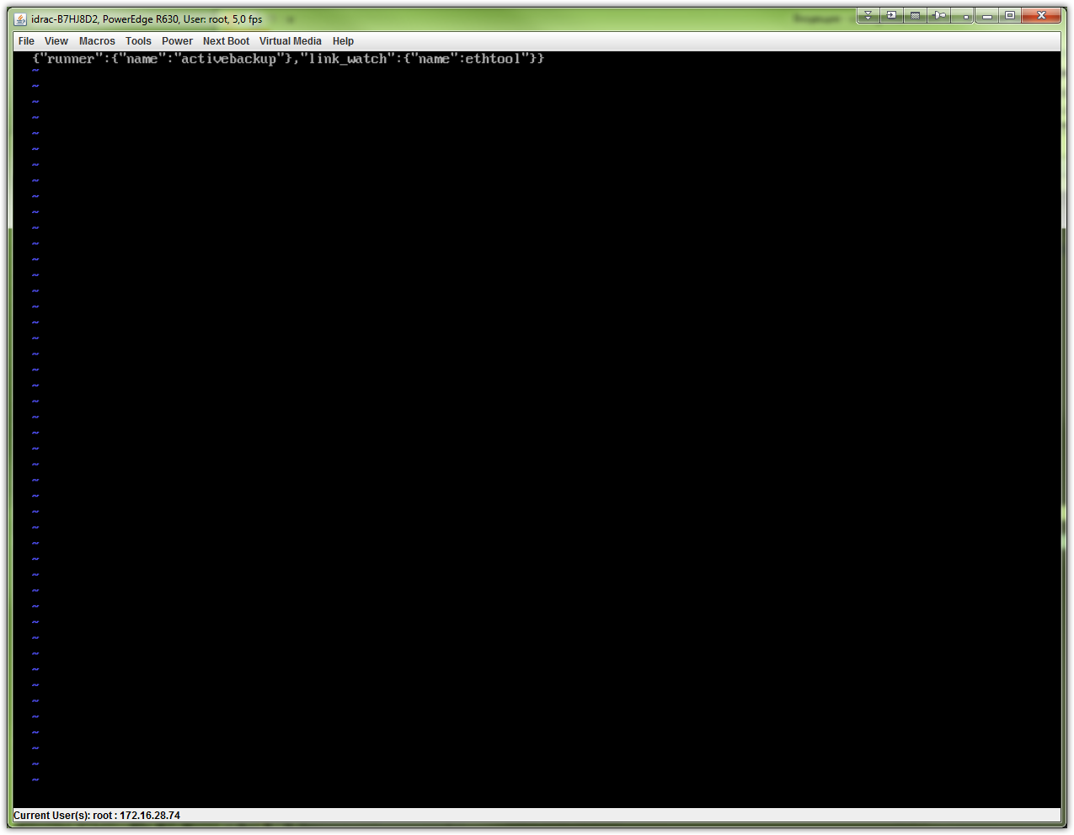

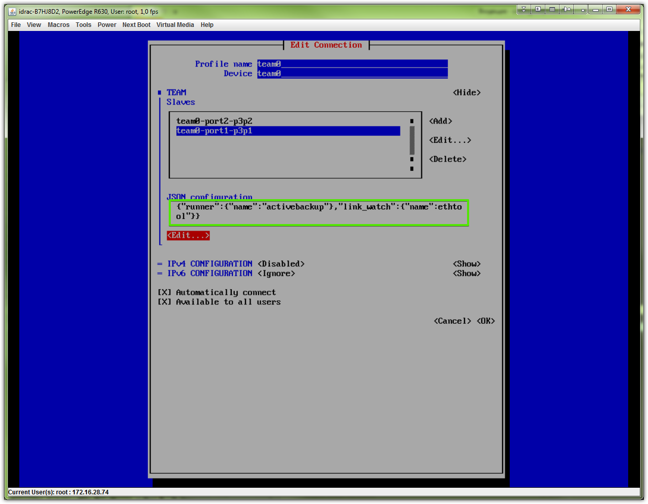
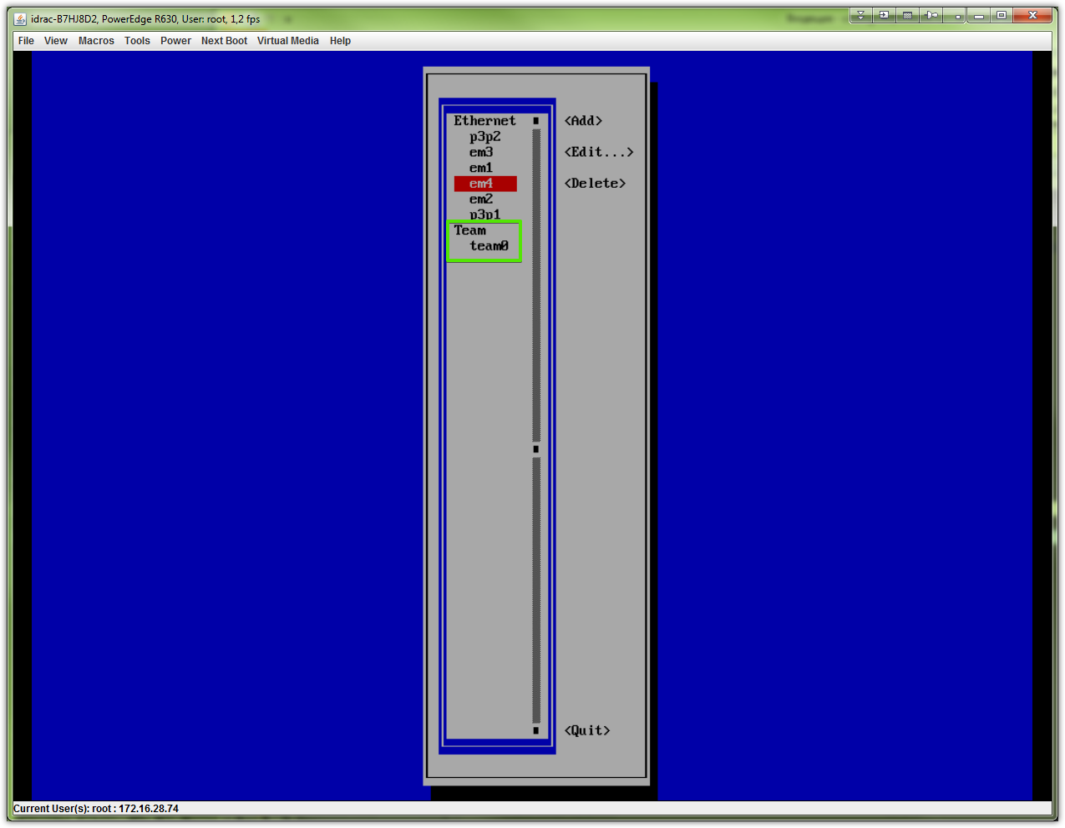

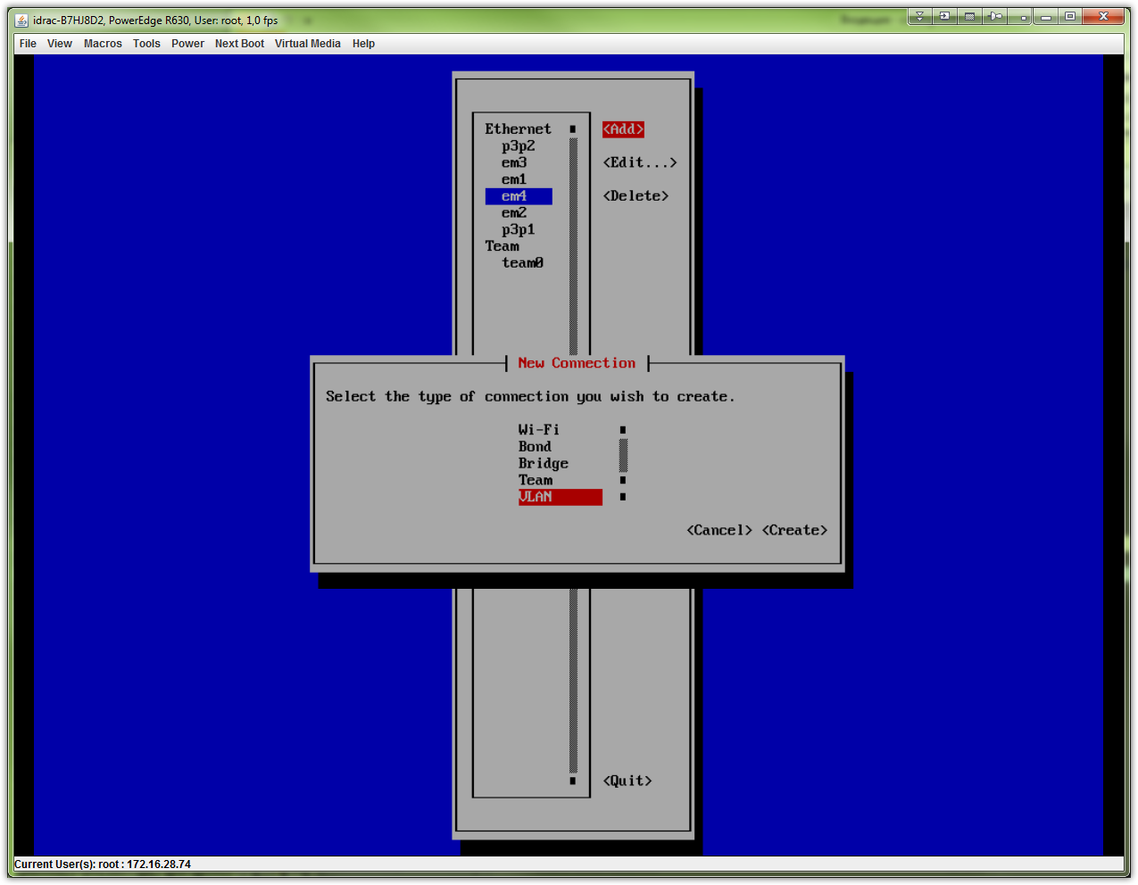

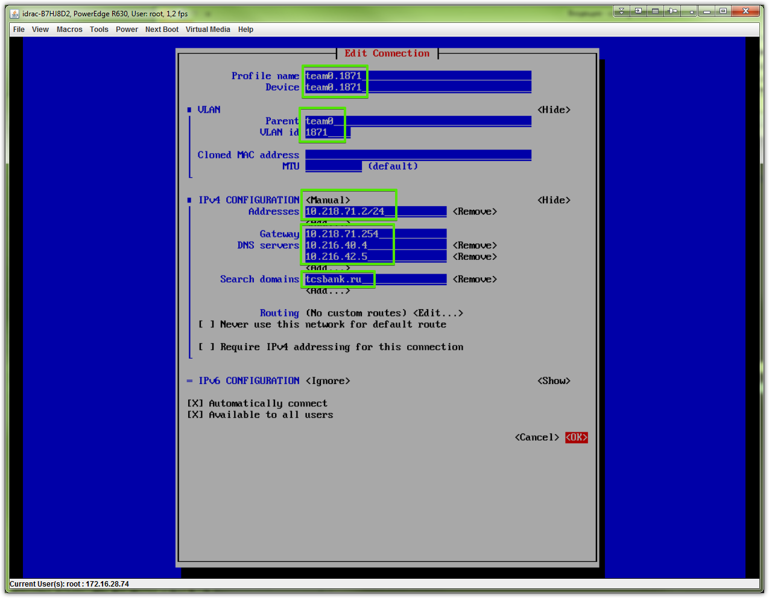
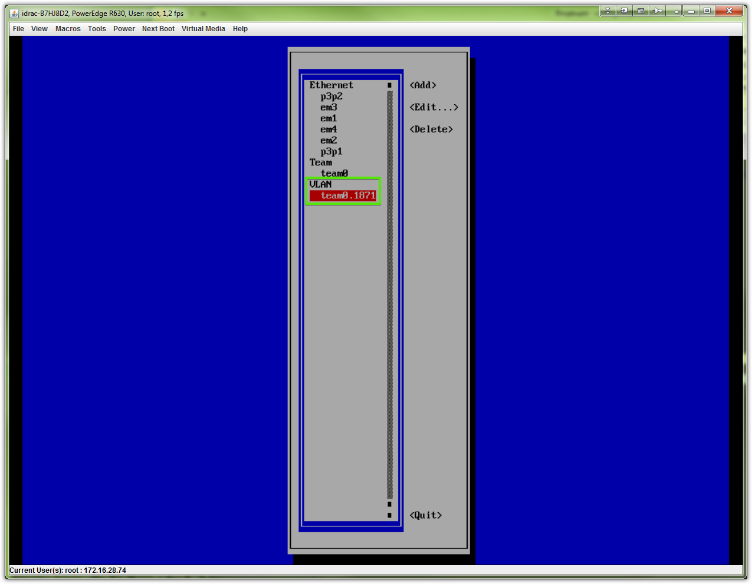
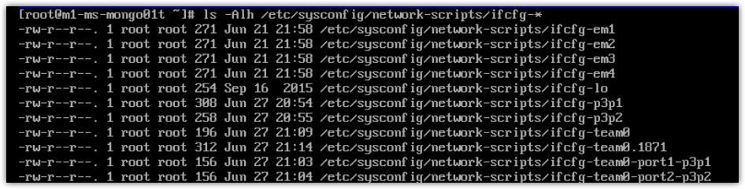

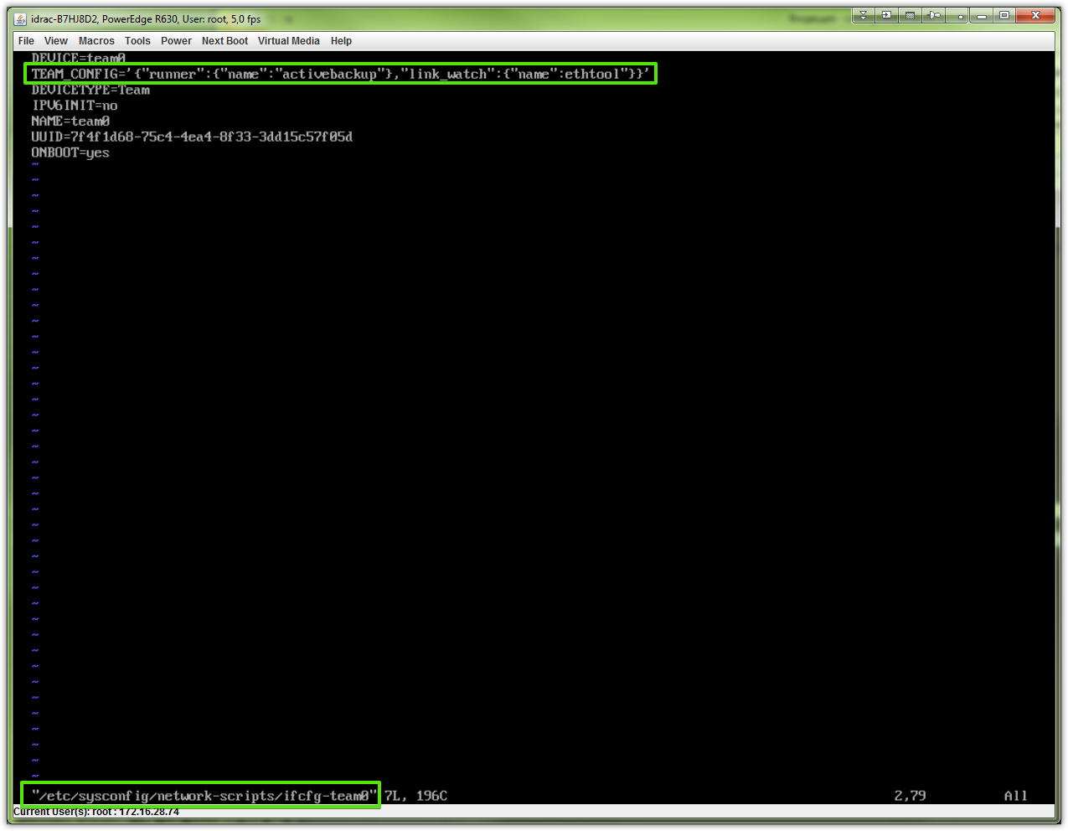
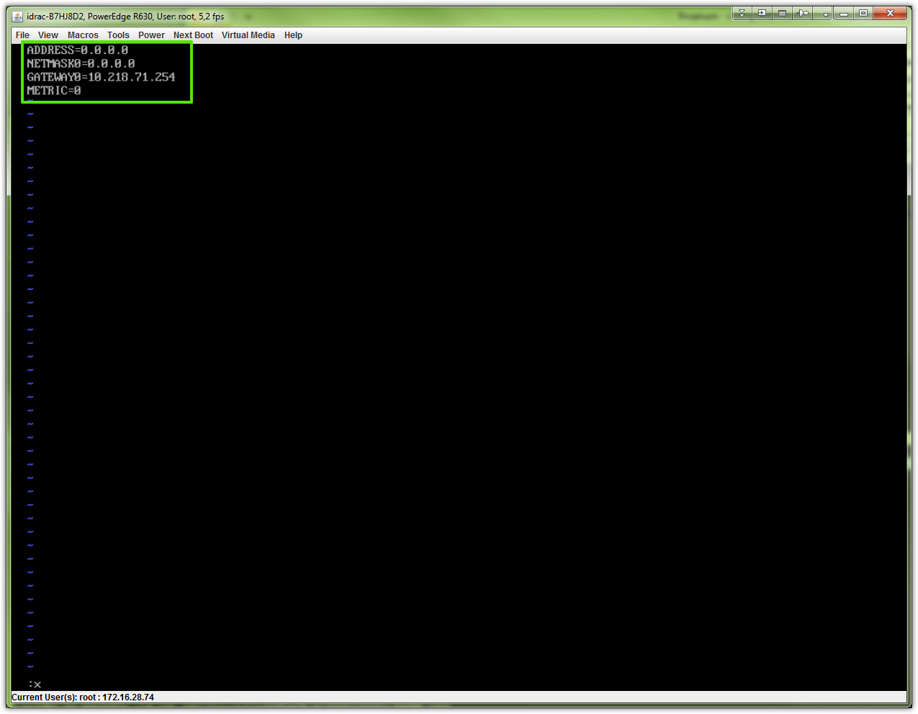
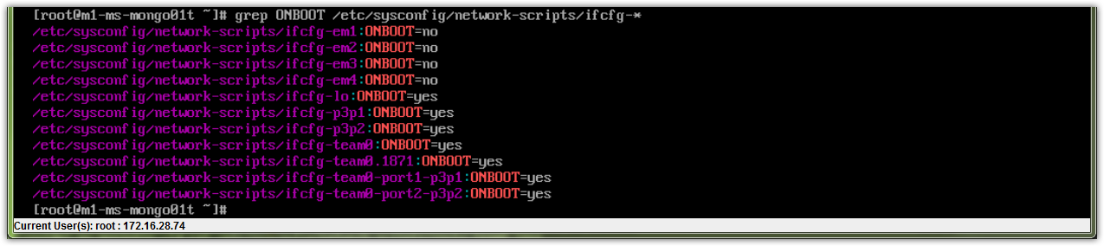

# We must start/restart all interfaces, that related with teaming - only in this case teaming start working.
# I mean interfaces “team0-port1-p3p1” and “team0-port2-p3p2” must be started/restarted!

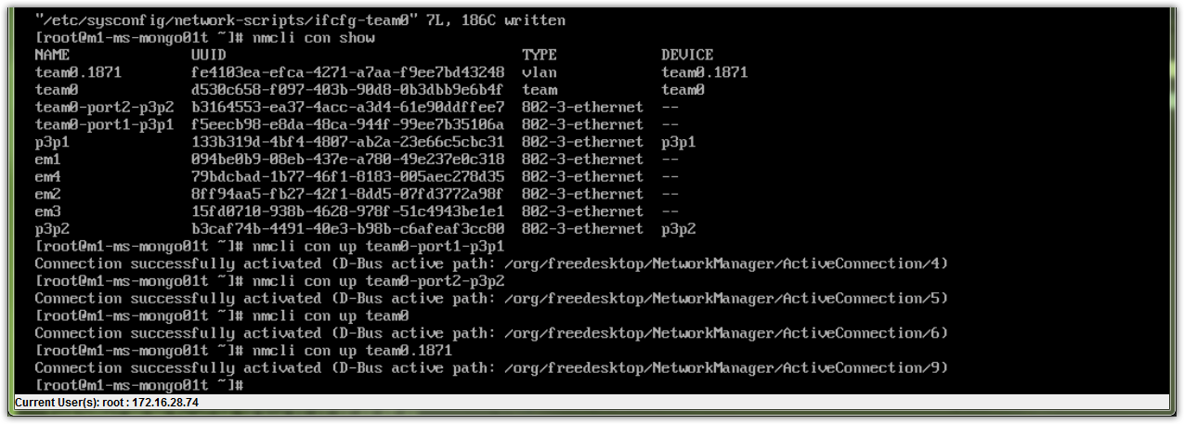
# If we start teeming manually - we have default route.
# But if we reboot server - there is no default route, and we couldn’t ssh to it and ping from this server other server, exclude default gateway x.x.x.254 and servers in same network.
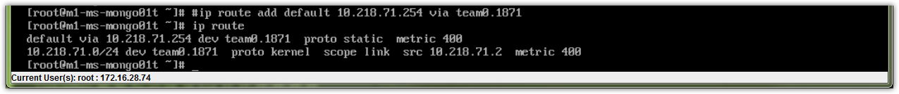
# That’s because needs to be created and configured file, that contain default routes.
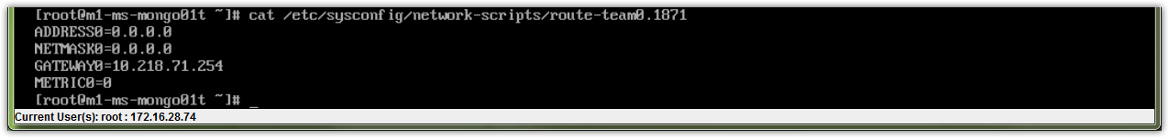

20160628
# How looks final config files.

From: Belogrud Sergey Vladimirovich
Sent: Tuesday, June 28, 2016 1:02 PM
To: Zbiranik Evgeniy Aleksandrovich
Subject: Настройка teaming.

Добрый день.

Настройка teaming.

[root@m1-ms-mongo01p ~]# ls -Alh /etc/sysconfig/network-scripts/ifcfg-*
-rw-r--r--. 1 root root 271 Jun 21 22:14 /etc/sysconfig/network-scripts/ifcfg-em1
-rw-r--r--. 1 root root 271 Jun 21 22:14 /etc/sysconfig/network-scripts/ifcfg-em2
-rw-r--r--. 1 root root 271 Jun 21 22:14 /etc/sysconfig/network-scripts/ifcfg-em3
-rw-r--r--. 1 root root 271 Jun 21 22:14 /etc/sysconfig/network-scripts/ifcfg-em4
-rw-r--r--. 1 root root 254 Sep 16 2015 /etc/sysconfig/network-scripts/ifcfg-lo
-rw-r--r--. 1 root root 257 Jun 27 19:22 /etc/sysconfig/network-scripts/ifcfg-p3p1
-rw-r--r--. 1 root root 257 Jun 27 19:22 /etc/sysconfig/network-scripts/ifcfg-p3p2
-rw-r--r--. 1 root root 186 Jun 27 19:27 /etc/sysconfig/network-scripts/ifcfg-team0
-rw-r--r--. 1 root root 312 Jun 27 19:21 /etc/sysconfig/network-scripts/ifcfg-team0.1866
-rw-r--r--. 1 root root 156 Jun 27 19:18 /etc/sysconfig/network-scripts/ifcfg-team0-port1-p3p1
-rw-r--r--. 1 root root 156 Jun 27 19:18 /etc/sysconfig/network-scripts/ifcfg-team0-port2-p3p2
[root@m1-ms-mongo01p ~]#

[root@m1-ms-mongo01p ~]# cat /etc/sysconfig/network-scripts/ifcfg-p3p1
TYPE=Ethernet
DEFROUTE=yes
PEERDNS=yes
PEERROUTES=yes
IPV4_FAILURE_FATAL=no
IPV6INIT=no
IPV6_AUTOCONF=yes
IPV6_DEFROUTE=yes
IPV6_PEERDNS=yes
IPV6_PEERROUTES=yes
IPV6_FAILURE_FATAL=no
NAME=p3p1
UUID=a72958c4-4caa-42ec-aa7b-90b04bc324af
DEVICE=p3p1
ONBOOT=no

[root@m1-ms-mongo01p ~]# cat /etc/sysconfig/network-scripts/ifcfg-p3p2
TYPE=Ethernet
DEFROUTE=yes
PEERDNS=yes
PEERROUTES=yes
IPV4_FAILURE_FATAL=no
IPV6INIT=no
IPV6_AUTOCONF=yes
IPV6_DEFROUTE=yes
IPV6_PEERDNS=yes
IPV6_PEERROUTES=yes
IPV6_FAILURE_FATAL=no
NAME=p3p2
UUID=ced3e0f4-cc55-4cf0-82b8-a38b55b31662
DEVICE=p3p2
ONBOOT=no

[root@m1-ms-mongo01p ~]# cat /etc/sysconfig/network-scripts/ifcfg-team0-port1-p3p1
NAME=team0-port1-p3p1
UUID=6e13f80a-837e-462c-a988-ff35b6987765
DEVICE=p3p1
ONBOOT=yes
TEAM_MASTER=7cdad649-1522-4465-b7ab-952702bc220e
DEVICETYPE=TeamPort
TEAM_PORT_CONFIG='{"prio":100}'

[root@m1-ms-mongo01p ~]# cat /etc/sysconfig/network-scripts/ifcfg-team0-port2-p3p2
NAME=team0-port2-p3p2
UUID=b7d2c7e6-692f-4730-90db-171f6f0f77d2
DEVICE=p3p2
ONBOOT=yes
TEAM_MASTER=7cdad649-1522-4465-b7ab-952702bc220e
DEVICETYPE=TeamPort
TEAM_PORT_CONFIG='{"prio":200}'

[root@m1-ms-mongo01p ~]# cat /etc/sysconfig/network-scripts/ifcfg-team0
DEVICE=team0
DEVICETYPE=Team
IPV6INIT=no
NAME=team0
UUID=7cdad649-1522-4465-b7ab-952702bc220e
ONBOOT=yes
TEAM_CONFIG='{"runner":{"name":"activebackup"},"link_watch":{"name":"ethtool"}}'

[root@m1-ms-mongo01p ~]# cat /etc/sysconfig/network-scripts/ifcfg-team0.1866
VLAN=yes
TYPE=Vlan
DEVICE=team0.1866
PHYSDEV=team0
VLAN_ID=1866
REORDER_HDR=0
BOOTPROTO=none
IPADDR=10.218.66.2
PREFIX=24
GATEWAY=10.218.66.254
DNS1=10.216.40.4
DNS2=10.216.42.5
DOMAIN=tcsbank.ru
DEFROUTE=yes
IPV4_FAILURE_FATAL=no
IPV6INIT=no
NAME=team0.1866
UUID=c72d2df9-8dc9-4023-8f2d-50ce26b3a852
ONBOOT=yes
[root@m1-ms-mongo01p ~]#

[root@m1-ms-mongo01p ~]# cat /etc/sysconfig/network-scripts/route-team0.1866
ADDRESS0=0.0.0.0
NETMASK0=0.0.0.0
GATEWAY0=10.218.66.254
METRIC0=0
[root@m1-ms-mongo01p ~]#

С уважением,

Сергей Белогруд
Старший системный администратор

# Here is example how had configured network by Evgeniy Zbiranik.
# One interesting thing was highlited by me. He used name instead UUID. That’s more human understandable.
#
# How Evgeniy Zbiranik configured teaming on his server.
#
[root@ds-cassandra01p ~]# ls -Alh /etc/sysconfig/network-scripts/
total 248K
-rw-r--r-- 1 root root 141 Jun 24 19:25 ifcfg-em1
-rw-r--r-- 1 root root 141 Jun 24 19:25 ifcfg-em2
-rw-r--r-- 1 root root 254 Sep 16 2015 ifcfg-lo
-rw-r--r-- 1 root root 158 Jun 24 19:33 ifcfg-team0
-rw-r--r-- 1 root root 309 Jun 24 19:59 ifcfg-vlan1865
lrwxrwxrwx 1 root root 24 Jun 24 12:54 ifdown -> ../../../usr/sbin/ifdown
-rwxr-xr-x 1 root root 627 Sep 16 2015 ifdown-bnep
-rwxr-xr-x 1 root root 5.7K Sep 16 2015 ifdown-eth
-rwxr-xr-x 1 root root 6.1K Nov 6 2015 ifdown-ib
-rwxr-xr-x 1 root root 781 Sep 16 2015 ifdown-ippp
-rwxr-xr-x 1 root root 4.2K Sep 16 2015 ifdown-jjjj
lrwxrwxrwx 1 root root 11 Jun 24 12:54 ifdown-isdn -> ifdown-ippp
-rwxr-xr-x 1 root root 1.7K Sep 16 2015 ifdown-post
-rwxr-xr-x 1 root root 1.1K Sep 16 2015 ifdown-ppp
-rwxr-xr-x 1 root root 837 Sep 16 2015 ifdown-routes
-rwxr-xr-x 1 root root 1.5K Sep 16 2015 ifdown-sit
-rwxr-xr-x 1 root root 1.6K Apr 2 2015 ifdown-Team
-rwxr-xr-x 1 root root 1.6K Apr 2 2015 ifdown-TeamPort
-rwxr-xr-x 1 root root 1.5K Sep 16 2015 ifdown-tunnel
lrwxrwxrwx 1 root root 22 Jun 24 12:54 ifup -> ../../../usr/sbin/ifup
-rwxr-xr-x 1 root root 13K Sep 16 2015 ifup-aliases
-rwxr-xr-x 1 root root 859 Sep 16 2015 ifup-bnep
-rwxr-xr-x 1 root root 12K Sep 16 2015 ifup-eth
-rwxr-xr-x 1 root root 10K Nov 6 2015 ifup-ib
-rwxr-xr-x 1 root root 12K Sep 16 2015 ifup-ippp
-rwxr-xr-x 1 root root 11K Sep 16 2015 ifup-ipv6
lrwxrwxrwx 1 root root 9 Jun 24 12:54 ifup-isdn -> ifup-ippp
-rwxr-xr-x 1 root root 642 Sep 16 2015 ifup-plip
-rwxr-xr-x 1 root root 1.1K Sep 16 2015 ifup-plusb
-rwxr-xr-x 1 root root 2.6K Sep 16 2015 ifup-post
-rwxr-xr-x 1 root root 4.1K Sep 16 2015 ifup-ppp
-rwxr-xr-x 1 root root 1.9K Sep 16 2015 ifup-routes
-rwxr-xr-x 1 root root 3.2K Sep 16 2015 ifup-sit
-rwxr-xr-x 1 root root 1.8K Apr 2 2015 ifup-Team
-rwxr-xr-x 1 root root 1.9K Apr 2 2015 ifup-TeamPort
-rwxr-xr-x 1 root root 2.7K Sep 16 2015 ifup-tunnel
-rwxr-xr-x 1 root root 1.7K Sep 16 2015 ifup-wireless
-rwxr-xr-x 1 root root 4.6K Sep 16 2015 init.ipv6-global
-rw-r--r-- 1 root root 15K Sep 16 2015 network-functions
-rw-r--r-- 1 root root 26K Sep 16 2015 network-functions-ipv6
-rw-r--r-- 1 root root 67 Jun 24 20:00 route-vlan1865
[root@ds-cassandra01p ~]# cat /etc/sysconfig/network-scripts/route-vlan1865
ADDRESS0=0.0.0.0
NETMASK0=0.0.0.0
GATEWAY0=10.218.65.254
METRIC0=0
[root@ds-cassandra01p ~]# cat /etc/sysconfig/network-scripts/ifcfg-team0
DEVICE=team0
NAME=team0
DEVICETYPE=Team
BOOTPROTO=none
USERCTL=no
ONBOOT=yes
TEAM_CONFIG='{"runner":{"name":"activebackup"},"link_watch":{"name":"ethtool"}}'
[root@ds-cassandra01p ~]# cat /etc/sysconfig/network-scripts/ifcfg-vlan1865
VLAN=yes
TYPE=Vlan
DEVICE=vlan1865
PHYSDEV=team0
VLAN_ID=1865
REORDER_HDR=0
BOOTPROTO=none
IPV4_FAILURE_FATAL=yes
IPV6INIT=no
NAME=vlan1865
ONBOOT=yes
DNS1=10.216.40.4
DNS2=10.216.42.5
DOMAIN=tcsbank.ru
DEFROUTE=yes
UUID=995fa9b1-afba-b392-a00f-ceba7e9a1e25
IPADDR=10.218.65.2
PREFIX=24
GATEWAY=10.218.65.254
[root@ds-cassandra01p ~]# cat /etc/sysconfig/network-scripts/ifcfg-em1
TYPE=Ethernet
NAME=em1
DEVICE=em1
ONBOOT=yes
BOOTPROTO=none
USERCTL=no
DEVICETYPE=TeamPort
TEAM_MASTER=team0
TEAM_PORT_CONFIG='{"prio":100}'
[root@ds-cassandra01p ~]# cat /etc/sysconfig/network-scripts/ifcfg-em2
TYPE=Ethernet
NAME=em2
DEVICE=em2
ONBOOT=yes
BOOTPROTO=none
USERCTL=no
DEVICETYPE=TeamPort
TEAM_MASTER=team0
TEAM_PORT_CONFIG='{"prio":101}'
[root@ds-cassandra01p ~]#

# This text was taked from “new server/20160617 #SD907604 New three hardware servers should be configured m1-ms-mongo01t, m1-ms-mongo01p, ds-ms-mongo01p” file.

# Here we can see, that one port on server has no link. That’s means, that it could not approriate plugged or failed cable used or some error has network switch.
[root@ds-ms-mongo01p ~]# ip link
1: lo: <LOOPBACK,UP,LOWER_UP> mtu 65536 qdisc noqueue state UNKNOWN mode DEFAULT
link/loopback 00:00:00:00:00:00 brd 00:00:00:00:00:00
2: em1: <NO-CARRIER,BROADCAST,MULTICAST,UP> mtu 1500 qdisc mq state DOWN mode DEFAULT qlen 1000
link/ether 14:18:77:66:8a:f9 brd ff:ff:ff:ff:ff:ff
3: em2: <NO-CARRIER,BROADCAST,MULTICAST,UP> mtu 1500 qdisc mq state DOWN mode DEFAULT qlen 1000
link/ether 14:18:77:66:8a:fa brd ff:ff:ff:ff:ff:ff
4: em3: <NO-CARRIER,BROADCAST,MULTICAST,UP> mtu 1500 qdisc mq state DOWN mode DEFAULT qlen 1000
link/ether 14:18:77:66:8a:fb brd ff:ff:ff:ff:ff:ff
5: em4: <NO-CARRIER,BROADCAST,MULTICAST,UP> mtu 1500 qdisc mq state DOWN mode DEFAULT qlen 1000
link/ether 14:18:77:66:8a:fc brd ff:ff:ff:ff:ff:ff
6: p3p1: <BROADCAST,MULTICAST,UP,LOWER_UP> mtu 1500 qdisc mq master team0 state UP mode DEFAULT qlen 1000
link/ether 00:90:fa:af:2b:42 brd ff:ff:ff:ff:ff:ff
7: p3p2: <NO-CARRIER,BROADCAST,MULTICAST,UP> mtu 1500 qdisc mq master team0 state DOWN mode DEFAULT qlen 1000
link/ether 00:90:fa:af:2b:42 brd ff:ff:ff:ff:ff:ff
8: team0: <BROADCAST,MULTICAST,UP,LOWER_UP> mtu 1500 qdisc noqueue state UP mode DEFAULT
link/ether 00:90:fa:af:2b:42 brd ff:ff:ff:ff:ff:ff
9: team0.1865@team0: <BROADCAST,MULTICAST,UP,LOWER_UP> mtu 1500 qdisc noqueue state UP mode DEFAULT
link/ether 00:90:fa:af:2b:42 brd ff:ff:ff:ff:ff:ff

[root@ds-ms-mongo01p ~]# ip link show p3p2
7: p3p2: <NO-CARRIER,BROADCAST,MULTICAST,UP> mtu 1500 qdisc mq master team0 state DOWN mode DEFAULT qlen 1000
link/ether 00:90:fa:af:2b:42 brd ff:ff:ff:ff:ff:ff
[root@ds-ms-mongo01p ~]#

[root@ds-ms-mongo01p ~]# ethtool -i p3p2
driver: be2net
version: 10.6.0.3r
firmware-version: 11.0.270.2002
bus-info: 0000:04:00.1
supports-statistics: yes
supports-test: yes
supports-eeprom-access: yes
supports-register-dump: no
supports-priv-flags: no

[root@ds-ms-mongo01p ~]# ethtool p3p2
Settings for p3p2:
Supported ports: [ FIBRE ]
Supported link modes: 1000baseT/Full
10000baseT/Full
Supported pause frame use: Symmetric
Supports auto-negotiation: No
Advertised link modes: Not reported
Advertised pause frame use: No
Advertised auto-negotiation: No
Speed: Unknown!
Duplex: Unknown! (255)
Port: FIBRE
PHYAD: 1
Transceiver: external
Auto-negotiation: off
Supports Wake-on: g
Wake-on: g
Current message level: 0x00000000 (0)

Link detected: no
[root@ds-ms-mongo01p ~]#

[root@ds-ms-mongo01p ~]# ip link show p3p1
6: p3p1: <BROADCAST,MULTICAST,UP,LOWER_UP> mtu 1500 qdisc mq master team0 state UP mode DEFAULT qlen 1000
link/ether 00:90:fa:af:2b:42 brd ff:ff:ff:ff:ff:ff
[root@ds-ms-mongo01p ~]#

[root@ds-ms-mongo01p ~]# ethtool p3p1
Settings for p3p1:
Supported ports: [ FIBRE ]
Supported link modes: 1000baseT/Full
10000baseT/Full
Supported pause frame use: Symmetric
Supports auto-negotiation: No
Advertised link modes: Not reported
Advertised pause frame use: No
Advertised auto-negotiation: No
Speed: 10000Mb/s
Duplex: Full
Port: Direct Attach Copper
PHYAD: 0
Transceiver: external
Auto-negotiation: off
Supports Wake-on: g
Wake-on: g
Current message level: 0x00000000 (0)

Link detected: yes
[root@ds-ms-mongo01p ~]#

................................................................................
................................................................................

[root@ds-ms-mongo01p ~]# read -s -p "Enter Proxy Password: " PROXY_PASSWORD ; echo ; read -s -p "Enter RHN Password: " RHN_PASSWORD ; subscription-manager register --proxy=mwg.gtm.tcsbank.ru:8080 --proxyuser=rhsm_user --proxypass=$PROXY_PASSWORD --username=tcsbank17012012 --password=$RHN_PASSWORD --auto-attach
Enter Proxy Password:
Enter RHN Password: Registering to: subscription.rhn.redhat.com:443/subscription
The system has been registered with ID: 03374417-0249-4a95-abc3-ea8f4603ac7c

Installed Product Current Status:
Product Name: Red Hat Enterprise Linux Server
Status: Subscribed

[root@ds-ms-mongo01p ~]#

[root@ds-ms-mongo01p ~]# yum install http://repo-linux.tcsbank.ru/puppetlabs/yum/puppetlabs-release-el-7.noarch.rpm
Loaded plugins: langpacks, product-id, search-disabled-repos, subscription-manager
[Errno 111] Connection refused
puppetlabs-release-el-7.noarch.rpm | 12 kB 00:00:00
Examining /var/tmp/yum-root-AuF0Jh/puppetlabs-release-el-7.noarch.rpm: puppetlabs-release-7-12.noarch
Marking /var/tmp/yum-root-AuF0Jh/puppetlabs-release-el-7.noarch.rpm to be installed
Resolving Dependencies
--> Running transaction check
---> Package puppetlabs-release.noarch 0:7-12 will be installed
--> Finished Dependency Resolution
https://cdn.redhat.com/content/dist/rhel/server/7/7Server/x86_64/os/repodata/repomd.xml: [Errno 14] curl#7 - "Failed connect to cdn.redhat.com:443; Connection refused"
Trying other mirror.
https://cdn.redhat.com/content/dist/rhel/server/7/7Server/x86_64/os/repodata/repomd.xml: [Errno 14] curl#7 - "Failed connect to cdn.redhat.com:443; Connection refused"
Trying other mirror.
https://cdn.redhat.com/content/dist/rhel/server/7/7Server/x86_64/os/repodata/repomd.xml: [Errno 14] curl#7 - "Failed connect to cdn.redhat.com:443; Connection refused"
Trying other mirror.
https://cdn.redhat.com/content/dist/rhel/server/7/7Server/x86_64/os/repodata/repomd.xml: [Errno 14] curl#7 - "Failed connect to cdn.redhat.com:443; Connection refused"
Trying other mirror.
https://cdn.redhat.com/content/dist/rhel/server/7/7Server/x86_64/os/repodata/repomd.xml: [Errno 14] curl#7 - "Failed connect to cdn.redhat.com:443; Connection refused"
Trying other mirror.
https://cdn.redhat.com/content/dist/rhel/server/7/7Server/x86_64/os/repodata/repomd.xml: [Errno 14] curl#7 - "Failed connect to cdn.redhat.com:443; Connection refused"
Trying other mirror.
https://cdn.redhat.com/content/dist/rhel/server/7/7Server/x86_64/os/repodata/repomd.xml: [Errno 14] curl#7 - "Failed connect to cdn.redhat.com:443; Connection refused"
Trying other mirror.
https://cdn.redhat.com/content/dist/rhel/server/7/7Server/x86_64/os/repodata/repomd.xml: [Errno 14] curl#7 - "Failed connect to cdn.redhat.com:443; Connection refused"
Trying other mirror.
https://cdn.redhat.com/content/dist/rhel/server/7/7Server/x86_64/os/repodata/repomd.xml: [Errno 14] curl#7 - "Failed connect to cdn.redhat.com:443; Connection refused"
Trying other mirror.
https://cdn.redhat.com/content/dist/rhel/server/7/7Server/x86_64/os/repodata/repomd.xml: [Errno 14] curl#7 - "Failed connect to cdn.redhat.com:443; Connection refused"
Trying other mirror.
http://repo-linux.tcsbank.ru/dell/rhel/7Server/x86_64/repodata/repomd.xml: [Errno 14] HTTP Error 404 - Not Found
Trying other mirror.
To address this issue please refer to the below knowledge base article

https://access.redhat.com/articles/1320623

If above article doesn't help to resolve this issue please open a ticket with Red Hat Support.

Dependencies Resolved

=====================================================================================================================================================================================================
Package Arch Version Repository Size
=====================================================================================================================================================================================================
Installing:
puppetlabs-release noarch 7-12 /puppetlabs-release-el-7.noarch 11 k

Transaction Summary
=====================================================================================================================================================================================================
Install 1 Package

Total size: 11 k
Installed size: 11 k
Is this ok [y/d/N]: y
Downloading packages:
Running transaction check
Running transaction test
Transaction test succeeded
Running transaction
Installing : puppetlabs-release-7-12.noarch 1/1
https://cdn.redhat.com/content/dist/rhel/server/7/7Server/x86_64/os/repodata/repomd.xml: [Errno 14] curl#7 - "Failed connect to cdn.redhat.com:443; Connection refused"
Trying other mirror.
https://cdn.redhat.com/content/dist/rhel/server/7/7Server/x86_64/os/repodata/repomd.xml: [Errno 14] curl#7 - "Failed connect to cdn.redhat.com:443; Connection refused"
Trying other mirror.
https://cdn.redhat.com/content/dist/rhel/server/7/7Server/x86_64/os/repodata/repomd.xml: [Errno 14] curl#7 - "Failed connect to cdn.redhat.com:443; Connection refused"
Trying other mirror.
https://cdn.redhat.com/content/dist/rhel/server/7/7Server/x86_64/os/repodata/repomd.xml: [Errno 14] curl#7 - "Failed connect to cdn.redhat.com:443; Connection refused"
Trying other mirror.
https://cdn.redhat.com/content/dist/rhel/server/7/7Server/x86_64/os/repodata/repomd.xml: [Errno 14] curl#7 - "Failed connect to cdn.redhat.com:443; Connection refused"
Trying other mirror.
https://cdn.redhat.com/content/dist/rhel/server/7/7Server/x86_64/os/repodata/repomd.xml: [Errno 14] curl#7 - "Failed connect to cdn.redhat.com:443; Connection refused"
Trying other mirror.
https://cdn.redhat.com/content/dist/rhel/server/7/7Server/x86_64/os/repodata/repomd.xml: [Errno 14] curl#7 - "Failed connect to cdn.redhat.com:443; Connection refused"
Trying other mirror.
https://cdn.redhat.com/content/dist/rhel/server/7/7Server/x86_64/os/repodata/repomd.xml: [Errno 14] curl#7 - "Failed connect to cdn.redhat.com:443; Connection refused"
Trying other mirror.
https://cdn.redhat.com/content/dist/rhel/server/7/7Server/x86_64/os/repodata/repomd.xml: [Errno 14] curl#7 - "Failed connect to cdn.redhat.com:443; Connection refused"
Trying other mirror.
https://cdn.redhat.com/content/dist/rhel/server/7/7Server/x86_64/os/repodata/repomd.xml: [Errno 14] curl#7 - "Failed connect to cdn.redhat.com:443; Connection refused"
Trying other mirror.
http://repo-linux.tcsbank.ru/dell/rhel/7Server/x86_64/repodata/repomd.xml: [Errno 14] HTTP Error 404 - Not Found
Trying other mirror.
https://cdn.redhat.com/content/dist/rhel/server/7/7Server/x86_64/os/repodata/repomd.xml: [Errno 14] curl#7 - "Failed connect to cdn.redhat.com:443; Connection refused"
Trying other mirror.
https://cdn.redhat.com/content/dist/rhel/server/7/7Server/x86_64/os/repodata/repomd.xml: [Errno 14] curl#7 - "Failed connect to cdn.redhat.com:443; Connection refused"
Trying other mirror.
https://cdn.redhat.com/content/dist/rhel/server/7/7Server/x86_64/os/repodata/repomd.xml: [Errno 14] curl#7 - "Failed connect to cdn.redhat.com:443; Connection refused"
Trying other mirror.
https://cdn.redhat.com/content/dist/rhel/server/7/7Server/x86_64/os/repodata/repomd.xml: [Errno 14] curl#7 - "Failed connect to cdn.redhat.com:443; Connection refused"
Trying other mirror.
https://cdn.redhat.com/content/dist/rhel/server/7/7Server/x86_64/os/repodata/repomd.xml: [Errno 14] curl#7 - "Failed connect to cdn.redhat.com:443; Connection refused"
Trying other mirror.
https://cdn.redhat.com/content/dist/rhel/server/7/7Server/x86_64/os/repodata/repomd.xml: [Errno 14] curl#7 - "Failed connect to cdn.redhat.com:443; Connection refused"
Trying other mirror.
https://cdn.redhat.com/content/dist/rhel/server/7/7Server/x86_64/os/repodata/repomd.xml: [Errno 14] curl#7 - "Failed connect to cdn.redhat.com:443; Connection refused"
Trying other mirror.
https://cdn.redhat.com/content/dist/rhel/server/7/7Server/x86_64/os/repodata/repomd.xml: [Errno 14] curl#7 - "Failed connect to cdn.redhat.com:443; Connection refused"
Trying other mirror.
https://cdn.redhat.com/content/dist/rhel/server/7/7Server/x86_64/os/repodata/repomd.xml: [Errno 14] curl#7 - "Failed connect to cdn.redhat.com:443; Connection refused"
Trying other mirror.
https://cdn.redhat.com/content/dist/rhel/server/7/7Server/x86_64/os/repodata/repomd.xml: [Errno 14] curl#7 - "Failed connect to cdn.redhat.com:443; Connection refused"
Trying other mirror.
failure: repodata/repomd.xml from rhel-7-server-rpms: [Errno 256] No more mirrors to try.
https://cdn.redhat.com/content/dist/rhel/server/7/7Server/x86_64/os/repodata/repomd.xml: [Errno 14] curl#7 - "Failed connect to cdn.redhat.com:443; Connection refused"
https://cdn.redhat.com/content/dist/rhel/server/7/7Server/x86_64/os/repodata/repomd.xml: [Errno 14] curl#7 - "Failed connect to cdn.redhat.com:443; Connection refused"
https://cdn.redhat.com/content/dist/rhel/server/7/7Server/x86_64/os/repodata/repomd.xml: [Errno 14] curl#7 - "Failed connect to cdn.redhat.com:443; Connection refused"
https://cdn.redhat.com/content/dist/rhel/server/7/7Server/x86_64/os/repodata/repomd.xml: [Errno 14] curl#7 - "Failed connect to cdn.redhat.com:443; Connection refused"
https://cdn.redhat.com/content/dist/rhel/server/7/7Server/x86_64/os/repodata/repomd.xml: [Errno 14] curl#7 - "Failed connect to cdn.redhat.com:443; Connection refused"
https://cdn.redhat.com/content/dist/rhel/server/7/7Server/x86_64/os/repodata/repomd.xml: [Errno 14] curl#7 - "Failed connect to cdn.redhat.com:443; Connection refused"
https://cdn.redhat.com/content/dist/rhel/server/7/7Server/x86_64/os/repodata/repomd.xml: [Errno 14] curl#7 - "Failed connect to cdn.redhat.com:443; Connection refused"
https://cdn.redhat.com/content/dist/rhel/server/7/7Server/x86_64/os/repodata/repomd.xml: [Errno 14] curl#7 - "Failed connect to cdn.redhat.com:443; Connection refused"
https://cdn.redhat.com/content/dist/rhel/server/7/7Server/x86_64/os/repodata/repomd.xml: [Errno 14] curl#7 - "Failed connect to cdn.redhat.com:443; Connection refused"
https://cdn.redhat.com/content/dist/rhel/server/7/7Server/x86_64/os/repodata/repomd.xml: [Errno 14] curl#7 - "Failed connect to cdn.redhat.com:443; Connection refused"
Verifying : puppetlabs-release-7-12.noarch 1/1

Installed:
puppetlabs-release.noarch 0:7-12

Complete!
[root@ds-ms-mongo01p ~]#

# In this file one string should be replaced with other.
#
[root@ds-ms-mongo01p ~]# vim /etc/yum.repos.d/puppetlabs.repo
...
:%s/yum.puppetlabs.com/repo-linux.tcsbank.ru\/puppetlabs\/yum/gc

................................................................................
................................................................................

[root@ds-ms-mongo01p ~]# hwclock --show
Tue 28 Jun 2016 05:46:55 PM MSK -0.344218 seconds
[root@ds-ms-mongo01p ~]# date
Tue Jun 28 17:46:57 MSK 2016
[root@ds-ms-mongo01p ~]#

[root@ds-ms-mongo01p ~]# date --set=1447
Tue Jun 28 14:47:00 MSK 2016
[root@ds-ms-mongo01p ~]# hwclock --show
Tue 28 Jun 2016 05:48:19 PM MSK -0.906641 seconds
[root@ds-ms-mongo01p ~]# hwclock --systohc
[root@ds-ms-mongo01p ~]# hwclock --show
Tue 28 Jun 2016 02:47:26 PM MSK -0.453475 seconds
[root@ds-ms-mongo01p ~]#

................................................................................

[root@ds-ms-mongo01p ~]# subscription-manager list

+-------------------------------------------+
Installed Product Status
+-------------------------------------------+
Product Name: Red Hat Enterprise Linux Server
Product ID: 69
Version: 7.2
Arch: x86_64
Status: Subscribed
Status Details:
Starts: 01/28/2016
Ends: 01/28/2017

[root@ds-ms-mongo01p ~]#

................................................................................

[root@ds-ms-mongo01p ~]# subscription-manager
Usage: subscription-manager MODULE-NAME [MODULE-OPTIONS] [--help]

Primary Modules:

attach Attach a specified subscription to the registered system
list List subscription and product information for this system
refresh Pull the latest subscription data from the server
register Register this system to the Customer Portal or another subscription management service
release Configure which operating system release to use
remove Remove all or specific subscriptions from this system
status Show status information for this system's subscriptions and products
unregister Unregister this system from the Customer Portal or another subscription management service

Other Modules:

auto-attach Set if subscriptions are attached on a schedule (default of daily)
clean Remove all local system and subscription data without affecting the server
config List, set, or remove the configuration parameters in use by this system
environments Display the environments available for a user
facts View or update the detected system information
identity Display the identity certificate for this system or request a new one
import Import certificates which were provided outside of the tool
orgs Display the organizations against which a user can register a system
plugins View and configure subscription-manager plugins
redeem Attempt to redeem a subscription for a preconfigured system
repo-override Manage custom content repository settings
repos List the repositories which this system is entitled to use
service-level Manage service levels for this system
subscribe Deprecated, see attach
unsubscribe Deprecated, see remove
version Print version information

[root@ds-ms-mongo01p ~]#

[root@ds-ms-mongo01p ~]# subscription-manager status
+-------------------------------------------+
System Status Details
+-------------------------------------------+
Overall Status: Current

[root@ds-ms-mongo01p ~]#

[root@ds-ms-mongo01p ~]# subscription-manager --proxy=mwg.gtm.tcsbank.ru:8080 --proxyuser=rhsm_user --proxypass=$PROXY_PASSWORD refresh
All local data refreshed
[root@ds-ms-mongo01p ~]#
[root@ds-ms-mongo01p ~]# subscription-manager --proxy=mwg.gtm.tcsbank.ru:8080 --proxyuser=rhsm_user --proxypass=$PROXY_PASSWORD list

+-------------------------------------------+
Installed Product Status
+-------------------------------------------+
Product Name: Red Hat Enterprise Linux Server
Product ID: 69
Version: 7.2
Arch: x86_64
Status: Subscribed
Status Details:
Starts: 01/28/2016
Ends: 01/28/2017

[root@ds-ms-mongo01p ~]# subscription-manager --proxy=mwg.gtm.tcsbank.ru:8080 --proxyuser=rhsm_user --proxypass=$PROXY_PASSWORD status
+-------------------------------------------+
System Status Details
+-------------------------------------------+
Overall Status: Current

[root@ds-ms-mongo01p ~]#

[root@ds-ms-mongo01p ~]# subscription-manager --proxy=mwg.gtm.tcsbank.ru:8080 --proxyuser=rhsm_user --proxypass=$PROXY_PASSWORD attach

All installed products are covered by valid entitlements. No need to update subscriptions at this time.

Installed Product Current Status:
Product Name: Red Hat Enterprise Linux Server
Status: Subscribed

[root@ds-ms-mongo01p ~]#

[root@ds-ms-mongo01p ~]# subscription-manager --proxy=mwg.gtm.tcsbank.ru:8080 --proxyuser=rhsm_user --proxypass=$PROXY_PASSWORD repos
+----------------------------------------------------------+
Available Repositories in /etc/yum.repos.d/redhat.repo
+----------------------------------------------------------+
Repo ID: rhel-7-server-optional-debug-rpms
Repo Name: Red Hat Enterprise Linux 7 Server - Optional (Debug RPMs)
Repo URL: https://cdn.redhat.com/content/dist/rhel/server/7/$releasever/$basearch/optional/debug
Enabled: 0

Repo ID: rhel-7-server-rhn-tools-beta-debug-rpms
Repo Name: RHN Tools for Red Hat Enterprise Linux 7 Server Beta (Debug RPMs)
Repo URL: https://cdn.redhat.com/content/beta/rhel/server/7/$basearch/rhn-tools/debug
Enabled: 0

Repo ID: rhel-7-server-v2vwin-1-debug-rpms
Repo Name: Red Hat Virt V2V Tool for RHEL 7 (Debug RPMs)
Repo URL: https://cdn.redhat.com/content/dist/rhel/server/7/$releasever/$basearch/v2vwin/debug
Enabled: 0

Repo ID: rhel-7-server-satellite-tools-6-beta-rpms
Repo Name: Red Hat Satellite Tools 6 Beta (for RHEL 7 Server) (RPMs)
Repo URL: https://cdn.redhat.com/content/beta/rhel/server/7/$basearch/sat-tools/6/os
Enabled: 0

Repo ID: rhel-7-server-rhn-tools-debug-rpms
Repo Name: RHN Tools for Red Hat Enterprise Linux 7 Server (Debug RPMs)
Repo URL: https://cdn.redhat.com/content/dist/rhel/server/7/$releasever/$basearch/rhn-tools/debug
Enabled: 0

Repo ID: rhel-server-rhscl-7-beta-rpms
Repo Name: Red Hat Software Collections Beta RPMs for Red Hat Enterprise Linux 7 Server
Repo URL: https://cdn.redhat.com/content/beta/rhel/server/7/$basearch/rhscl/1/os
Enabled: 0

Repo ID: rhel-7-server-rhceph-1.3-tools-debug-rpms
Repo Name: Red Hat Ceph Storage Tools 1.3 for Red Hat Enterprise Linux 7 Server (Debug RPMs)
Repo URL: https://cdn.redhat.com/content/dist/rhel/server/7/$releasever/$basearch/ceph-tools/1.3/debug
Enabled: 0

Repo ID: rhel-7-server-optional-fastrack-debug-rpms
Repo Name: Red Hat Enterprise Linux 7 Server - Optional Fastrack (Debug RPMs)
Repo URL: https://cdn.redhat.com/content/fastrack/rhel/server/7/$basearch/optional/debug
Enabled: 0

Repo ID: rhel-7-server-extras-source-rpms
Repo Name: Red Hat Enterprise Linux 7 Server - Extras (Source RPMs)
Repo URL: https://cdn.redhat.com/content/dist/rhel/server/7/7Server/$basearch/extras/source/SRPMS
Enabled: 0

Repo ID: rhel-7-server-satellite-tools-6.1-debug-rpms
Repo Name: Red Hat Satellite Tools 6.1 (for RHEL 7 Server) (Debug RPMs)
Repo URL: https://cdn.redhat.com/content/dist/rhel/server/7/7Server/$basearch/sat-tools/6.1/debug
Enabled: 0

Repo ID: rhel-server-rhscl-7-eus-source-rpms
Repo Name: Red Hat Software Collections Source RPMs for Red Hat Enterprise Linux 7 RHEL 7 Server EUS
Repo URL: https://cdn.redhat.com/content/eus/rhel/server/7/$releasever/$basearch/rhscl/1/source/SRPMS
Enabled: 0

Repo ID: rhel-server-rhscl-7-eus-debug-rpms
Repo Name: Red Hat Software Collections Debug RPMs for Red Hat Enterprise Linux 7 RHEL 7 Server EUS
Repo URL: https://cdn.redhat.com/content/eus/rhel/server/7/$releasever/$basearch/rhscl/1/debug
Enabled: 0

Repo ID: rhel-7-server-satellite-tools-6-beta-source-rpms
Repo Name: Red Hat Satellite Tools 6 Beta (for RHEL 7 Server) (Source RPMs)
Repo URL: https://cdn.redhat.com/content/beta/rhel/server/7/$basearch/sat-tools/6/source/SRPMS
Enabled: 0

Repo ID: rhel-7-server-v2vwin-1-rpms
Repo Name: Red Hat Virt V2V Tool for RHEL 7 (RPMs)
Repo URL: https://cdn.redhat.com/content/dist/rhel/server/7/$releasever/$basearch/v2vwin/os
Enabled: 0

Repo ID: rhel-7-server-rpms
Repo Name: Red Hat Enterprise Linux 7 Server (RPMs)
Repo URL: https://cdn.redhat.com/content/dist/rhel/server/7/$releasever/$basearch/os
Enabled: 1

Repo ID: rhel-7-server-beta-rpms
Repo Name: Red Hat Enterprise Linux 7 Server Beta (RPMs)
Repo URL: https://cdn.redhat.com/content/beta/rhel/server/7/$basearch/os
Enabled: 0

Repo ID: rhel-7-server-dotnet-beta-debug-rpms
Repo Name: dotNET on RHEL Beta Debug RPMs for Red Hat Enterprise Linux 7 Server
Repo URL: https://cdn.redhat.com/content/beta/rhel/server/7/$basearch/dotnet/1/debug
Enabled: 0

Repo ID: rhel-7-server-extras-rpms
Repo Name: Red Hat Enterprise Linux 7 Server - Extras (RPMs)
Repo URL: https://cdn.redhat.com/content/dist/rhel/server/7/7Server/$basearch/extras/os
Enabled: 0

Repo ID: rhel-7-server-openstack-8-tools-source-rpms
Repo Name: Red Hat OpenStack Platform 8 Tools for RHEL 7 Server (Source RPMs)
Repo URL: https://cdn.redhat.com/content/dist/rhel/server/7/$releasever/$basearch/openstack-tools/8/source/SRPMS
Enabled: 0

Repo ID: rhel-server-rhscl-7-eus-rpms
Repo Name: Red Hat Software Collections RPMs for Red Hat Enterprise Linux 7 RHEL 7 Server EUS
Repo URL: https://cdn.redhat.com/content/eus/rhel/server/7/$releasever/$basearch/rhscl/1/os
Enabled: 0

Repo ID: rhel-7-server-supplementary-beta-debug-rpms
Repo Name: Red Hat Enterprise Linux 7 Server - Supplementary Beta (Debug RPMs)
Repo URL: https://cdn.redhat.com/content/beta/rhel/server/7/$basearch/supplementary/debug
Enabled: 0

Repo ID: rh-gluster-3-client-for-rhel-7-server-source-rpms
Repo Name: Red Hat Storage Native Client for RHEL 7 (Source RPMs)
Repo URL: https://cdn.redhat.com/content/dist/rhel/server/7/$releasever/$basearch/rhs-client/source/SRPMS
Enabled: 0

Repo ID: rhel-7-server-rhn-tools-beta-rpms
Repo Name: RHN Tools for Red Hat Enterprise Linux 7 Server Beta (RPMs)
Repo URL: https://cdn.redhat.com/content/beta/rhel/server/7/$basearch/rhn-tools/os
Enabled: 0

Repo ID: rhel-7-server-rh-common-beta-rpms
Repo Name: Red Hat Enterprise Linux 7 Server - RH Common Beta (RPMs)
Repo URL: https://cdn.redhat.com/content/beta/rhel/server/7/$basearch/rh-common/os
Enabled: 0

Repo ID: rhel-7-server-supplementary-debug-rpms
Repo Name: Red Hat Enterprise Linux 7 Server - Supplementary (Debug RPMs)
Repo URL: https://cdn.redhat.com/content/dist/rhel/server/7/$releasever/$basearch/supplementary/debug
Enabled: 0

Repo ID: rhel-server-rhscl-7-debug-rpms
Repo Name: Red Hat Software Collections Debug RPMs for Red Hat Enterprise Linux 7 Server
Repo URL: https://cdn.redhat.com/content/dist/rhel/server/7/$releasever/$basearch/rhscl/1/debug
Enabled: 0

Repo ID: rhel-7-server-openstack-7.0-tools-rpms
Repo Name: Red Hat OpenStack Tools 7.0 for Red Hat Enterprise Linux 7 Server (RPMs)
Repo URL: https://cdn.redhat.com/content/dist/rhel/server/7/$releasever/$basearch/openstack-tools/7.0/os
Enabled: 0

Repo ID: rhel-server-rhscl-7-beta-source-rpms
Repo Name: Red Hat Software Collections Beta Source RPMs for Red Hat Enterprise Linux 7 Server
Repo URL: https://cdn.redhat.com/content/beta/rhel/server/7/$basearch/rhscl/1/source/SRPMS
Enabled: 0

Repo ID: rhel-7-server-openstack-8-tools-debug-rpms
Repo Name: Red Hat OpenStack Platform 8 Tools for RHEL 7 Server (Debug RPMs)
Repo URL: https://cdn.redhat.com/content/dist/rhel/server/7/$releasever/$basearch/openstack-tools/8/debug
Enabled: 0

Repo ID: rhel-7-server-thirdparty-oracle-java-beta-rpms
Repo Name: Red Hat Enterprise Linux 7 Server - Oracle Java Beta (RPMs)
Repo URL: https://cdn.redhat.com/content/beta/rhel/server/7/$basearch/oracle-java/os
Enabled: 0

Repo ID: rhel-7-server-rhn-tools-rpms
Repo Name: RHN Tools for Red Hat Enterprise Linux 7 Server (RPMs)
Repo URL: https://cdn.redhat.com/content/dist/rhel/server/7/$releasever/$basearch/rhn-tools/os
Enabled: 0

Repo ID: rhel-7-server-beta-source-rpms
Repo Name: Red Hat Enterprise Linux 7 Server Beta (Source RPMs)
Repo URL: https://cdn.redhat.com/content/beta/rhel/server/7/$basearch/source/SRPMS
Enabled: 0

Repo ID: rhel-7-server-extras-debug-rpms
Repo Name: Red Hat Enterprise Linux 7 Server - Extras (Debug RPMs)
Repo URL: https://cdn.redhat.com/content/dist/rhel/server/7/7Server/$basearch/extras/debug
Enabled: 0

Repo ID: rhel-7-server-rh-common-beta-debug-rpms
Repo Name: Red Hat Enterprise Linux 7 Server - RH Common Beta (Debug RPMs)
Repo URL: https://cdn.redhat.com/content/beta/rhel/server/7/$basearch/rh-common/debug
Enabled: 0

Repo ID: rhel-7-server-debug-rpms
Repo Name: Red Hat Enterprise Linux 7 Server (Debug RPMs)
Repo URL: https://cdn.redhat.com/content/dist/rhel/server/7/$releasever/$basearch/debug
Enabled: 0

Repo ID: rhel-7-server-thirdparty-oracle-java-rpms
Repo Name: Red Hat Enterprise Linux 7 Server - Oracle Java (RPMs)
Repo URL: https://cdn.redhat.com/content/dist/rhel/server/7/$releasever/$basearch/oracle-java/os
Enabled: 0

Repo ID: rhel-server-rhscl-7-source-rpms
Repo Name: Red Hat Software Collections Source RPMs for Red Hat Enterprise Linux 7 Server
Repo URL: https://cdn.redhat.com/content/dist/rhel/server/7/$releasever/$basearch/rhscl/1/source/SRPMS
Enabled: 0

Repo ID: rhel-7-server-fastrack-rpms
Repo Name: Red Hat Enterprise Linux 7 Server - Fastrack (RPMs)
Repo URL: https://cdn.redhat.com/content/fastrack/rhel/server/7/$basearch/os
Enabled: 0

Repo ID: rhel-7-server-satellite-tools-6-beta-debug-rpms
Repo Name: Red Hat Satellite Tools 6 Beta (for RHEL 7 Server) (Debug RPMs)
Repo URL: https://cdn.redhat.com/content/beta/rhel/server/7/$basearch/sat-tools/6/debug
Enabled: 0

Repo ID: rhel-7-server-dotnet-beta-source-rpms
Repo Name: dotNET on RHEL Beta Source RPMs for Red Hat Enterprise Linux 7 Server
Repo URL: https://cdn.redhat.com/content/beta/rhel/server/7/$basearch/dotnet/1/source/SRPMS
Enabled: 0

Repo ID: rhel-7-server-optional-beta-debug-rpms
Repo Name: Red Hat Enterprise Linux 7 Server - Optional Beta (Debug RPMs)
Repo URL: https://cdn.redhat.com/content/beta/rhel/server/7/$basearch/optional/debug
Enabled: 0

Repo ID: rhel-7-server-rh-common-rpms
Repo Name: Red Hat Enterprise Linux 7 Server - RH Common (RPMs)
Repo URL: https://cdn.redhat.com/content/dist/rhel/server/7/$releasever/$basearch/rh-common/os
Enabled: 0

Repo ID: rhel-7-server-dotnet-rpms
Repo Name: dotNET on RHEL RPMs for Red Hat Enterprise Linux 7 Server
Repo URL: https://cdn.redhat.com/content/dist/rhel/server/7/$releasever/$basearch/dotnet/1/os
Enabled: 0

Repo ID: rhel-7-server-rh-common-debug-rpms
Repo Name: Red Hat Enterprise Linux 7 Server - RH Common (Debug RPMs)
Repo URL: https://cdn.redhat.com/content/dist/rhel/server/7/$releasever/$basearch/rh-common/debug
Enabled: 0

Repo ID: rhel-server-rhscl-7-beta-debug-rpms
Repo Name: Red Hat Software Collections Beta Debug RPMs for Red Hat Enterprise Linux 7 Server
Repo URL: https://cdn.redhat.com/content/beta/rhel/server/7/$basearch/rhscl/1/debug
Enabled: 0

Repo ID: rh-gluster-3-client-for-rhel-7-server-debug-rpms
Repo Name: Red Hat Storage Native Client for RHEL 7 (Debug RPMs)
Repo URL: https://cdn.redhat.com/content/dist/rhel/server/7/$releasever/$basearch/rhs-client/debug
Enabled: 0

Repo ID: rhel-7-server-optional-fastrack-rpms
Repo Name: Red Hat Enterprise Linux 7 Server - Optional Fastrack (RPMs)
Repo URL: https://cdn.redhat.com/content/fastrack/rhel/server/7/$basearch/optional/os
Enabled: 0

Repo ID: rhel-7-server-dotnet-source-rpms
Repo Name: dotNET on RHEL Source RPMs for Red Hat Enterprise Linux 7 Server
Repo URL: https://cdn.redhat.com/content/dist/rhel/server/7/$releasever/$basearch/dotnet/1/source/SRPMS
Enabled: 0

Repo ID: rh-gluster-3-client-for-rhel-7-server-rpms
Repo Name: Red Hat Storage Native Client for RHEL 7 (RPMs)
Repo URL: https://cdn.redhat.com/content/dist/rhel/server/7/$releasever/$basearch/rhs-client/os
Enabled: 0

Repo ID: rhel-7-server-supplementary-source-rpms
Repo Name: Red Hat Enterprise Linux 7 Server - Supplementary (Source RPMs)
Repo URL: https://cdn.redhat.com/content/dist/rhel/server/7/$releasever/$basearch/supplementary/source/SRPMS
Enabled: 0

Repo ID: rhel-7-server-supplementary-beta-source-rpms
Repo Name: Red Hat Enterprise Linux 7 Server - Supplementary Beta (Source RPMs)
Repo URL: https://cdn.redhat.com/content/beta/rhel/server/7/$basearch/supplementary/source/SRPMS
Enabled: 0

Repo ID: rhel-7-server-satellite-tools-6.1-rpms
Repo Name: Red Hat Satellite Tools 6.1 (for RHEL 7 Server) (RPMs)
Repo URL: https://cdn.redhat.com/content/dist/rhel/server/7/7Server/$basearch/sat-tools/6.1/os
Enabled: 0

Repo ID: rhel-7-server-satellite-tools-6.1-source-rpms
Repo Name: Red Hat Satellite Tools 6.1 (for RHEL 7 Server) (Source RPMs)
Repo URL: https://cdn.redhat.com/content/dist/rhel/server/7/7Server/$basearch/sat-tools/6.1/source/SRPMS
Enabled: 0

Repo ID: rhel-7-server-supplementary-rpms
Repo Name: Red Hat Enterprise Linux 7 Server - Supplementary (RPMs)
Repo URL: https://cdn.redhat.com/content/dist/rhel/server/7/$releasever/$basearch/supplementary/os
Enabled: 0

Repo ID: rhel-7-server-rhn-tools-beta-source-rpms
Repo Name: RHN Tools for Red Hat Enterprise Linux 7 Server Beta (Source RPMs)
Repo URL: https://cdn.redhat.com/content/beta/rhel/server/7/$basearch/rhn-tools/source/SRPMS
Enabled: 0

Repo ID: rhel-7-server-v2vwin-1-source-rpms
Repo Name: Red Hat Virt V2V Tool for RHEL 7 (Source RPMs)
Repo URL: https://cdn.redhat.com/content/dist/rhel/server/7/$releasever/$basearch/v2vwin/source/SRPMS
Enabled: 0

Repo ID: rhel-7-server-source-rpms
Repo Name: Red Hat Enterprise Linux 7 Server (Source RPMs)
Repo URL: https://cdn.redhat.com/content/dist/rhel/server/7/$releasever/$basearch/source/SRPMS
Enabled: 0

Repo ID: rhel-7-server-optional-rpms
Repo Name: Red Hat Enterprise Linux 7 Server - Optional (RPMs)
Repo URL: https://cdn.redhat.com/content/dist/rhel/server/7/$releasever/$basearch/optional/os
Enabled: 0

Repo ID: rhel-7-server-rh-common-beta-source-rpms
Repo Name: Red Hat Enterprise Linux 7 Server - RH Common Beta (Source RPMs)
Repo URL: https://cdn.redhat.com/content/beta/rhel/server/7/$basearch/rh-common/source/SRPMS
Enabled: 0

Repo ID: rhel-7-server-rhceph-1.3-tools-source-rpms
Repo Name: Red Hat Ceph Storage Tools 1.3 for Red Hat Enterprise Linux 7 Server (Source RPMs)
Repo URL: https://cdn.redhat.com/content/dist/rhel/server/7/$releasever/$basearch/ceph-tools/1.3/source/SRPMS
Enabled: 0

Repo ID: rhel-7-server-fastrack-source-rpms
Repo Name: Red Hat Enterprise Linux 7 Server - Fastrack (Source RPMs)
Repo URL: https://cdn.redhat.com/content/fastrack/rhel/server/7/$basearch/source/SRPMS
Enabled: 0

Repo ID: rhel-7-server-openstack-8-tools-rpms
Repo Name: Red Hat OpenStack Platform 8 Tools for RHEL 7 Server (RPMs)
Repo URL: https://cdn.redhat.com/content/dist/rhel/server/7/$releasever/$basearch/openstack-tools/8/os
Enabled: 0

Repo ID: rhel-server-rhscl-7-rpms
Repo Name: Red Hat Software Collections RPMs for Red Hat Enterprise Linux 7 Server
Repo URL: https://cdn.redhat.com/content/dist/rhel/server/7/$releasever/$basearch/rhscl/1/os
Enabled: 0

Repo ID: rhel-7-server-dotnet-beta-rpms
Repo Name: dotNET on RHEL Beta RPMs for Red Hat Enterprise Linux 7 Server
Repo URL: https://cdn.redhat.com/content/beta/rhel/server/7/$basearch/dotnet/1/os
Enabled: 0

Repo ID: rhel-7-server-supplementary-beta-rpms
Repo Name: Red Hat Enterprise Linux 7 Server - Supplementary Beta (RPMs)
Repo URL: https://cdn.redhat.com/content/beta/rhel/server/7/$basearch/supplementary/os
Enabled: 0

Repo ID: rhel-7-server-rhceph-1.3-tools-rpms
Repo Name: Red Hat Ceph Storage Tools 1.3 for Red Hat Enterprise Linux 7 Server (RPMs)
Repo URL: https://cdn.redhat.com/content/dist/rhel/server/7/$releasever/$basearch/ceph-tools/1.3/os
Enabled: 0

Repo ID: rhel-7-server-optional-beta-source-rpms
Repo Name: Red Hat Enterprise Linux 7 Server - Optional Beta (Source RPMs)
Repo URL: https://cdn.redhat.com/content/beta/rhel/server/7/$basearch/optional/source/SRPMS
Enabled: 0

Repo ID: rhel-7-server-dotnet-debug-rpms
Repo Name: dotNET on RHEL Debug RPMs for Red Hat Enterprise Linux 7 Server
Repo URL: https://cdn.redhat.com/content/dist/rhel/server/7/$releasever/$basearch/dotnet/1/debug
Enabled: 0

Repo ID: rhel-7-server-thirdparty-oracle-java-source-rpms
Repo Name: Red Hat Enterprise Linux 7 Server - Oracle Java (Source RPMs)
Repo URL: https://cdn.redhat.com/content/dist/rhel/server/7/$releasever/$basearch/oracle-java/source/SRPMS
Enabled: 0

Repo ID: rhel-7-server-rhn-tools-source-rpms
Repo Name: RHN Tools for Red Hat Enterprise Linux 7 Server (Source RPMs)
Repo URL: https://cdn.redhat.com/content/dist/rhel/server/7/$releasever/$basearch/rhn-tools/source/SRPMS
Enabled: 0

Repo ID: rhel-7-server-fastrack-debug-rpms
Repo Name: Red Hat Enterprise Linux 7 Server - Fastrack (Debug RPMs)
Repo URL: https://cdn.redhat.com/content/fastrack/rhel/server/7/$basearch/debug
Enabled: 0

Repo ID: rhel-7-server-rh-common-source-rpms
Repo Name: Red Hat Enterprise Linux 7 Server - RH Common (Source RPMs)
Repo URL: https://cdn.redhat.com/content/dist/rhel/server/7/$releasever/$basearch/rh-common/source/SRPMS
Enabled: 0

Repo ID: rhel-7-server-openstack-7.0-tools-debug-rpms
Repo Name: Red Hat OpenStack Tools 7.0 for Red Hat Enterprise Linux 7 Server (Debug RPMs)
Repo URL: https://cdn.redhat.com/content/dist/rhel/server/7/$releasever/$basearch/openstack-tools/7.0/debug
Enabled: 0

Repo ID: rhel-7-server-thirdparty-oracle-java-beta-source-rpms
Repo Name: Red Hat Enterprise Linux 7 Server - Oracle Java Beta (Source RPMs)
Repo URL: https://cdn.redhat.com/content/beta/rhel/server/7/$basearch/oracle-java/source/SRPMS
Enabled: 0

Repo ID: rhel-7-server-beta-debug-rpms
Repo Name: Red Hat Enterprise Linux 7 Server Beta (Debug RPMs)
Repo URL: https://cdn.redhat.com/content/beta/rhel/server/7/$basearch/debug
Enabled: 0

Repo ID: rhel-7-server-optional-source-rpms
Repo Name: Red Hat Enterprise Linux 7 Server - Optional (Source RPMs)
Repo URL: https://cdn.redhat.com/content/dist/rhel/server/7/$releasever/$basearch/optional/source/SRPMS
Enabled: 0

Repo ID: rhel-7-server-openstack-7.0-tools-source-rpms
Repo Name: Red Hat OpenStack Tools 7.0 for Red Hat Enterprise Linux 7 Server (Source RPMs)
Repo URL: https://cdn.redhat.com/content/dist/rhel/server/7/$releasever/$basearch/openstack-tools/7.0/source/SRPMS
Enabled: 0

Repo ID: rhel-7-server-optional-beta-rpms
Repo Name: Red Hat Enterprise Linux 7 Server - Optional Beta (RPMs)
Repo URL: https://cdn.redhat.com/content/beta/rhel/server/7/$basearch/optional/os
Enabled: 0

Repo ID: rhel-7-server-optional-fastrack-source-rpms
Repo Name: Red Hat Enterprise Linux 7 Server - Optional Fastrack (Source RPMs)
Repo URL: https://cdn.redhat.com/content/fastrack/rhel/server/7/$basearch/optional/source/SRPMS
Enabled: 0

[root@ds-ms-mongo01p ~]#

................................................................................
................................................................................

[root@ds-ms-mongo01p ~]# mkdir -p ~/work/20160628-1516
[root@ds-ms-mongo01p ~]# mv /etc/yum.repos.d/redhat.repo !$
mv /etc/yum.repos.d/redhat.repo ~/work/20160628-1516
[root@ds-ms-mongo01p ~]#

................................................................................
................................................................................

#
# Only after this correction repositories start work correctly!
#
# Thank you for help this article:
# https://access.redhat.com/solutions/65300
#
[root@ds-ms-mongo01p ~]# vim /etc/rhsm/rhsm.conf
...
# an http proxy server to use
proxy_hostname = mwg.gtm.tcsbank.ru

# port for http proxy server
proxy_port = 8080

# user name for authenticating to an http proxy, if needed
proxy_user = rhsm_user

# password for basic http proxy auth, if needed
proxy_password = 6eKoEvNHFS5IycxhqH5W
...

[root@ds-ms-mongo01p ~]# yum repolist
Loaded plugins: langpacks, product-id, search-disabled-repos, subscription-manager
puppetlabs-deps | 2.5 kB 00:00:00
puppetlabs-products | 2.5 kB 00:00:00
rhel-7-server-rpms | 3.7 kB 00:00:00
rhel-7-server-rpms/7Server/x86_64/primary_db | 22 MB 00:00:19
(1/2): rhel-7-server-rpms/7Server/x86_64/group_gz | 134 kB 00:00:00
(2/2): rhel-7-server-rpms/7Server/x86_64/updateinfo | 1.2 MB 00:00:02
repo id repo name status
puppetlabs-deps/x86_64 Puppet Labs Dependencies El 7 - x86_64 17
puppetlabs-products/x86_64 Puppet Labs Products El 7 - x86_64 213
rhel-7-server-rpms/7Server/x86_64 Red Hat Enterprise Linux 7 Server (RPMs) 11,042
repolist: 11,272
[root@ds-ms-mongo01p ~]#

................................................................................

#
# Here is the first step what should be done.
#
[root@ds-ms-mongo01p ~]# yum update
Loaded plugins: langpacks, product-id, search-disabled-repos, subscription-manager
puppetlabs-deps | 2.5 kB 00:00:00
puppetlabs-products | 2.5 kB 00:00:00
Resolving Dependencies
--> Running transaction check
---> Package NetworkManager.x86_64 1:1.0.6-27.el7 will be updated
---> Package NetworkManager.x86_64 1:1.0.6-30.el7_2 will be an update
---> Package NetworkManager-config-server.x86_64 1:1.0.6-27.el7 will be updated
---> Package NetworkManager-config-server.x86_64 1:1.0.6-30.el7_2 will be an update
---> Package NetworkManager-libnm.x86_64 1:1.0.6-27.el7 will be updated
---> Package NetworkManager-libnm.x86_64 1:1.0.6-30.el7_2 will be an update
---> Package NetworkManager-team.x86_64 1:1.0.6-27.el7 will be updated
---> Package NetworkManager-team.x86_64 1:1.0.6-30.el7_2 will be an update
---> Package NetworkManager-tui.x86_64 1:1.0.6-27.el7 will be updated
---> Package NetworkManager-tui.x86_64 1:1.0.6-30.el7_2 will be an update
---> Package abrt.x86_64 0:2.1.11-34.el7 will be updated
---> Package abrt.x86_64 0:2.1.11-35.el7 will be an update
---> Package abrt-addon-ccpp.x86_64 0:2.1.11-34.el7 will be updated
---> Package abrt-addon-ccpp.x86_64 0:2.1.11-35.el7 will be an update
---> Package abrt-addon-kerneloops.x86_64 0:2.1.11-34.el7 will be updated
---> Package abrt-addon-kerneloops.x86_64 0:2.1.11-35.el7 will be an update
---> Package abrt-addon-pstoreoops.x86_64 0:2.1.11-34.el7 will be updated
---> Package abrt-addon-pstoreoops.x86_64 0:2.1.11-35.el7 will be an update
---> Package abrt-addon-python.x86_64 0:2.1.11-34.el7 will be updated
---> Package abrt-addon-python.x86_64 0:2.1.11-35.el7 will be an update
---> Package abrt-addon-vmcore.x86_64 0:2.1.11-34.el7 will be updated
---> Package abrt-addon-vmcore.x86_64 0:2.1.11-35.el7 will be an update
---> Package abrt-addon-xorg.x86_64 0:2.1.11-34.el7 will be updated
---> Package abrt-addon-xorg.x86_64 0:2.1.11-35.el7 will be an update
---> Package abrt-cli.x86_64 0:2.1.11-34.el7 will be updated
---> Package abrt-cli.x86_64 0:2.1.11-35.el7 will be an update
---> Package abrt-console-notification.x86_64 0:2.1.11-34.el7 will be updated
---> Package abrt-console-notification.x86_64 0:2.1.11-35.el7 will be an update
---> Package abrt-dbus.x86_64 0:2.1.11-34.el7 will be updated
---> Package abrt-dbus.x86_64 0:2.1.11-35.el7 will be an update
---> Package abrt-libs.x86_64 0:2.1.11-34.el7 will be updated
---> Package abrt-libs.x86_64 0:2.1.11-35.el7 will be an update
---> Package abrt-python.x86_64 0:2.1.11-34.el7 will be updated
---> Package abrt-python.x86_64 0:2.1.11-35.el7 will be an update
---> Package abrt-tui.x86_64 0:2.1.11-34.el7 will be updated
---> Package abrt-tui.x86_64 0:2.1.11-35.el7 will be an update
---> Package avahi-autoipd.x86_64 0:0.6.31-15.el7 will be updated
---> Package avahi-autoipd.x86_64 0:0.6.31-15.el7_2.1 will be an update
---> Package avahi-libs.x86_64 0:0.6.31-15.el7 will be updated
---> Package avahi-libs.x86_64 0:0.6.31-15.el7_2.1 will be an update
---> Package bind-libs.x86_64 32:9.9.4-29.el7 will be updated
---> Package bind-libs.x86_64 32:9.9.4-29.el7_2.3 will be an update
---> Package bind-libs-lite.x86_64 32:9.9.4-29.el7 will be updated
---> Package bind-libs-lite.x86_64 32:9.9.4-29.el7_2.3 will be an update
---> Package bind-license.noarch 32:9.9.4-29.el7 will be updated
---> Package bind-license.noarch 32:9.9.4-29.el7_2.3 will be an update
---> Package bind-utils.x86_64 32:9.9.4-29.el7 will be updated
---> Package bind-utils.x86_64 32:9.9.4-29.el7_2.3 will be an update
---> Package ca-certificates.noarch 0:2015.2.4-71.el7 will be updated
---> Package ca-certificates.noarch 0:2015.2.6-70.1.el7_2 will be an update
---> Package chkconfig.x86_64 0:1.3.61-5.el7 will be updated
---> Package chkconfig.x86_64 0:1.3.61-5.el7_2.1 will be an update
---> Package coreutils.x86_64 0:8.22-15.el7 will be updated
---> Package coreutils.x86_64 0:8.22-15.el7_2.1 will be an update
---> Package crash.x86_64 0:7.1.2-2.el7 will be updated
---> Package crash.x86_64 0:7.1.2-3.el7_2.1 will be an update
---> Package cronie.x86_64 0:1.4.11-14.el7 will be updated
---> Package cronie.x86_64 0:1.4.11-14.el7_2.1 will be an update
---> Package cronie-anacron.x86_64 0:1.4.11-14.el7 will be updated
---> Package cronie-anacron.x86_64 0:1.4.11-14.el7_2.1 will be an update
---> Package cyrus-sasl-lib.x86_64 0:2.1.26-19.2.el7 will be updated
---> Package cyrus-sasl-lib.x86_64 0:2.1.26-20.el7_2 will be an update
---> Package cyrus-sasl-plain.x86_64 0:2.1.26-19.2.el7 will be updated
---> Package cyrus-sasl-plain.x86_64 0:2.1.26-20.el7_2 will be an update
---> Package device-mapper.x86_64 7:1.02.107-5.el7 will be updated
---> Package device-mapper.x86_64 7:1.02.107-5.el7_2.4 will be an update
---> Package device-mapper-event.x86_64 7:1.02.107-5.el7 will be updated
---> Package device-mapper-event.x86_64 7:1.02.107-5.el7_2.4 will be an update
---> Package device-mapper-event-libs.x86_64 7:1.02.107-5.el7 will be updated
---> Package device-mapper-event-libs.x86_64 7:1.02.107-5.el7_2.4 will be an update
---> Package device-mapper-libs.x86_64 7:1.02.107-5.el7 will be updated
---> Package device-mapper-libs.x86_64 7:1.02.107-5.el7_2.4 will be an update
---> Package device-mapper-multipath.x86_64 0:0.4.9-85.el7 will be updated
---> Package device-mapper-multipath.x86_64 0:0.4.9-85.el7_2.5 will be an update
---> Package device-mapper-multipath-libs.x86_64 0:0.4.9-85.el7 will be updated
---> Package device-mapper-multipath-libs.x86_64 0:0.4.9-85.el7_2.5 will be an update
---> Package dracut.x86_64 0:033-359.el7 will be updated
---> Package dracut.x86_64 0:033-360.el7_2.1 will be an update
---> Package dracut-config-rescue.x86_64 0:033-359.el7 will be updated
---> Package dracut-config-rescue.x86_64 0:033-360.el7_2.1 will be an update
---> Package dracut-network.x86_64 0:033-359.el7 will be updated
---> Package dracut-network.x86_64 0:033-360.el7_2.1 will be an update
---> Package glibc.x86_64 0:2.17-105.el7 will be updated
---> Package glibc.x86_64 0:2.17-106.el7_2.6 will be an update
---> Package glibc-common.x86_64 0:2.17-105.el7 will be updated
---> Package glibc-common.x86_64 0:2.17-106.el7_2.6 will be an update
---> Package glibc-devel.x86_64 0:2.17-105.el7 will be updated
---> Package glibc-devel.x86_64 0:2.17-106.el7_2.6 will be an update
---> Package glibc-headers.x86_64 0:2.17-105.el7 will be updated
---> Package glibc-headers.x86_64 0:2.17-106.el7_2.6 will be an update
---> Package gmp.x86_64 1:6.0.0-11.el7 will be updated
---> Package gmp.x86_64 1:6.0.0-12.el7_1 will be an update
---> Package gnutls.x86_64 0:3.3.8-12.el7_1.1 will be updated
---> Package gnutls.x86_64 0:3.3.8-14.el7_2 will be an update
---> Package graphite2.x86_64 0:1.2.2-5.el7 will be updated
---> Package graphite2.x86_64 0:1.3.6-1.el7_2 will be an update
---> Package grub2.x86_64 1:2.02-0.29.el7 will be updated
---> Package grub2.x86_64 1:2.02-0.34.el7_2 will be an update
---> Package grub2-tools.x86_64 1:2.02-0.29.el7 will be updated
---> Package grub2-tools.x86_64 1:2.02-0.34.el7_2 will be an update
---> Package initscripts.x86_64 0:9.49.30-1.el7 will be updated
---> Package initscripts.x86_64 0:9.49.30-1.el7_2.2 will be an update
---> Package iproute.x86_64 0:3.10.0-54.el7 will be updated
---> Package iproute.x86_64 0:3.10.0-54.el7_2.1 will be an update
---> Package iscsi-initiator-utils.x86_64 0:6.2.0.873-32.el7 will be updated
---> Package iscsi-initiator-utils.x86_64 0:6.2.0.873-33.el7_2.1 will be an update
---> Package iscsi-initiator-utils-iscsiuio.x86_64 0:6.2.0.873-32.el7 will be updated
---> Package iscsi-initiator-utils-iscsiuio.x86_64 0:6.2.0.873-33.el7_2.1 will be an update
---> Package kernel.x86_64 0:3.10.0-327.22.2.el7 will be installed
---> Package kernel-headers.x86_64 0:3.10.0-327.el7 will be updated
---> Package kernel-headers.x86_64 0:3.10.0-327.22.2.el7 will be an update
---> Package kernel-tools.x86_64 0:3.10.0-327.el7 will be updated
---> Package kernel-tools.x86_64 0:3.10.0-327.22.2.el7 will be an update
---> Package kernel-tools-libs.x86_64 0:3.10.0-327.el7 will be updated
---> Package kernel-tools-libs.x86_64 0:3.10.0-327.22.2.el7 will be an update
---> Package kexec-tools.x86_64 0:2.0.7-38.el7 will be updated
---> Package kexec-tools.x86_64 0:2.0.7-38.el7_2.1 will be an update
---> Package kpartx.x86_64 0:0.4.9-85.el7 will be updated
---> Package kpartx.x86_64 0:0.4.9-85.el7_2.5 will be an update
---> Package kpatch.noarch 0:0.1.10-4.el7 will be updated
---> Package kpatch.noarch 0:0.3.1-1.el7_2 will be an update
---> Package krb5-libs.x86_64 0:1.13.2-10.el7 will be updated
---> Package krb5-libs.x86_64 0:1.13.2-12.el7_2 will be an update
---> Package libblkid.x86_64 0:2.23.2-26.el7 will be updated
---> Package libblkid.x86_64 0:2.23.2-26.el7_2.2 will be an update
---> Package libgudev1.x86_64 0:219-19.el7 will be updated
---> Package libgudev1.x86_64 0:219-19.el7_2.11 will be an update
---> Package libldb.x86_64 0:1.1.20-1.el7 will be updated
---> Package libldb.x86_64 0:1.1.25-1.el7_2 will be an update
---> Package libmount.x86_64 0:2.23.2-26.el7 will be updated
---> Package libmount.x86_64 0:2.23.2-26.el7_2.2 will be an update
---> Package libndp.x86_64 0:1.2-4.el7 will be updated
---> Package libndp.x86_64 0:1.2-6.el7_2 will be an update
---> Package libpng.x86_64 2:1.5.13-5.el7 will be updated
---> Package libpng.x86_64 2:1.5.13-7.el7_2 will be an update
---> Package libreport.x86_64 0:2.1.11-30.el7 will be updated
---> Package libreport.x86_64 0:2.1.11-31.el7 will be an update
---> Package libreport-cli.x86_64 0:2.1.11-30.el7 will be updated
---> Package libreport-cli.x86_64 0:2.1.11-31.el7 will be an update
---> Package libreport-filesystem.x86_64 0:2.1.11-30.el7 will be updated
---> Package libreport-filesystem.x86_64 0:2.1.11-31.el7 will be an update
---> Package libreport-plugin-mailx.x86_64 0:2.1.11-30.el7 will be updated
---> Package libreport-plugin-mailx.x86_64 0:2.1.11-31.el7 will be an update
---> Package libreport-plugin-rhtsupport.x86_64 0:2.1.11-30.el7 will be updated
---> Package libreport-plugin-rhtsupport.x86_64 0:2.1.11-31.el7 will be an update
---> Package libreport-plugin-ureport.x86_64 0:2.1.11-30.el7 will be updated
---> Package libreport-plugin-ureport.x86_64 0:2.1.11-31.el7 will be an update
---> Package libreport-python.x86_64 0:2.1.11-30.el7 will be updated
---> Package libreport-python.x86_64 0:2.1.11-31.el7 will be an update
---> Package libreport-rhel.x86_64 0:2.1.11-30.el7 will be updated
---> Package libreport-rhel.x86_64 0:2.1.11-31.el7 will be an update
---> Package libreport-web.x86_64 0:2.1.11-30.el7 will be updated
---> Package libreport-web.x86_64 0:2.1.11-31.el7 will be an update
---> Package libsmbclient.x86_64 0:4.2.3-10.el7 will be updated
---> Package libsmbclient.x86_64 0:4.2.10-6.2.el7_2 will be an update
---> Package libssh2.x86_64 0:1.4.3-10.el7 will be updated
---> Package libssh2.x86_64 0:1.4.3-10.el7_2.1 will be an update
---> Package libsss_idmap.x86_64 0:1.13.0-40.el7 will be updated
---> Package libsss_idmap.x86_64 0:1.13.0-40.el7_2.9 will be an update
---> Package libsss_nss_idmap.x86_64 0:1.13.0-40.el7 will be updated
---> Package libsss_nss_idmap.x86_64 0:1.13.0-40.el7_2.9 will be an update
---> Package libtalloc.x86_64 0:2.1.2-1.el7 will be updated
---> Package libtalloc.x86_64 0:2.1.5-1.el7_2 will be an update
---> Package libtdb.x86_64 0:1.3.6-2.el7 will be updated
---> Package libtdb.x86_64 0:1.3.8-1.el7_2 will be an update
---> Package libteam.x86_64 0:1.17-5.el7 will be updated
---> Package libteam.x86_64 0:1.17-6.el7_2 will be an update
---> Package libtevent.x86_64 0:0.9.25-1.el7 will be updated
---> Package libtevent.x86_64 0:0.9.26-1.el7_2.1 will be an update
---> Package libuuid.x86_64 0:2.23.2-26.el7 will be updated
---> Package libuuid.x86_64 0:2.23.2-26.el7_2.2 will be an update
---> Package libwbclient.x86_64 0:4.2.3-10.el7 will be updated
---> Package libwbclient.x86_64 0:4.2.10-6.2.el7_2 will be an update
---> Package libxml2.x86_64 0:2.9.1-5.el7_1.2 will be updated
---> Package libxml2.x86_64 0:2.9.1-6.el7_2.3 will be an update
---> Package libxml2-python.x86_64 0:2.9.1-5.el7_1.2 will be updated
---> Package libxml2-python.x86_64 0:2.9.1-6.el7_2.3 will be an update
---> Package logrotate.x86_64 0:3.8.6-6.el7 will be updated
---> Package logrotate.x86_64 0:3.8.6-7.el7_2 will be an update
---> Package lvm2.x86_64 7:2.02.130-5.el7 will be updated
---> Package lvm2.x86_64 7:2.02.130-5.el7_2.4 will be an update
---> Package lvm2-libs.x86_64 7:2.02.130-5.el7 will be updated
---> Package lvm2-libs.x86_64 7:2.02.130-5.el7_2.4 will be an update
---> Package mariadb-libs.x86_64 1:5.5.44-2.el7 will be updated
---> Package mariadb-libs.x86_64 1:5.5.47-1.el7_2 will be an update
---> Package nfs-utils.x86_64 1:1.3.0-0.21.el7 will be updated
---> Package nfs-utils.x86_64 1:1.3.0-0.21.el7_2.1 will be an update
---> Package nspr.x86_64 0:4.10.8-2.el7_1 will be updated
---> Package nspr.x86_64 0:4.11.0-1.el7_2 will be an update
---> Package nss.x86_64 0:3.19.1-18.el7 will be updated
---> Package nss.x86_64 0:3.21.0-9.el7_2 will be an update
---> Package nss-softokn.x86_64 0:3.16.2.3-13.el7_1 will be updated
---> Package nss-softokn.x86_64 0:3.16.2.3-14.2.el7_2 will be an update
---> Package nss-softokn-freebl.x86_64 0:3.16.2.3-13.el7_1 will be updated
---> Package nss-softokn-freebl.x86_64 0:3.16.2.3-14.2.el7_2 will be an update
---> Package nss-sysinit.x86_64 0:3.19.1-18.el7 will be updated
---> Package nss-sysinit.x86_64 0:3.21.0-9.el7_2 will be an update
---> Package nss-tools.x86_64 0:3.19.1-18.el7 will be updated
---> Package nss-tools.x86_64 0:3.21.0-9.el7_2 will be an update
---> Package nss-util.x86_64 0:3.19.1-4.el7_1 will be updated
---> Package nss-util.x86_64 0:3.21.0-2.2.el7_2 will be an update
---> Package ntpdate.x86_64 0:4.2.6p5-22.el7 will be updated
---> Package ntpdate.x86_64 0:4.2.6p5-22.el7_2.2 will be an update
---> Package ntsysv.x86_64 0:1.3.61-5.el7 will be updated
---> Package ntsysv.x86_64 0:1.3.61-5.el7_2.1 will be an update
---> Package numactl-libs.x86_64 0:2.0.9-5.el7_1 will be updated
---> Package numactl-libs.x86_64 0:2.0.9-6.el7_2 will be an update
---> Package openldap.x86_64 0:2.4.40-8.el7 will be updated
---> Package openldap.x86_64 0:2.4.40-9.el7_2 will be an update
---> Package openssh.x86_64 0:6.6.1p1-22.el7 will be updated
---> Package openssh.x86_64 0:6.6.1p1-25.el7_2 will be an update
---> Package openssh-clients.x86_64 0:6.6.1p1-22.el7 will be updated
---> Package openssh-clients.x86_64 0:6.6.1p1-25.el7_2 will be an update
---> Package openssh-server.x86_64 0:6.6.1p1-22.el7 will be updated
---> Package openssh-server.x86_64 0:6.6.1p1-25.el7_2 will be an update
---> Package openssl.x86_64 1:1.0.1e-42.el7_1.9 will be updated
---> Package openssl.x86_64 1:1.0.1e-51.el7_2.5 will be an update
---> Package openssl-libs.x86_64 1:1.0.1e-42.el7_1.9 will be updated
---> Package openssl-libs.x86_64 1:1.0.1e-51.el7_2.5 will be an update
---> Package pcre.x86_64 0:8.32-15.el7 will be updated
---> Package pcre.x86_64 0:8.32-15.el7_2.1 will be an update
---> Package perf.x86_64 0:3.10.0-327.el7 will be updated
---> Package perf.x86_64 0:3.10.0-327.22.2.el7 will be an update
---> Package polkit.x86_64 0:0.112-5.el7 will be updated
---> Package polkit.x86_64 0:0.112-7.el7_2 will be an update
---> Package procps-ng.x86_64 0:3.3.10-3.el7 will be updated
---> Package procps-ng.x86_64 0:3.3.10-5.el7_2 will be an update
---> Package pytalloc.x86_64 0:2.1.2-1.el7 will be updated
---> Package pytalloc.x86_64 0:2.1.5-1.el7_2 will be an update
---> Package python-perf.x86_64 0:3.10.0-327.el7 will be updated
---> Package python-perf.x86_64 0:3.10.0-327.22.2.el7 will be an update
---> Package python-pyudev.noarch 0:0.15-7.el7 will be updated
---> Package python-pyudev.noarch 0:0.15-7.el7_2.1 will be an update
---> Package quota.x86_64 1:4.01-11.el7 will be updated
---> Package quota.x86_64 1:4.01-11.el7_2.1 will be an update
---> Package quota-nls.noarch 1:4.01-11.el7 will be updated
---> Package quota-nls.noarch 1:4.01-11.el7_2.1 will be an update
---> Package rdma.noarch 0:7.2_4.1_rc6-1.el7 will be updated
---> Package rdma.noarch 0:7.2_4.1_rc6-2.el7 will be an update
---> Package rpcbind.x86_64 0:0.2.0-32.el7 will be updated
---> Package rpcbind.x86_64 0:0.2.0-33.el7_2.1 will be an update
---> Package samba-client.x86_64 0:4.2.3-10.el7 will be updated
---> Package samba-client.x86_64 0:4.2.10-6.2.el7_2 will be an update
---> Package samba-client-libs.x86_64 0:4.2.3-10.el7 will be updated
---> Package samba-client-libs.x86_64 0:4.2.10-6.2.el7_2 will be an update
---> Package samba-common.noarch 0:4.2.3-10.el7 will be updated
---> Package samba-common.noarch 0:4.2.10-6.2.el7_2 will be an update
---> Package samba-common-libs.x86_64 0:4.2.3-10.el7 will be updated
---> Package samba-common-libs.x86_64 0:4.2.10-6.2.el7_2 will be an update
---> Package samba-common-tools.x86_64 0:4.2.3-10.el7 will be updated
---> Package samba-common-tools.x86_64 0:4.2.10-6.2.el7_2 will be an update
---> Package samba-libs.x86_64 0:4.2.3-10.el7 will be updated
---> Package samba-libs.x86_64 0:4.2.10-6.2.el7_2 will be an update
---> Package selinux-policy.noarch 0:3.13.1-60.el7 will be updated
---> Package selinux-policy.noarch 0:3.13.1-60.el7_2.7 will be an update
---> Package selinux-policy-targeted.noarch 0:3.13.1-60.el7 will be updated
---> Package selinux-policy-targeted.noarch 0:3.13.1-60.el7_2.7 will be an update
---> Package sos.noarch 0:3.2-35.el7 will be updated
---> Package sos.noarch 0:3.2-35.el7_2.3 will be an update
---> Package sssd-client.x86_64 0:1.13.0-40.el7 will be updated
---> Package sssd-client.x86_64 0:1.13.0-40.el7_2.9 will be an update
---> Package sudo.x86_64 0:1.8.6p7-16.el7 will be updated
---> Package sudo.x86_64 0:1.8.6p7-17.el7_2 will be an update
---> Package systemd.x86_64 0:219-19.el7 will be updated
---> Package systemd.x86_64 0:219-19.el7_2.11 will be an update
---> Package systemd-libs.x86_64 0:219-19.el7 will be updated
---> Package systemd-libs.x86_64 0:219-19.el7_2.11 will be an update
---> Package systemd-python.x86_64 0:219-19.el7 will be updated
---> Package systemd-python.x86_64 0:219-19.el7_2.11 will be an update
---> Package systemd-sysv.x86_64 0:219-19.el7 will be updated
---> Package systemd-sysv.x86_64 0:219-19.el7_2.11 will be an update
---> Package teamd.x86_64 0:1.17-5.el7 will be updated
---> Package teamd.x86_64 0:1.17-6.el7_2 will be an update
---> Package tuned.noarch 0:2.5.1-4.el7 will be updated
---> Package tuned.noarch 0:2.5.1-4.el7_2.3 will be an update
---> Package tzdata.noarch 0:2015g-1.el7 will be updated
---> Package tzdata.noarch 0:2016e-1.el7 will be an update
---> Package util-linux.x86_64 0:2.23.2-26.el7 will be updated
---> Package util-linux.x86_64 0:2.23.2-26.el7_2.2 will be an update
--> Finished Dependency Resolution

Dependencies Resolved

=====================================================================================================================================================================================================
Package Arch Version Repository Size
=====================================================================================================================================================================================================
Installing:
kernel x86_64 3.10.0-327.22.2.el7 rhel-7-server-rpms 33 M
Updating:
NetworkManager x86_64 1:1.0.6-30.el7_2 rhel-7-server-rpms 2.0 M
NetworkManager-config-server x86_64 1:1.0.6-30.el7_2 rhel-7-server-rpms 122 k
NetworkManager-libnm x86_64 1:1.0.6-30.el7_2 rhel-7-server-rpms 498 k
NetworkManager-team x86_64 1:1.0.6-30.el7_2 rhel-7-server-rpms 132 k
NetworkManager-tui x86_64 1:1.0.6-30.el7_2 rhel-7-server-rpms 212 k
abrt x86_64 2.1.11-35.el7 rhel-7-server-rpms 529 k
abrt-addon-ccpp x86_64 2.1.11-35.el7 rhel-7-server-rpms 187 k
abrt-addon-kerneloops x86_64 2.1.11-35.el7 rhel-7-server-rpms 102 k
abrt-addon-pstoreoops x86_64 2.1.11-35.el7 rhel-7-server-rpms 93 k
abrt-addon-python x86_64 2.1.11-35.el7 rhel-7-server-rpms 98 k
abrt-addon-vmcore x86_64 2.1.11-35.el7 rhel-7-server-rpms 103 k
abrt-addon-xorg x86_64 2.1.11-35.el7 rhel-7-server-rpms 93 k
abrt-cli x86_64 2.1.11-35.el7 rhel-7-server-rpms 84 k
abrt-console-notification x86_64 2.1.11-35.el7 rhel-7-server-rpms 85 k
abrt-dbus x86_64 2.1.11-35.el7 rhel-7-server-rpms 118 k
abrt-libs x86_64 2.1.11-35.el7 rhel-7-server-rpms 105 k
abrt-python x86_64 2.1.11-35.el7 rhel-7-server-rpms 106 k
abrt-tui x86_64 2.1.11-35.el7 rhel-7-server-rpms 96 k
avahi-autoipd x86_64 0.6.31-15.el7_2.1 rhel-7-server-rpms 39 k
avahi-libs x86_64 0.6.31-15.el7_2.1 rhel-7-server-rpms 61 k
bind-libs x86_64 32:9.9.4-29.el7_2.3 rhel-7-server-rpms 1.0 M
bind-libs-lite x86_64 32:9.9.4-29.el7_2.3 rhel-7-server-rpms 724 k
bind-license noarch 32:9.9.4-29.el7_2.3 rhel-7-server-rpms 82 k
bind-utils x86_64 32:9.9.4-29.el7_2.3 rhel-7-server-rpms 200 k
ca-certificates noarch 2015.2.6-70.1.el7_2 rhel-7-server-rpms 428 k
chkconfig x86_64 1.3.61-5.el7_2.1 rhel-7-server-rpms 173 k
coreutils x86_64 8.22-15.el7_2.1 rhel-7-server-rpms 3.2 M
crash x86_64 7.1.2-3.el7_2.1 rhel-7-server-rpms 2.6 M
cronie x86_64 1.4.11-14.el7_2.1 rhel-7-server-rpms 90 k
cronie-anacron x86_64 1.4.11-14.el7_2.1 rhel-7-server-rpms 35 k
cyrus-sasl-lib x86_64 2.1.26-20.el7_2 rhel-7-server-rpms 155 k
cyrus-sasl-plain x86_64 2.1.26-20.el7_2 rhel-7-server-rpms 38 k
device-mapper x86_64 7:1.02.107-5.el7_2.4 rhel-7-server-rpms 252 k
device-mapper-event x86_64 7:1.02.107-5.el7_2.4 rhel-7-server-rpms 167 k
device-mapper-event-libs x86_64 7:1.02.107-5.el7_2.4 rhel-7-server-rpms 169 k
device-mapper-libs x86_64 7:1.02.107-5.el7_2.4 rhel-7-server-rpms 305 k
device-mapper-multipath x86_64 0.4.9-85.el7_2.5 rhel-7-server-rpms 119 k
device-mapper-multipath-libs x86_64 0.4.9-85.el7_2.5 rhel-7-server-rpms 222 k
dracut x86_64 033-360.el7_2.1 rhel-7-server-rpms 311 k
dracut-config-rescue x86_64 033-360.el7_2.1 rhel-7-server-rpms 50 k
dracut-network x86_64 033-360.el7_2.1 rhel-7-server-rpms 90 k
glibc x86_64 2.17-106.el7_2.6 rhel-7-server-rpms 3.6 M
glibc-common x86_64 2.17-106.el7_2.6 rhel-7-server-rpms 11 M
glibc-devel x86_64 2.17-106.el7_2.6 rhel-7-server-rpms 1.0 M
glibc-headers x86_64 2.17-106.el7_2.6 rhel-7-server-rpms 662 k
gmp x86_64 1:6.0.0-12.el7_1 rhel-7-server-rpms 281 k
gnutls x86_64 3.3.8-14.el7_2 rhel-7-server-rpms 662 k
graphite2 x86_64 1.3.6-1.el7_2 rhel-7-server-rpms 112 k
grub2 x86_64 1:2.02-0.34.el7_2 rhel-7-server-rpms 1.5 M
grub2-tools x86_64 1:2.02-0.34.el7_2 rhel-7-server-rpms 3.3 M
initscripts x86_64 9.49.30-1.el7_2.2 rhel-7-server-rpms 429 k
iproute x86_64 3.10.0-54.el7_2.1 rhel-7-server-rpms 526 k
iscsi-initiator-utils x86_64 6.2.0.873-33.el7_2.1 rhel-7-server-rpms 418 k
iscsi-initiator-utils-iscsiuio x86_64 6.2.0.873-33.el7_2.1 rhel-7-server-rpms 82 k
kernel-headers x86_64 3.10.0-327.22.2.el7 rhel-7-server-rpms 3.2 M
kernel-tools x86_64 3.10.0-327.22.2.el7 rhel-7-server-rpms 2.4 M
kernel-tools-libs x86_64 3.10.0-327.22.2.el7 rhel-7-server-rpms 2.3 M
kexec-tools x86_64 2.0.7-38.el7_2.1 rhel-7-server-rpms 306 k
kpartx x86_64 0.4.9-85.el7_2.5 rhel-7-server-rpms 60 k
kpatch noarch 0.3.1-1.el7_2 rhel-7-server-rpms 8.4 k
krb5-libs x86_64 1.13.2-12.el7_2 rhel-7-server-rpms 843 k
libblkid x86_64 2.23.2-26.el7_2.2 rhel-7-server-rpms 167 k
libgudev1 x86_64 219-19.el7_2.11 rhel-7-server-rpms 66 k
libldb x86_64 1.1.25-1.el7_2 rhel-7-server-rpms 125 k
libmount x86_64 2.23.2-26.el7_2.2 rhel-7-server-rpms 169 k
libndp x86_64 1.2-6.el7_2 rhel-7-server-rpms 31 k
libpng x86_64 2:1.5.13-7.el7_2 rhel-7-server-rpms 213 k
libreport x86_64 2.1.11-31.el7 rhel-7-server-rpms 431 k
libreport-cli x86_64 2.1.11-31.el7 rhel-7-server-rpms 49 k
libreport-filesystem x86_64 2.1.11-31.el7 rhel-7-server-rpms 36 k
libreport-plugin-mailx x86_64 2.1.11-31.el7 rhel-7-server-rpms 55 k
libreport-plugin-rhtsupport x86_64 2.1.11-31.el7 rhel-7-server-rpms 64 k
libreport-plugin-ureport x86_64 2.1.11-31.el7 rhel-7-server-rpms 54 k
libreport-python x86_64 2.1.11-31.el7 rhel-7-server-rpms 66 k
libreport-rhel x86_64 2.1.11-31.el7 rhel-7-server-rpms 43 k
libreport-web x86_64 2.1.11-31.el7 rhel-7-server-rpms 53 k
libsmbclient x86_64 4.2.10-6.2.el7_2 rhel-7-server-rpms 120 k
libssh2 x86_64 1.4.3-10.el7_2.1 rhel-7-server-rpms 134 k
libsss_idmap x86_64 1.13.0-40.el7_2.9 rhel-7-server-rpms 103 k
libsss_nss_idmap x86_64 1.13.0-40.el7_2.9 rhel-7-server-rpms 103 k
libtalloc x86_64 2.1.5-1.el7_2 rhel-7-server-rpms 34 k
libtdb x86_64 1.3.8-1.el7_2 rhel-7-server-rpms 45 k
libteam x86_64 1.17-6.el7_2 rhel-7-server-rpms 45 k
libtevent x86_64 0.9.26-1.el7_2.1 rhel-7-server-rpms 33 k
libuuid x86_64 2.23.2-26.el7_2.2 rhel-7-server-rpms 74 k
libwbclient x86_64 4.2.10-6.2.el7_2 rhel-7-server-rpms 97 k
libxml2 x86_64 2.9.1-6.el7_2.3 rhel-7-server-rpms 668 k
libxml2-python x86_64 2.9.1-6.el7_2.3 rhel-7-server-rpms 247 k
logrotate x86_64 3.8.6-7.el7_2 rhel-7-server-rpms 66 k
lvm2 x86_64 7:2.02.130-5.el7_2.4 rhel-7-server-rpms 1.0 M
lvm2-libs x86_64 7:2.02.130-5.el7_2.4 rhel-7-server-rpms 873 k
mariadb-libs x86_64 1:5.5.47-1.el7_2 rhel-7-server-rpms 755 k
nfs-utils x86_64 1:1.3.0-0.21.el7_2.1 rhel-7-server-rpms 371 k
nspr x86_64 4.11.0-1.el7_2 rhel-7-server-rpms 126 k
nss x86_64 3.21.0-9.el7_2 rhel-7-server-rpms 850 k
nss-softokn x86_64 3.16.2.3-14.2.el7_2 rhel-7-server-rpms 305 k
nss-softokn-freebl x86_64 3.16.2.3-14.2.el7_2 rhel-7-server-rpms 204 k
nss-sysinit x86_64 3.21.0-9.el7_2 rhel-7-server-rpms 55 k
nss-tools x86_64 3.21.0-9.el7_2 rhel-7-server-rpms 487 k
nss-util x86_64 3.21.0-2.2.el7_2 rhel-7-server-rpms 72 k
ntpdate x86_64 4.2.6p5-22.el7_2.2 rhel-7-server-rpms 84 k
ntsysv x86_64 1.3.61-5.el7_2.1 rhel-7-server-rpms 36 k
numactl-libs x86_64 2.0.9-6.el7_2 rhel-7-server-rpms 29 k
openldap x86_64 2.4.40-9.el7_2 rhel-7-server-rpms 348 k
openssh x86_64 6.6.1p1-25.el7_2 rhel-7-server-rpms 435 k
openssh-clients x86_64 6.6.1p1-25.el7_2 rhel-7-server-rpms 639 k
openssh-server x86_64 6.6.1p1-25.el7_2 rhel-7-server-rpms 436 k
openssl x86_64 1:1.0.1e-51.el7_2.5 rhel-7-server-rpms 712 k
openssl-libs x86_64 1:1.0.1e-51.el7_2.5 rhel-7-server-rpms 952 k
pcre x86_64 8.32-15.el7_2.1 rhel-7-server-rpms 420 k
perf x86_64 3.10.0-327.22.2.el7 rhel-7-server-rpms 3.3 M
polkit x86_64 0.112-7.el7_2 rhel-7-server-rpms 166 k
procps-ng x86_64 3.3.10-5.el7_2 rhel-7-server-rpms 287 k
pytalloc x86_64 2.1.5-1.el7_2 rhel-7-server-rpms 14 k
python-perf x86_64 3.10.0-327.22.2.el7 rhel-7-server-rpms 2.4 M
python-pyudev noarch 0.15-7.el7_2.1 rhel-7-server-rpms 54 k
quota x86_64 1:4.01-11.el7_2.1 rhel-7-server-rpms 178 k
quota-nls noarch 1:4.01-11.el7_2.1 rhel-7-server-rpms 91 k
rdma noarch 7.2_4.1_rc6-2.el7 rhel-7-server-rpms 28 k
rpcbind x86_64 0.2.0-33.el7_2.1 rhel-7-server-rpms 58 k
samba-client x86_64 4.2.10-6.2.el7_2 rhel-7-server-rpms 497 k
samba-client-libs x86_64 4.2.10-6.2.el7_2 rhel-7-server-rpms 4.3 M
samba-common noarch 4.2.10-6.2.el7_2 rhel-7-server-rpms 273 k
samba-common-libs x86_64 4.2.10-6.2.el7_2 rhel-7-server-rpms 157 k
samba-common-tools x86_64 4.2.10-6.2.el7_2 rhel-7-server-rpms 445 k
samba-libs x86_64 4.2.10-6.2.el7_2 rhel-7-server-rpms 261 k
selinux-policy noarch 3.13.1-60.el7_2.7 rhel-7-server-rpms 376 k
selinux-policy-targeted noarch 3.13.1-60.el7_2.7 rhel-7-server-rpms 3.9 M
sos noarch 3.2-35.el7_2.3 rhel-7-server-rpms 316 k
sssd-client x86_64 1.13.0-40.el7_2.9 rhel-7-server-rpms 158 k
sudo x86_64 1.8.6p7-17.el7_2 rhel-7-server-rpms 732 k
systemd x86_64 219-19.el7_2.11 rhel-7-server-rpms 5.1 M
systemd-libs x86_64 219-19.el7_2.11 rhel-7-server-rpms 358 k
systemd-python x86_64 219-19.el7_2.11 rhel-7-server-rpms 99 k
systemd-sysv x86_64 219-19.el7_2.11 rhel-7-server-rpms 53 k
teamd x86_64 1.17-6.el7_2 rhel-7-server-rpms 109 k
tuned noarch 2.5.1-4.el7_2.3 rhel-7-server-rpms 193 k
tzdata noarch 2016e-1.el7 rhel-7-server-rpms 442 k
util-linux x86_64 2.23.2-26.el7_2.2 rhel-7-server-rpms 1.9 M

Transaction Summary
=====================================================================================================================================================================================================
Install 1 Package
Upgrade 139 Packages

Total download size: 120 M
Is this ok [y/d/N]: y
Downloading packages:
Delta RPMs disabled because /usr/bin/applydeltarpm not installed.
...
(136/140): teamd-1.17-6.el7_2.x86_64.rpm | 109 kB 00:00:00
(137/140): systemd-219-19.el7_2.11.x86_64.rpm | 5.1 MB 00:00:04
(138/140): tuned-2.5.1-4.el7_2.3.noarch.rpm | 193 kB 00:00:00
(139/140): tzdata-2016e-1.el7.noarch.rpm | 442 kB 00:00:00
(140/140): util-linux-2.23.2-26.el7_2.2.x86_64.rpm | 1.9 MB 00:00:01
-----------------------------------------------------------------------------------------------------------------------------------------------------------------------------------------------------
Total 1.1 MB/s | 120 MB 00:01:53
Retrieving key from file:///etc/pki/rpm-gpg/RPM-GPG-KEY-redhat-release
Importing GPG key 0xFD431D51:
Userid : "Red Hat, Inc. (release key 2) <security@redhat.com>"
Fingerprint: 567e 347a d004 4ade 55ba 8a5f 199e 2f91 fd43 1d51
Package : redhat-release-server-7.2-9.el7.x86_64 (@anaconda/7.2)
From : /etc/pki/rpm-gpg/RPM-GPG-KEY-redhat-release
Is this ok [y/N]: y
Importing GPG key 0x2FA658E0:
Userid : "Red Hat, Inc. (auxiliary key) <security@redhat.com>"
Fingerprint: 43a6 e49c 4a38 f4be 9abf 2a53 4568 9c88 2fa6 58e0
Package : redhat-release-server-7.2-9.el7.x86_64 (@anaconda/7.2)
From : /etc/pki/rpm-gpg/RPM-GPG-KEY-redhat-release
Is this ok [y/N]: y
Running transaction check
Running transaction test
Transaction test succeeded
Running transaction
...

................................................................................
................................................................................

# If I had puted properly proxy configuration to the file /etc/rhsm/rhsm.conf
# procedure of registration into RHN looks like below:
[root@m1-ms-mongo01p ~]# vim /etc/rhsm/rhsm.conf
...
# an http proxy server to use
proxy_hostname = mwg.gtm.tcsbank.ru

# port for http proxy server
proxy_port = 8080

# user name for authenticating to an http proxy, if needed
proxy_user = rhsm_user

# password for basic http proxy auth, if needed
proxy_password = 6eKoEvNHFS5IycxhqH5W
...
"/etc/rhsm/rhsm.conf" 70L, 1714C written

[root@m1-ms-mongo01p ~]# read -s -p "Enter RHN Password: " RHN_PASSWORD ; echo ; subscription-manager register --username=tcsbank17012012 --password=$RHN_PASSWORD --auto-attach
Enter RHN Password:
Registering to: subscription.rhn.redhat.com:443/subscription
The system has been registered with ID: cdd104aa-3401-469e-b9ac-5e5d6d69a056

Installed Product Current Status:
Product Name: Red Hat Enterprise Linux Server
Status: Subscribed

[root@m1-ms-mongo01p ~]#

[root@m1-ms-mongo01p ~]# yum repolist
Loaded plugins: langpacks, product-id, search-disabled-repos, subscription-manager
rhel-7-server-rpms | 3.7 kB 00:00:00
rhel-7-server-rpms/7Server/x86_64/primary_db | 22 MB 00:00:12
(1/2): rhel-7-server-rpms/7Server/x86_64/group_gz | 134 kB 00:00:00
(2/2): rhel-7-server-rpms/7Server/x86_64/updateinfo | 1.2 MB 00:00:01
repo id repo name status
rhel-7-server-rpms/7Server/x86_64 Red Hat Enterprise Linux 7 Server (RPMs) 11,042
repolist: 11,042
[root@m1-ms-mongo01p ~]#

[root@m1-ms-mongo01p ~]# yum install puppet
Loaded plugins: langpacks, product-id, search-disabled-repos, subscription-manager
puppetlabs-deps | 2.5 kB 00:00:00
puppetlabs-products | 2.5 kB 00:00:00
rhel-7-server-rpms | 3.7 kB 00:00:00
(1/2): puppetlabs-deps/x86_64/primary_db | 8.4 kB 00:00:00
(2/2): puppetlabs-products/x86_64/primary_db | 67 kB 00:00:00
Resolving Dependencies
--> Running transaction check
---> Package puppet.noarch 0:3.8.7-1.el7 will be installed
--> Processing Dependency: ruby >= 1.8 for package: puppet-3.8.7-1.el7.noarch
--> Processing Dependency: facter >= 1:1.7.0 for package: puppet-3.8.7-1.el7.noarch
--> Processing Dependency: hiera >= 1.0.0 for package: puppet-3.8.7-1.el7.noarch
--> Processing Dependency: ruby >= 1.8.7 for package: puppet-3.8.7-1.el7.noarch
--> Processing Dependency: rubygem-json for package: puppet-3.8.7-1.el7.noarch
--> Processing Dependency: /usr/bin/ruby for package: puppet-3.8.7-1.el7.noarch
--> Processing Dependency: ruby-augeas for package: puppet-3.8.7-1.el7.noarch
--> Processing Dependency: ruby(selinux) for package: puppet-3.8.7-1.el7.noarch
--> Processing Dependency: ruby-shadow for package: puppet-3.8.7-1.el7.noarch
--> Running transaction check
---> Package facter.x86_64 1:2.4.6-1.el7 will be installed
---> Package hiera.noarch 0:1.3.4-1.el7 will be installed
---> Package libselinux-ruby.x86_64 0:2.2.2-6.el7 will be installed
---> Package ruby.x86_64 0:2.0.0.598-25.el7_1 will be installed
--> Processing Dependency: ruby-libs(x86-64) = 2.0.0.598-25.el7_1 for package: ruby-2.0.0.598-25.el7_1.x86_64
--> Processing Dependency: rubygem(bigdecimal) >= 1.2.0 for package: ruby-2.0.0.598-25.el7_1.x86_64
--> Processing Dependency: ruby(rubygems) >= 2.0.14 for package: ruby-2.0.0.598-25.el7_1.x86_64
--> Processing Dependency: libruby.so.2.0()(64bit) for package: ruby-2.0.0.598-25.el7_1.x86_64
---> Package ruby-augeas.x86_64 0:0.4.1-3.el7 will be installed
---> Package ruby-shadow.x86_64 1:2.2.0-2.el7 will be installed
---> Package rubygem-json.x86_64 0:1.7.7-25.el7_1 will be installed
--> Running transaction check
---> Package ruby-libs.x86_64 0:2.0.0.598-25.el7_1 will be installed
---> Package rubygem-bigdecimal.x86_64 0:1.2.0-25.el7_1 will be installed
---> Package rubygems.noarch 0:2.0.14-25.el7_1 will be installed
--> Processing Dependency: rubygem(rdoc) >= 4.0.0 for package: rubygems-2.0.14-25.el7_1.noarch
--> Processing Dependency: rubygem(psych) >= 2.0.0 for package: rubygems-2.0.14-25.el7_1.noarch
--> Processing Dependency: rubygem(io-console) >= 0.4.2 for package: rubygems-2.0.14-25.el7_1.noarch
--> Running transaction check
---> Package rubygem-io-console.x86_64 0:0.4.2-25.el7_1 will be installed
---> Package rubygem-psych.x86_64 0:2.0.0-25.el7_1 will be installed
--> Processing Dependency: libyaml-0.so.2()(64bit) for package: rubygem-psych-2.0.0-25.el7_1.x86_64
---> Package rubygem-rdoc.noarch 0:4.0.0-25.el7_1 will be installed
--> Processing Dependency: ruby(irb) = 2.0.0.598 for package: rubygem-rdoc-4.0.0-25.el7_1.noarch
--> Running transaction check
---> Package libyaml.x86_64 0:0.1.4-11.el7_0 will be installed
---> Package ruby-irb.noarch 0:2.0.0.598-25.el7_1 will be installed
--> Finished Dependency Resolution

Dependencies Resolved

=====================================================================================================================================================================================================
Package Arch Version Repository Size
=====================================================================================================================================================================================================
Installing:
puppet noarch 3.8.7-1.el7 puppetlabs-products 1.5 M
Installing for dependencies:
facter x86_64 1:2.4.6-1.el7 puppetlabs-products 98 k
hiera noarch 1.3.4-1.el7 puppetlabs-products 23 k
libselinux-ruby x86_64 2.2.2-6.el7 rhel-7-server-rpms 127 k
libyaml x86_64 0.1.4-11.el7_0 rhel-7-server-rpms 55 k
ruby x86_64 2.0.0.598-25.el7_1 rhel-7-server-rpms 67 k
ruby-augeas x86_64 0.4.1-3.el7 puppetlabs-deps 22 k
ruby-irb noarch 2.0.0.598-25.el7_1 rhel-7-server-rpms 88 k
ruby-libs x86_64 2.0.0.598-25.el7_1 rhel-7-server-rpms 2.8 M
ruby-shadow x86_64 1:2.2.0-2.el7 puppetlabs-deps 14 k
rubygem-bigdecimal x86_64 1.2.0-25.el7_1 rhel-7-server-rpms 79 k
rubygem-io-console x86_64 0.4.2-25.el7_1 rhel-7-server-rpms 50 k
rubygem-json x86_64 1.7.7-25.el7_1 rhel-7-server-rpms 75 k
rubygem-psych x86_64 2.0.0-25.el7_1 rhel-7-server-rpms 77 k
rubygem-rdoc noarch 4.0.0-25.el7_1 rhel-7-server-rpms 318 k
rubygems noarch 2.0.14-25.el7_1 rhel-7-server-rpms 212 k

Transaction Summary
=====================================================================================================================================================================================================
Install 1 Package (+15 Dependent packages)

Total download size: 5.6 M
Installed size: 15 M
Is this ok [y/d/N]: y
Downloading packages:
warning: /var/cache/yum/x86_64/7Server/puppetlabs-products/packages/hiera-1.3.4-1.el7.noarch.rpm: Header V4 RSA/SHA512 Signature, key ID 4bd6ec30: NOKEY
Public key for hiera-1.3.4-1.el7.noarch.rpm is not installed
(1/16): hiera-1.3.4-1.el7.noarch.rpm | 23 kB 00:00:00
(2/16): facter-2.4.6-1.el7.x86_64.rpm | 98 kB 00:00:00
(3/16): puppet-3.8.7-1.el7.noarch.rpm | 1.5 MB 00:00:00
(4/16): libyaml-0.1.4-11.el7_0.x86_64.rpm | 55 kB 00:00:02
Public key for ruby-augeas-0.4.1-3.el7.x86_64.rpm is not installed
(5/16): ruby-augeas-0.4.1-3.el7.x86_64.rpm | 22 kB 00:00:00
(6/16): ruby-2.0.0.598-25.el7_1.x86_64.rpm | 67 kB 00:00:01
(7/16): libselinux-ruby-2.2.2-6.el7.x86_64.rpm | 127 kB 00:00:04
(8/16): ruby-shadow-2.2.0-2.el7.x86_64.rpm | 14 kB 00:00:00
(9/16): ruby-irb-2.0.0.598-25.el7_1.noarch.rpm | 88 kB 00:00:07
(10/16): ruby-libs-2.0.0.598-25.el7_1.x86_64.rpm | 2.8 MB 00:00:07
(11/16): rubygem-io-console-0.4.2-25.el7_1.x86_64.rpm | 50 kB 00:00:02
(12/16): rubygem-bigdecimal-1.2.0-25.el7_1.x86_64.rpm | 79 kB 00:00:02
(13/16): rubygem-json-1.7.7-25.el7_1.x86_64.rpm | 75 kB 00:00:00
(14/16): rubygem-psych-2.0.0-25.el7_1.x86_64.rpm | 77 kB 00:00:02
(15/16): rubygem-rdoc-4.0.0-25.el7_1.noarch.rpm | 318 kB 00:00:02
(16/16): rubygems-2.0.14-25.el7_1.noarch.rpm | 212 kB 00:00:03
-----------------------------------------------------------------------------------------------------------------------------------------------------------------------------------------------------
Total 289 kB/s | 5.6 MB 00:00:19
Retrieving key from file:///etc/pki/rpm-gpg/RPM-GPG-KEY-puppetlabs
Importing GPG key 0x4BD6EC30:
Userid : "Puppet Labs Release Key (Puppet Labs Release Key) <info@puppetlabs.com>"
Fingerprint: 47b3 20eb 4c7c 375a a9da e1a0 1054 b7a2 4bd6 ec30
Package : puppetlabs-release-7-12.noarch (@/puppetlabs-release-el-7.noarch)
From : /etc/pki/rpm-gpg/RPM-GPG-KEY-puppetlabs
Is this ok [y/N]: y
Running transaction check
Running transaction test
Transaction test succeeded
Running transaction
Installing : ruby-libs-2.0.0.598-25.el7_1.x86_64 1/16
Installing : ruby-augeas-0.4.1-3.el7.x86_64 2/16
Installing : libselinux-ruby-2.2.2-6.el7.x86_64 3/16
Installing : libyaml-0.1.4-11.el7_0.x86_64 4/16
Installing : rubygem-bigdecimal-1.2.0-25.el7_1.x86_64 5/16
Installing : rubygem-io-console-0.4.2-25.el7_1.x86_64 6/16
Installing : rubygem-json-1.7.7-25.el7_1.x86_64 7/16
Installing : rubygem-rdoc-4.0.0-25.el7_1.noarch 8/16
Installing : ruby-irb-2.0.0.598-25.el7_1.noarch 9/16
Installing : ruby-2.0.0.598-25.el7_1.x86_64 10/16
Installing : rubygems-2.0.14-25.el7_1.noarch 11/16
Installing : rubygem-psych-2.0.0-25.el7_1.x86_64 12/16
Installing : 1:facter-2.4.6-1.el7.x86_64 13/16
Installing : 1:ruby-shadow-2.2.0-2.el7.x86_64 14/16
Installing : hiera-1.3.4-1.el7.noarch 15/16
Installing : puppet-3.8.7-1.el7.noarch 16/16
Verifying : libyaml-0.1.4-11.el7_0.x86_64 1/16
Verifying : libselinux-ruby-2.2.2-6.el7.x86_64 2/16
Verifying : 1:facter-2.4.6-1.el7.x86_64 3/16
Verifying : rubygem-rdoc-4.0.0-25.el7_1.noarch 4/16
Verifying : ruby-augeas-0.4.1-3.el7.x86_64 5/16
Verifying : 1:ruby-shadow-2.2.0-2.el7.x86_64 6/16
Verifying : rubygems-2.0.14-25.el7_1.noarch 7/16
Verifying : hiera-1.3.4-1.el7.noarch 8/16
Verifying : rubygem-bigdecimal-1.2.0-25.el7_1.x86_64 9/16
Verifying : rubygem-io-console-0.4.2-25.el7_1.x86_64 10/16
Verifying : rubygem-json-1.7.7-25.el7_1.x86_64 11/16
Verifying : ruby-libs-2.0.0.598-25.el7_1.x86_64 12/16
Verifying : ruby-2.0.0.598-25.el7_1.x86_64 13/16
Verifying : puppet-3.8.7-1.el7.noarch 14/16
Verifying : rubygem-psych-2.0.0-25.el7_1.x86_64 15/16
Verifying : ruby-irb-2.0.0.598-25.el7_1.noarch 16/16

Installed:
puppet.noarch 0:3.8.7-1.el7

Dependency Installed:
facter.x86_64 1:2.4.6-1.el7 hiera.noarch 0:1.3.4-1.el7 libselinux-ruby.x86_64 0:2.2.2-6.el7 libyaml.x86_64 0:0.1.4-11.el7_0
ruby.x86_64 0:2.0.0.598-25.el7_1 ruby-augeas.x86_64 0:0.4.1-3.el7 ruby-irb.noarch 0:2.0.0.598-25.el7_1 ruby-libs.x86_64 0:2.0.0.598-25.el7_1
ruby-shadow.x86_64 1:2.2.0-2.el7 rubygem-bigdecimal.x86_64 0:1.2.0-25.el7_1 rubygem-io-console.x86_64 0:0.4.2-25.el7_1 rubygem-json.x86_64 0:1.7.7-25.el7_1
rubygem-psych.x86_64 0:2.0.0-25.el7_1 rubygem-rdoc.noarch 0:4.0.0-25.el7_1 rubygems.noarch 0:2.0.14-25.el7_1

Complete!
[root@m1-ms-mongo01p ~]#

[root@m1-ms-mongo01p ~]# puppet agent
[root@m1-ms-mongo01p ~]#

[root@puppet ~]# puppet cert list | grep m1-ms-mongo01p
"m1-ms-mongo01p.tcsbank.ru" (SHA256) DA:2B:BC:E0:AA:94:C7:3C:E1:11:13:C3:E4:AB:E3:FF:44:B6:84:C0:46:17:80:A3:86:AD:23:33:FD:C4:BB:C7
[root@puppet ~]# puppet cert sign m1-ms-mongo01p.tcsbank.ru
Notice: Signed certificate request for m1-ms-mongo01p.tcsbank.ru
Notice: Removing file Puppet::SSL::CertificateRequest m1-ms-mongo01p.tcsbank.ru at '/var/lib/puppet/ssl/ca/requests/m1-ms-mongo01p.tcsbank.ru.pem'
[root@puppet ~]#

[root@m1-ms-mongo01p ~]# puppet agent -t
Info: Retrieving pluginfacts
Info: Retrieving plugin
Info: Loading facts
...
Info: Class[Puppet::Service]: Scheduling refresh of Service[puppet]
Notice: /Stage[main]/Puppet::Service/Service[puppet]/ensure: ensure changed 'stopped' to 'running'
Info: /Stage[main]/Puppet::Service/Service[puppet]: Unscheduling refresh on Service[puppet]
Notice: Finished catalog run in 8.33 seconds
[root@m1-ms-mongo01p ~]#

1. Added puppet grops to server: all-servers, Mongodb Servers.
2. Added classes: etckeeper.
3. Added classes: nrpe. Apply it and then remove. Because of if I have custom disk check it will be lost. File /etc/nrpe.d/check_disk.cfg will be rewriten by puppet. Before apply this manifest we should install packages “net-snmp, net-snmp-utils”.
4. Added classes: disable::selinux.

................................................................................
................................................................................

[root@m1-ms-mongo01p ~]# yum install net-snmp net-snmp-utils
Loaded plugins: etckeeper, langpacks, product-id, search-disabled-repos, subscription-manager
Resolving Dependencies
--> Running transaction check
---> Package net-snmp.x86_64 1:5.7.2-24.el7_2.1 will be installed
--> Processing Dependency: net-snmp-libs = 1:5.7.2-24.el7_2.1 for package: 1:net-snmp-5.7.2-24.el7_2.1.x86_64
--> Processing Dependency: net-snmp-agent-libs = 1:5.7.2-24.el7_2.1 for package: 1:net-snmp-5.7.2-24.el7_2.1.x86_64
--> Processing Dependency: libnetsnmptrapd.so.31()(64bit) for package: 1:net-snmp-5.7.2-24.el7_2.1.x86_64
--> Processing Dependency: libnetsnmpmibs.so.31()(64bit) for package: 1:net-snmp-5.7.2-24.el7_2.1.x86_64
--> Processing Dependency: libnetsnmpagent.so.31()(64bit) for package: 1:net-snmp-5.7.2-24.el7_2.1.x86_64
--> Processing Dependency: libnetsnmp.so.31()(64bit) for package: 1:net-snmp-5.7.2-24.el7_2.1.x86_64
---> Package net-snmp-utils.x86_64 1:5.7.2-24.el7_2.1 will be installed
--> Running transaction check
---> Package net-snmp-agent-libs.x86_64 1:5.7.2-24.el7_2.1 will be installed
---> Package net-snmp-libs.x86_64 1:5.7.2-24.el7_2.1 will be installed
--> Finished Dependency Resolution

Dependencies Resolved

=====================================================================================================================================================================================================
Package Arch Version Repository Size
=====================================================================================================================================================================================================
Installing:
net-snmp x86_64 1:5.7.2-24.el7_2.1 rhel-7-server-rpms 321 k
net-snmp-utils x86_64 1:5.7.2-24.el7_2.1 rhel-7-server-rpms 197 k
Installing for dependencies:
net-snmp-agent-libs x86_64 1:5.7.2-24.el7_2.1 rhel-7-server-rpms 702 k
net-snmp-libs x86_64 1:5.7.2-24.el7_2.1 rhel-7-server-rpms 747 k

Transaction Summary
=====================================================================================================================================================================================================
Install 2 Packages (+2 Dependent packages)

Total download size: 1.9 M
Installed size: 6.2 M
Is this ok [y/d/N]: y
Downloading packages:
(1/4): net-snmp-5.7.2-24.el7_2.1.x86_64.rpm | 321 kB 00:00:00
(2/4): net-snmp-agent-libs-5.7.2-24.el7_2.1.x86_64.rpm | 702 kB 00:00:01
(3/4): net-snmp-utils-5.7.2-24.el7_2.1.x86_64.rpm | 197 kB 00:00:00
(4/4): net-snmp-libs-5.7.2-24.el7_2.1.x86_64.rpm | 747 kB 00:00:01
-----------------------------------------------------------------------------------------------------------------------------------------------------------------------------------------------------
Total 955 kB/s | 1.9 MB 00:00:02
Running transaction check
Running transaction test
Transaction test succeeded
Running transaction
etckeeper: pre transaction commit
Installing : 1:net-snmp-libs-5.7.2-24.el7_2.1.x86_64 1/4
Installing : 1:net-snmp-agent-libs-5.7.2-24.el7_2.1.x86_64 2/4
Installing : 1:net-snmp-5.7.2-24.el7_2.1.x86_64 3/4
Installing : 1:net-snmp-utils-5.7.2-24.el7_2.1.x86_64 4/4
etckeeper: post transaction commit
Verifying : 1:net-snmp-agent-libs-5.7.2-24.el7_2.1.x86_64 1/4
Verifying : 1:net-snmp-5.7.2-24.el7_2.1.x86_64 2/4
Verifying : 1:net-snmp-utils-5.7.2-24.el7_2.1.x86_64 3/4
Verifying : 1:net-snmp-libs-5.7.2-24.el7_2.1.x86_64 4/4

Installed:
net-snmp.x86_64 1:5.7.2-24.el7_2.1 net-snmp-utils.x86_64 1:5.7.2-24.el7_2.1

Dependency Installed:
net-snmp-agent-libs.x86_64 1:5.7.2-24.el7_2.1 net-snmp-libs.x86_64 1:5.7.2-24.el7_2.1

Complete!
[root@m1-ms-mongo01p ~]#

................................................................................
................................................................................

5. Added classes: snmpconfig.
# But this class running with error.
# Because in rhel 7 is absent "service snmpd start" command.
#

[root@m1-ms-mongo01t ~]# puppet agent -t
Info: Retrieving pluginfacts
Info: Retrieving plugin
Info: Loading facts
Info: Caching catalog for m1-ms-mongo01t.tcsbank.ru
Info: Applying configuration version '1467123795'
Notice: /Stage[main]/Snmpconfig/File[/etc/snmp]/group: group changed 'root' to 'wheel'
Notice: /Stage[main]/Snmpconfig/File[/etc/snmp]/mode: mode changed '0755' to '0750'
Notice: /Stage[main]/Snmpconfig/File[/etc/snmp/includer.sh]/ensure: defined content as '{md5}683805e594ad37ab5b2af36bff8a6f38'
Notice: /Stage[main]/Snmpconfig/File[/etc/snmp/config.d]/ensure: created
Notice: /Stage[main]/Snmpconfig/File[/etc/snmp/config.d/rocomm.conf]/ensure: defined content as '{md5}c3635e965a111b34e41c1769374e5130'
Info: /Stage[main]/Snmpconfig/File[/etc/snmp/config.d/rocomm.conf]: Scheduling refresh of Exec[/etc/init.d/snmpd reload]
Error: /Stage[main]/Snmpconfig/Exec[/etc/init.d/snmpd reload]: Failed to call refresh: Could not find command '/etc/init.d/snmpd'
Error: /Stage[main]/Snmpconfig/Exec[/etc/init.d/snmpd reload]: Could not find command '/etc/init.d/snmpd'
Notice: /Stage[main]/Snmpconfig/Exec[run_includer]/returns: executed successfully
Notice: /Stage[main]/Puppet::Service/Service[puppet]/ensure: ensure changed 'stopped' to 'running'
Info: /Stage[main]/Puppet::Service/Service[puppet]: Unscheduling refresh on Service[puppet]
Notice: Finished catalog run in 1.05 seconds
[root@m1-ms-mongo01t ~]#

[root@m1-ms-mongo01t ~]# systemctl list-unit-files
UNIT FILE STATE
...
snmpd.service disabled
snmptrapd.service disabled
...

# Anyway, it put appropriate configuration for snmp.
#

[root@m1-ms-mongo01t ~]# systemctl start snmpd.service
[root@m1-ms-mongo01t ~]# systemctl status snmpd.service
● snmpd.service - Simple Network Management Protocol (SNMP) Daemon.
Loaded: loaded (/usr/lib/systemd/system/snmpd.service; disabled; vendor preset: disabled)
Active: active (running) since Tue 2016-06-28 18:05:00 MSK; 2s ago
Main PID: 20991 (snmpd)
CGroup: /system.slice/snmpd.service
└─20991 /usr/sbin/snmpd -LS0-6d -f

Jun 28 18:05:00 m1-ms-mongo01t.tcsbank.ru systemd[1]: Starting Simple Network Management Protocol (SNMP) Daemon....
Jun 28 18:05:00 m1-ms-mongo01t.tcsbank.ru snmpd[20991]: NET-SNMP version 5.7.2
Jun 28 18:05:00 m1-ms-mongo01t.tcsbank.ru systemd[1]: Started Simple Network Management Protocol (SNMP) Daemon..
[root@m1-ms-mongo01t ~]#

[root@m1-ms-mongo01t ~]# systemctl list-unit-files snmpd.service
UNIT FILE STATE
snmpd.service disabled

1 unit files listed.
[root@m1-ms-mongo01t ~]# systemctl enable snmpd.service
Created symlink from /etc/systemd/system/multi-user.target.wants/snmpd.service to /usr/lib/systemd/system/snmpd.service.
[root@m1-ms-mongo01t ~]# systemctl list-unit-files snmpd.service
UNIT FILE STATE
snmpd.service enabled

1 unit files listed.
[root@m1-ms-mongo01t ~]#

................................................................................
................................................................................

[root@m1-ms-mongo01p ~]# cat > /etc/yum.repos.d/tcs-dell-dsu.repo
[tcs-dell-dsu]
name=DSU
baseurl=http://repo-linux.tcsbank.ru/dell/dsu
enabled=1
gpgcheck=0
proxy=_none_
[root@m1-ms-mongo01p ~]# yum repolist
Loaded plugins: etckeeper, langpacks, product-id, search-disabled-repos, subscription-manager
tcs-dell-dsu | 2.5 kB 00:00:00
tcs-dell-dsu/primary_db | 209 kB 00:00:00
repo id repo name status
puppetlabs-deps/x86_64 Puppet Labs Dependencies El 7 - x86_64 17
puppetlabs-products/x86_64 Puppet Labs Products El 7 - x86_64 213
rhel-7-server-rpms/7Server/x86_64 Red Hat Enterprise Linux 7 Server (RPMs) 11,042
tcs-dell-dsu DSU 784
tcs-epel/7Server/x86_64 Extra Packages for Enterprise Linux 7Server - x86_64 10,201
repolist: 22,257
[root@m1-ms-mongo01p ~]#

[root@m1-ms-mongo01p ~]# cat > /etc/yum.repos.d/tcs-dell.repo
[tcs-dell]
name=DLR
baseurl=http://repo-linux.tcsbank.ru/dell/rhel/6/$basearch
enabled=1
gpgcheck=0
proxy=_none_
[root@m1-ms-mongo01p ~]# yum repolist
Loaded plugins: etckeeper, langpacks, product-id, search-disabled-repos, subscription-manager
tcs-dell | 2.5 kB 00:00:00
tcs-dell/x86_64/primary_db | 918 kB 00:00:00
repo id repo name status
puppetlabs-deps/x86_64 Puppet Labs Dependencies El 7 - x86_64 17
puppetlabs-products/x86_64 Puppet Labs Products El 7 - x86_64 213
rhel-7-server-rpms/7Server/x86_64 Red Hat Enterprise Linux 7 Server (RPMs) 11,042
tcs-dell/x86_64 DLR 5,202
tcs-dell-dsu DSU 784
tcs-epel/7Server/x86_64 Extra Packages for Enterprise Linux 7Server - x86_64 10,201
repolist: 27,459
[root@m1-ms-mongo01p ~]#

................................................................................
................................................................................

[root@m1-ms-mongo01p ~]# yum install srvadmin-idracadm7
Loaded plugins: etckeeper, langpacks, product-id, search-disabled-repos, subscription-manager
Resolving Dependencies
--> Running transaction check
---> Package srvadmin-idracadm7.x86_64 0:8.1.0-4.69.7.sles12 will be installed
--> Processing Dependency: srvadmin-omilcore for package: srvadmin-idracadm7-8.1.0-4.69.7.sles12.x86_64
--> Processing Dependency: libargtable2.so.0()(64bit) for package: srvadmin-idracadm7-8.1.0-4.69.7.sles12.x86_64
--> Running transaction check
---> Package srvadmin-argtable2.x86_64 0:8.1.0-4.5.8.sles11 will be installed
---> Package srvadmin-omilcore.x86_64 0:8.1.0-4.85.1.sles12 will be installed
--> Processing Dependency: smbios-utils-bin for package: srvadmin-omilcore-8.1.0-4.85.1.sles12.x86_64
--> Running transaction check
---> Package smbios-utils-bin.x86_64 0:2.2.27-4.4.83.sles11 will be installed
--> Processing Dependency: libsmbios2 for package: smbios-utils-bin-2.2.27-4.4.83.sles11.x86_64
--> Running transaction check
---> Package libsmbios2.x86_64 0:2.2.27-4.4.83.sles11 will be installed
--> Finished Dependency Resolution

Dependencies Resolved

=====================================================================================================================================================================================================
Package Arch Version Repository Size
=====================================================================================================================================================================================================
Installing:
srvadmin-idracadm7 x86_64 8.1.0-4.69.7.sles12 tcs-dell-dsu 522 k
Installing for dependencies:
libsmbios2 x86_64 2.2.27-4.4.83.sles11 tcs-dell-dsu 257 k
smbios-utils-bin x86_64 2.2.27-4.4.83.sles11 tcs-dell-dsu 94 k
srvadmin-argtable2 x86_64 8.1.0-4.5.8.sles11 tcs-dell-dsu 36 k
srvadmin-omilcore x86_64 8.1.0-4.85.1.sles12 tcs-dell-dsu 28 k

Transaction Summary
=====================================================================================================================================================================================================
Install 1 Package (+4 Dependent packages)

Total download size: 938 k
Installed size: 3.5 M
Is this ok [y/d/N]: y
Downloading packages:
(1/5): smbios-utils-bin-2.2.27-4.4.83.sles11.x86_64.rpm | 94 kB 00:00:00
(2/5): libsmbios2-2.2.27-4.4.83.sles11.x86_64.rpm | 257 kB 00:00:00
(3/5): srvadmin-argtable2-8.1.0-4.5.8.sles11.x86_64.rpm | 36 kB 00:00:00
(4/5): srvadmin-omilcore-8.1.0-4.85.1.sles12.x86_64.rpm | 28 kB 00:00:00
(5/5): srvadmin-idracadm7-8.1.0-4.69.7.sles12.x86_64.rpm | 522 kB 00:00:00
-----------------------------------------------------------------------------------------------------------------------------------------------------------------------------------------------------
Total 3.5 MB/s | 938 kB 00:00:00
Running transaction check
Running transaction test
Transaction test succeeded
Running transaction
etckeeper: pre transaction commit
Installing : libsmbios2-2.2.27-4.4.83.sles11.x86_64 1/5
Installing : smbios-utils-bin-2.2.27-4.4.83.sles11.x86_64 2/5
Installing : srvadmin-omilcore-8.1.0-4.85.1.sles12.x86_64 3/5
**********************************************************
After the install process completes, you may need
to log out and then log in again to reset the PATH
variable to access the Server Administrator CLI utilities

**********************************************************
Installing : srvadmin-argtable2-8.1.0-4.5.8.sles11.x86_64 4/5
Installing : srvadmin-idracadm7-8.1.0-4.69.7.sles12.x86_64 5/5
etckeeper: post transaction commit
Verifying : srvadmin-omilcore-8.1.0-4.85.1.sles12.x86_64 1/5
Verifying : srvadmin-argtable2-8.1.0-4.5.8.sles11.x86_64 2/5
Verifying : libsmbios2-2.2.27-4.4.83.sles11.x86_64 3/5
Verifying : smbios-utils-bin-2.2.27-4.4.83.sles11.x86_64 4/5
Verifying : srvadmin-idracadm7-8.1.0-4.69.7.sles12.x86_64 5/5

Installed:
srvadmin-idracadm7.x86_64 0:8.1.0-4.69.7.sles12

Dependency Installed:
libsmbios2.x86_64 0:2.2.27-4.4.83.sles11 smbios-utils-bin.x86_64 0:2.2.27-4.4.83.sles11 srvadmin-argtable2.x86_64 0:8.1.0-4.5.8.sles11 srvadmin-omilcore.x86_64 0:8.1.0-4.85.1.sles12

Complete!
[root@m1-ms-mongo01p ~]#

[root@m1-ms-mongo01p ~]# yum install srvadmin-idracadm
Loaded plugins: etckeeper, langpacks, product-id, search-disabled-repos, subscription-manager
Resolving Dependencies
--> Running transaction check
---> Package srvadmin-idracadm.x86_64 0:8.1.0-4.4.12.sles11 will be installed
--> Finished Dependency Resolution

Dependencies Resolved

=====================================================================================================================================================================================================
Package Arch Version Repository Size
=====================================================================================================================================================================================================
Installing:
srvadmin-idracadm x86_64 8.1.0-4.4.12.sles11 tcs-dell-dsu 500 k

Transaction Summary
=====================================================================================================================================================================================================
Install 1 Package

Total download size: 500 k
Installed size: 2.0 M
Is this ok [y/d/N]: y
Downloading packages:
srvadmin-idracadm-8.1.0-4.4.12.sles11.x86_64.rpm | 500 kB 00:00:00
Running transaction check
Running transaction test
Transaction test succeeded
Running transaction
etckeeper: pre transaction commit
Installing : srvadmin-idracadm-8.1.0-4.4.12.sles11.x86_64 1/1
etckeeper: post transaction commit
Verifying : srvadmin-idracadm-8.1.0-4.4.12.sles11.x86_64 1/1

Installed:
srvadmin-idracadm.x86_64 0:8.1.0-4.4.12.sles11

Complete!
[root@m1-ms-mongo01p ~]#

[root@m1-ms-mongo01p ~]# yum install dcism
Loaded plugins: etckeeper, langpacks, product-id, search-disabled-repos, subscription-manager
Resolving Dependencies
--> Running transaction check
---> Package dcism.x86_64 0:2.1.0-4.110.1.el6 will be installed
--> Processing Dependency: OpenIPMI for package: dcism-2.1.0-4.110.1.el6.x86_64
--> Running transaction check
---> Package OpenIPMI.x86_64 0:2.0.19-11.el7 will be installed
--> Processing Dependency: OpenIPMI-libs = 2.0.19-11.el7 for package: OpenIPMI-2.0.19-11.el7.x86_64
--> Processing Dependency: libOpenIPMIutils.so.0()(64bit) for package: OpenIPMI-2.0.19-11.el7.x86_64
--> Processing Dependency: libOpenIPMIui.so.1()(64bit) for package: OpenIPMI-2.0.19-11.el7.x86_64
--> Processing Dependency: libOpenIPMIposix.so.0()(64bit) for package: OpenIPMI-2.0.19-11.el7.x86_64
--> Processing Dependency: libOpenIPMIglib.so.0()(64bit) for package: OpenIPMI-2.0.19-11.el7.x86_64
--> Processing Dependency: libOpenIPMIcmdlang.so.0()(64bit) for package: OpenIPMI-2.0.19-11.el7.x86_64
--> Processing Dependency: libOpenIPMI.so.0()(64bit) for package: OpenIPMI-2.0.19-11.el7.x86_64
--> Processing Dependency: libIPMIlanserv.so.0()(64bit) for package: OpenIPMI-2.0.19-11.el7.x86_64
--> Running transaction check
---> Package OpenIPMI-libs.x86_64 0:2.0.19-11.el7 will be installed
--> Processing Dependency: OpenIPMI-modalias = 2.0.19-11.el7 for package: OpenIPMI-libs-2.0.19-11.el7.x86_64
--> Running transaction check
---> Package OpenIPMI-modalias.x86_64 0:2.0.19-11.el7 will be installed
--> Finished Dependency Resolution

Dependencies Resolved

=====================================================================================================================================================================================================
Package Arch Version Repository Size
=====================================================================================================================================================================================================
Installing:
dcism x86_64 2.1.0-4.110.1.el6 tcs-dell 469 k
Installing for dependencies:
OpenIPMI x86_64 2.0.19-11.el7 rhel-7-server-rpms 172 k
OpenIPMI-libs x86_64 2.0.19-11.el7 rhel-7-server-rpms 501 k
OpenIPMI-modalias x86_64 2.0.19-11.el7 rhel-7-server-rpms 15 k

Transaction Summary
=====================================================================================================================================================================================================
Install 1 Package (+3 Dependent packages)

Total download size: 1.1 M
Installed size: 3.3 M
Is this ok [y/d/N]: y
Downloading packages:
(1/4): OpenIPMI-2.0.19-11.el7.x86_64.rpm | 172 kB 00:00:00
(2/4): dcism-2.1.0-4.110.1.el6.x86_64.rpm | 469 kB 00:00:00
(3/4): OpenIPMI-libs-2.0.19-11.el7.x86_64.rpm | 501 kB 00:00:01
(4/4): OpenIPMI-modalias-2.0.19-11.el7.x86_64.rpm | 15 kB 00:00:00
-----------------------------------------------------------------------------------------------------------------------------------------------------------------------------------------------------
Total 608 kB/s | 1.1 MB 00:00:01
Running transaction check
Running transaction test
Transaction test succeeded
Running transaction
etckeeper: pre transaction commit
Installing : OpenIPMI-modalias-2.0.19-11.el7.x86_64 1/4
Installing : OpenIPMI-libs-2.0.19-11.el7.x86_64 2/4
Installing : OpenIPMI-2.0.19-11.el7.x86_64 3/4
Installing : dcism-2.1.0-4.110.1.el6.x86_64 4/4
etckeeper: post transaction commit
Verifying : OpenIPMI-libs-2.0.19-11.el7.x86_64 1/4
Verifying : OpenIPMI-modalias-2.0.19-11.el7.x86_64 2/4
Verifying : OpenIPMI-2.0.19-11.el7.x86_64 3/4
Verifying : dcism-2.1.0-4.110.1.el6.x86_64 4/4

Installed:
dcism.x86_64 0:2.1.0-4.110.1.el6

Dependency Installed:
OpenIPMI.x86_64 0:2.0.19-11.el7 OpenIPMI-libs.x86_64 0:2.0.19-11.el7 OpenIPMI-modalias.x86_64 0:2.0.19-11.el7

Complete!
[root@m1-ms-mongo01p ~]# racadm getniccfg | head
ERROR: RACADM is unable to process the requested subcommand because there is no
local RAC configuration to communicate with.

Local RACADM subcommand execution requires the following:

1. A Remote Access Controller (RAC) must be present on the managed server
2. Appropriate managed node software must be installed and running on the
server

IMPORTANT NOTE!
The RAC is unable to communicate with the BMC. This condition may
occur because of (1) no BMC is present, (2) missing or disfunctional
IPMI-related software components. Many RAC features depend on BMC
connectivity in order to work properly, and you may see failures
as a result.
[root@m1-ms-mongo01p ~]#

# Same as above, just in one line command.
[root@ds-ms-mongo01p ~]# yum install srvadmin-idracadm7 srvadmin-idracadm dcism

[root@m1-ms-mongo01p ~]# yum install --disablerepo tcs-dell-dsu srvadmin-deng-snmp srvadmin-idrac-snmp srvadmin-isvc-snmp srvadmin-server-snmp srvadmin-storage-snmp srvadmin-storageservices-snmp
Loaded plugins: etckeeper, langpacks, product-id, search-disabled-repos, subscription-manager
Resolving Dependencies
--> Running transaction check
---> Package srvadmin-deng-snmp.x86_64 0:8.1.0-4.8.1.el6 will be installed
--> Processing Dependency: srvadmin-deng = 8.1.0-4.8.1.el6 for package: srvadmin-deng-snmp-8.1.0-4.8.1.el6.x86_64
--> Processing Dependency: libdcsupt.so.8()(64bit) for package: srvadmin-deng-snmp-8.1.0-4.8.1.el6.x86_64
---> Package srvadmin-idrac-snmp.x86_64 0:8.1.0-4.4.7.el6 will be installed
--> Processing Dependency: libdcsdrs.so.8()(64bit) for package: srvadmin-idrac-snmp-8.1.0-4.4.7.el6.x86_64
---> Package srvadmin-isvc-snmp.x86_64 0:8.1.0-4.38.1.el6 will be installed
--> Processing Dependency: srvadmin-isvc = 8.1.0-4.38.1.el6 for package: srvadmin-isvc-snmp-8.1.0-4.38.1.el6.x86_64
--> Processing Dependency: srvadmin-hapi for package: srvadmin-isvc-snmp-8.1.0-4.38.1.el6.x86_64
--> Processing Dependency: libdcship.so.8()(64bit) for package: srvadmin-isvc-snmp-8.1.0-4.38.1.el6.x86_64
---> Package srvadmin-server-snmp.x86_64 0:8.1.0-4.3.1.el6 will be installed
--> Processing Dependency: srvadmin-ominst = 8.1.0 for package: srvadmin-server-snmp-8.1.0-4.3.1.el6.x86_64
--> Processing Dependency: srvadmin-base = 8.1.0 for package: srvadmin-server-snmp-8.1.0-4.3.1.el6.x86_64
---> Package srvadmin-storage-snmp.x86_64 0:8.1.0-4.138.2.el6 will be installed
--> Processing Dependency: srvadmin-storage = 8.1.0 for package: srvadmin-storage-snmp-8.1.0-4.138.2.el6.x86_64
--> Processing Dependency: libxmlsup.so.2()(64bit) for package: srvadmin-storage-snmp-8.1.0-4.138.2.el6.x86_64
--> Processing Dependency: libomacs.so.1()(64bit) for package: srvadmin-storage-snmp-8.1.0-4.138.2.el6.x86_64
--> Processing Dependency: libdsm_sm_queue.so()(64bit) for package: srvadmin-storage-snmp-8.1.0-4.138.2.el6.x86_64
--> Processing Dependency: libdsm_sm_evtmsg.so()(64bit) for package: srvadmin-storage-snmp-8.1.0-4.138.2.el6.x86_64
--> Processing Dependency: libdsm_sm_dcsif.so()(64bit) for package: srvadmin-storage-snmp-8.1.0-4.138.2.el6.x86_64
---> Package srvadmin-storageservices-snmp.x86_64 0:8.1.0-4.3.1.el6 will be installed
--> Processing Dependency: srvadmin-sysfsutils = 8.1.0 for package: srvadmin-storageservices-snmp-8.1.0-4.3.1.el6.x86_64
--> Processing Dependency: srvadmin-storelib = 8.1.0 for package: srvadmin-storageservices-snmp-8.1.0-4.3.1.el6.x86_64
--> Processing Dependency: srvadmin-smcommon = 8.1.0 for package: srvadmin-storageservices-snmp-8.1.0-4.3.1.el6.x86_64
--> Running transaction check
---> Package srvadmin-base.x86_64 0:8.1.0-4.3.1.el6 will be installed
--> Processing Dependency: srvadmin-cm = 8.1.0 for package: srvadmin-base-8.1.0-4.3.1.el6.x86_64
---> Package srvadmin-deng.x86_64 0:8.1.0-4.8.1.el6 will be installed
---> Package srvadmin-hapi.x86_64 0:8.1.0-4.10.2.el6 will be installed
---> Package srvadmin-isvc.x86_64 0:8.1.0-4.38.1.el6 will be installed
---> Package srvadmin-omacs.x86_64 0:8.1.0-4.92.1.el6 will be installed
---> Package srvadmin-ominst.x86_64 0:8.1.0-4.94.3.el6 will be installed
---> Package srvadmin-rac-components.x86_64 0:8.1.0-4.4.7.el6 will be installed
---> Package srvadmin-smcommon.x86_64 0:8.1.0-4.138.2.el6 will be installed
---> Package srvadmin-storage.x86_64 0:8.1.0-4.138.2.el6 will be installed
--> Processing Dependency: srvadmin-realssd for package: srvadmin-storage-8.1.0-4.138.2.el6.x86_64
--> Processing Dependency: srvadmin-nvme for package: srvadmin-storage-8.1.0-4.138.2.el6.x86_64
--> Processing Dependency: libRealSSD-API.so()(64bit) for package: srvadmin-storage-8.1.0-4.138.2.el6.x86_64
---> Package srvadmin-storelib.x86_64 0:8.1.0-4.139.1.el6 will be installed
--> Processing Dependency: srvadmin-storelib-sysfs-x86_64 for package: srvadmin-storelib-8.1.0-4.139.1.el6.x86_64
--> Processing Dependency: srvadmin-storelib-sysfs for package: srvadmin-storelib-8.1.0-4.139.1.el6.x86_64
---> Package srvadmin-sysfsutils.x86_64 0:8.1.0-4.1.1.el6 will be installed
---> Package srvadmin-xmlsup.x86_64 0:8.1.0-4.91.1.el6 will be installed
--> Running transaction check
---> Package srvadmin-cm.x86_64 0:8.1.0-4.1.249.el6 will be installed
---> Package srvadmin-nvme.x86_64 0:8.1.0-4.139.1.el6 will be installed
---> Package srvadmin-realssd.x86_64 0:8.1.0-4.139.1.el6 will be installed
---> Package srvadmin-storelib-sysfs.x86_64 0:8.1.0-4.1.1.el6 will be installed
--> Finished Dependency Resolution

Dependencies Resolved

=====================================================================================================================================================================================================
Package Arch Version Repository Size
=====================================================================================================================================================================================================
Installing:
srvadmin-deng-snmp x86_64 8.1.0-4.8.1.el6 tcs-dell 46 k
srvadmin-idrac-snmp x86_64 8.1.0-4.4.7.el6 tcs-dell 63 k
srvadmin-isvc-snmp x86_64 8.1.0-4.38.1.el6 tcs-dell 824 k
srvadmin-server-snmp x86_64 8.1.0-4.3.1.el6 tcs-dell 2.4 k
srvadmin-storage-snmp x86_64 8.1.0-4.138.2.el6 tcs-dell 191 k
srvadmin-storageservices-snmp x86_64 8.1.0-4.3.1.el6 tcs-dell 2.6 k
Installing for dependencies:
srvadmin-base x86_64 8.1.0-4.3.1.el6 tcs-dell 2.4 k
srvadmin-cm x86_64 8.1.0-4.1.249.el6 tcs-dell 70 M
srvadmin-deng x86_64 8.1.0-4.8.1.el6 tcs-dell 730 k
srvadmin-hapi x86_64 8.1.0-4.10.2.el6 tcs-dell 959 k
srvadmin-isvc x86_64 8.1.0-4.38.1.el6 tcs-dell 7.8 M
srvadmin-nvme x86_64 8.1.0-4.139.1.el6 tcs-dell 13 k
srvadmin-omacs x86_64 8.1.0-4.92.1.el6 tcs-dell 2.8 M
srvadmin-ominst x86_64 8.1.0-4.94.3.el6 tcs-dell 1.5 M
srvadmin-rac-components x86_64 8.1.0-4.4.7.el6 tcs-dell 37 k
srvadmin-realssd x86_64 8.1.0-4.139.1.el6 tcs-dell 117 k
srvadmin-smcommon x86_64 8.1.0-4.138.2.el6 tcs-dell 837 k
srvadmin-storage x86_64 8.1.0-4.138.2.el6 tcs-dell 3.4 M
srvadmin-storelib x86_64 8.1.0-4.139.1.el6 tcs-dell 520 k
srvadmin-storelib-sysfs x86_64 8.1.0-4.1.1.el6 tcs-dell 42 k
srvadmin-sysfsutils x86_64 8.1.0-4.1.1.el6 tcs-dell 53 k
srvadmin-xmlsup x86_64 8.1.0-4.91.1.el6 tcs-dell 54 k

Transaction Summary
=====================================================================================================================================================================================================
Install 6 Packages (+16 Dependent packages)

Total download size: 90 M
Installed size: 136 M
Is this ok [y/d/N]: y
Downloading packages:
(1/22): srvadmin-base-8.1.0-4.3.1.el6.x86_64.rpm | 2.4 kB 00:00:00
(2/22): srvadmin-deng-8.1.0-4.8.1.el6.x86_64.rpm | 730 kB 00:00:00
(3/22): srvadmin-deng-snmp-8.1.0-4.8.1.el6.x86_64.rpm | 46 kB 00:00:00
(4/22): srvadmin-hapi-8.1.0-4.10.2.el6.x86_64.rpm | 959 kB 00:00:00
(5/22): srvadmin-idrac-snmp-8.1.0-4.4.7.el6.x86_64.rpm | 63 kB 00:00:00
(6/22): srvadmin-cm-8.1.0-4.1.249.el6.x86_64.rpm | 70 MB 00:00:00
(7/22): srvadmin-isvc-snmp-8.1.0-4.38.1.el6.x86_64.rpm | 824 kB 00:00:00
(8/22): srvadmin-isvc-8.1.0-4.38.1.el6.x86_64.rpm | 7.8 MB 00:00:00
(9/22): srvadmin-nvme-8.1.0-4.139.1.el6.x86_64.rpm | 13 kB 00:00:00
(10/22): srvadmin-ominst-8.1.0-4.94.3.el6.x86_64.rpm | 1.5 MB 00:00:00
(11/22): srvadmin-omacs-8.1.0-4.92.1.el6.x86_64.rpm | 2.8 MB 00:00:00
(12/22): srvadmin-rac-components-8.1.0-4.4.7.el6.x86_64.rpm | 37 kB 00:00:00
(13/22): srvadmin-realssd-8.1.0-4.139.1.el6.x86_64.rpm | 117 kB 00:00:00
(14/22): srvadmin-server-snmp-8.1.0-4.3.1.el6.x86_64.rpm | 2.4 kB 00:00:00
(15/22): srvadmin-smcommon-8.1.0-4.138.2.el6.x86_64.rpm | 837 kB 00:00:00
(16/22): srvadmin-storage-8.1.0-4.138.2.el6.x86_64.rpm | 3.4 MB 00:00:00
(17/22): srvadmin-storage-snmp-8.1.0-4.138.2.el6.x86_64.rpm | 191 kB 00:00:00
(18/22): srvadmin-storageservices-snmp-8.1.0-4.3.1.el6.x86_64.rpm | 2.6 kB 00:00:00
(19/22): srvadmin-storelib-8.1.0-4.139.1.el6.x86_64.rpm | 520 kB 00:00:00
(20/22): srvadmin-storelib-sysfs-8.1.0-4.1.1.el6.x86_64.rpm | 42 kB 00:00:00
(21/22): srvadmin-sysfsutils-8.1.0-4.1.1.el6.x86_64.rpm | 53 kB 00:00:00
(22/22): srvadmin-xmlsup-8.1.0-4.91.1.el6.x86_64.rpm | 54 kB 00:00:00
-----------------------------------------------------------------------------------------------------------------------------------------------------------------------------------------------------
Total 56 MB/s | 90 MB 00:00:01
Running transaction check
Running transaction test
Transaction test succeeded
Running transaction
etckeeper: pre transaction commit
Installing : srvadmin-deng-8.1.0-4.8.1.el6.x86_64 1/22
Installing : srvadmin-omacs-8.1.0-4.92.1.el6.x86_64 2/22
Installing : srvadmin-smcommon-8.1.0-4.138.2.el6.x86_64 3/22
Installing : srvadmin-deng-snmp-8.1.0-4.8.1.el6.x86_64 4/22
Installing : srvadmin-hapi-8.1.0-4.10.2.el6.x86_64 5/22
Installing : srvadmin-isvc-8.1.0-4.38.1.el6.x86_64 6/22
Installing : srvadmin-ominst-8.1.0-4.94.3.el6.x86_64 7/22
Installing : srvadmin-xmlsup-8.1.0-4.91.1.el6.x86_64 8/22
Installing : srvadmin-cm-8.1.0-4.1.249.el6.x86_64 9/22
Installing : srvadmin-base-8.1.0-4.3.1.el6.x86_64 10/22
Installing : srvadmin-isvc-snmp-8.1.0-4.38.1.el6.x86_64 11/22
Installing : srvadmin-rac-components-8.1.0-4.4.7.el6.x86_64 12/22
Installing : srvadmin-idrac-snmp-8.1.0-4.4.7.el6.x86_64 13/22
Installing : srvadmin-nvme-8.1.0-4.139.1.el6.x86_64 14/22
Installing : srvadmin-realssd-8.1.0-4.139.1.el6.x86_64 15/22
Installing : srvadmin-sysfsutils-8.1.0-4.1.1.el6.x86_64 16/22
Installing : srvadmin-storelib-sysfs-8.1.0-4.1.1.el6.x86_64 17/22
Installing : srvadmin-storelib-8.1.0-4.139.1.el6.x86_64 18/22
Installing : srvadmin-storage-8.1.0-4.138.2.el6.x86_64 19/22
Installing : srvadmin-storage-snmp-8.1.0-4.138.2.el6.x86_64 20/22
Installing : srvadmin-storageservices-snmp-8.1.0-4.3.1.el6.x86_64 21/22
Installing : srvadmin-server-snmp-8.1.0-4.3.1.el6.x86_64 22/22
etckeeper: post transaction commit
Verifying : srvadmin-base-8.1.0-4.3.1.el6.x86_64 1/22
Verifying : srvadmin-storelib-sysfs-8.1.0-4.1.1.el6.x86_64 2/22
Verifying : srvadmin-smcommon-8.1.0-4.138.2.el6.x86_64 3/22
Verifying : srvadmin-isvc-8.1.0-4.38.1.el6.x86_64 4/22
Verifying : srvadmin-storage-snmp-8.1.0-4.138.2.el6.x86_64 5/22
Verifying : srvadmin-xmlsup-8.1.0-4.91.1.el6.x86_64 6/22
Verifying : srvadmin-sysfsutils-8.1.0-4.1.1.el6.x86_64 7/22
Verifying : srvadmin-cm-8.1.0-4.1.249.el6.x86_64 8/22
Verifying : srvadmin-idrac-snmp-8.1.0-4.4.7.el6.x86_64 9/22
Verifying : srvadmin-storageservices-snmp-8.1.0-4.3.1.el6.x86_64 10/22
Verifying : srvadmin-storage-8.1.0-4.138.2.el6.x86_64 11/22
Verifying : srvadmin-omacs-8.1.0-4.92.1.el6.x86_64 12/22
Verifying : srvadmin-deng-snmp-8.1.0-4.8.1.el6.x86_64 13/22
Verifying : srvadmin-ominst-8.1.0-4.94.3.el6.x86_64 14/22
Verifying : srvadmin-isvc-snmp-8.1.0-4.38.1.el6.x86_64 15/22
Verifying : srvadmin-realssd-8.1.0-4.139.1.el6.x86_64 16/22
Verifying : srvadmin-nvme-8.1.0-4.139.1.el6.x86_64 17/22
Verifying : srvadmin-rac-components-8.1.0-4.4.7.el6.x86_64 18/22
Verifying : srvadmin-server-snmp-8.1.0-4.3.1.el6.x86_64 19/22
Verifying : srvadmin-storelib-8.1.0-4.139.1.el6.x86_64 20/22
Verifying : srvadmin-deng-8.1.0-4.8.1.el6.x86_64 21/22
Verifying : srvadmin-hapi-8.1.0-4.10.2.el6.x86_64 22/22

Installed:
srvadmin-deng-snmp.x86_64 0:8.1.0-4.8.1.el6 srvadmin-idrac-snmp.x86_64 0:8.1.0-4.4.7.el6 srvadmin-isvc-snmp.x86_64 0:8.1.0-4.38.1.el6 srvadmin-server-snmp.x86_64 0:8.1.0-4.3.1.el6
srvadmin-storage-snmp.x86_64 0:8.1.0-4.138.2.el6 srvadmin-storageservices-snmp.x86_64 0:8.1.0-4.3.1.el6

Dependency Installed:
srvadmin-base.x86_64 0:8.1.0-4.3.1.el6 srvadmin-cm.x86_64 0:8.1.0-4.1.249.el6 srvadmin-deng.x86_64 0:8.1.0-4.8.1.el6 srvadmin-hapi.x86_64 0:8.1.0-4.10.2.el6
srvadmin-isvc.x86_64 0:8.1.0-4.38.1.el6 srvadmin-nvme.x86_64 0:8.1.0-4.139.1.el6 srvadmin-omacs.x86_64 0:8.1.0-4.92.1.el6 srvadmin-ominst.x86_64 0:8.1.0-4.94.3.el6
srvadmin-rac-components.x86_64 0:8.1.0-4.4.7.el6 srvadmin-realssd.x86_64 0:8.1.0-4.139.1.el6 srvadmin-smcommon.x86_64 0:8.1.0-4.138.2.el6 srvadmin-storage.x86_64 0:8.1.0-4.138.2.el6
srvadmin-storelib.x86_64 0:8.1.0-4.139.1.el6 srvadmin-storelib-sysfs.x86_64 0:8.1.0-4.1.1.el6 srvadmin-sysfsutils.x86_64 0:8.1.0-4.1.1.el6 srvadmin-xmlsup.x86_64 0:8.1.0-4.91.1.el6

Complete!
[root@m1-ms-mongo01p ~]#

#
# After reboot this shit start working.
#
[support@centos00 ~]$ SSHPASS="$(pass common/linux)" sshpass -e ssh -t -oStrictHostKeyChecking=no -oPubkeyAuthentication=no bsv@m1-ms-mongo01p
Last login: Tue Jun 28 19:09:41 2016 from tcs4500.tcsbank.ru
[bsv@m1-ms-mongo01p ~]$ sudo -i
[sudo] password for bsv:
[root@m1-ms-mongo01p ~]# racadm getniccfg | head

IPv4 settings:
NIC Enabled = 1
IPv4 Enabled = 1
DHCP Enabled = 0
IP Address = 10.219.9.36
Subnet Mask = 255.255.255.0
Gateway = 10.219.9.254

IPv6 settings:
[root@m1-ms-mongo01p ~]#

................................................................................

#
# Here are examples - how did it Zbiranik Evgeniy.
#
[root@ds-cassandra01p ~]# yum history info 12
Loaded plugins: langpacks, product-id, search-disabled-repos, subscription-manager
[Errno 111] Connection refused
Transaction ID : 12
Begin time : Tue Jun 28 10:01:31 2016
Begin rpmdb : 666:798514793e172d9ec214c289f4e4a098a15fa1ad
End time : 10:01:34 2016 (3 seconds)
End rpmdb : 688:df77486cd3d3902b2c6dd8b1421afdd7fada597d
User : root <root>
Return-Code : Success
Command Line : -y install --disablerepo tcs-dell-dsu srvadmin-deng-snmp srvadmin-idrac-snmp srvadmin-isvc-snmp srvadmin-server-snmp srvadmin-storage-snmp srvadmin-storageservices-snmp
Transaction performed with:
Installed rpm-4.11.3-17.el7.x86_64 @anaconda/7.2
Installed subscription-manager-1.15.9-15.el7.x86_64 @anaconda/7.2
Installed yum-3.4.3-132.el7.noarch @anaconda/7.2
Packages Altered:
...

[root@ds-cassandra01p ~]# yum history info 11
Loaded plugins: langpacks, product-id, search-disabled-repos, subscription-manager
[Errno 111] Connection refused
Transaction ID : 11
Begin time : Tue Jun 28 10:01:03 2016
Begin rpmdb : 660:0fdabc49e3c90a2c698a4d3705179d6215edfec9
End time : 10:01:04 2016 (1 seconds)
End rpmdb : 666:798514793e172d9ec214c289f4e4a098a15fa1ad
User : root <root>
Return-Code : Success
Command Line : --disablerepo tcs-dell-dsu install -y srvadmin-idracadm7 srvadmin-idracadm
Transaction performed with:
...

................................................................................
................................................................................

[root@m1-ms-mongo01p ~]# systemctl status firewalld
● firewalld.service - firewalld - dynamic firewall daemon
Loaded: loaded (/usr/lib/systemd/system/firewalld.service; enabled; vendor preset: enabled)
Active: active (running) since Tue 2016-06-28 19:31:15 MSK; 42min ago
Main PID: 2927 (firewalld)
CGroup: /system.slice/firewalld.service
└─2927 /usr/bin/python -Es /usr/sbin/firewalld --nofork --nopid

Jun 28 19:31:14 m1-ms-mongo01p.tcsbank.ru systemd[1]: Starting firewalld - dynamic firewall daemon...
Jun 28 19:31:15 m1-ms-mongo01p.tcsbank.ru systemd[1]: Started firewalld - dynamic firewall daemon.
[root@m1-ms-mongo01p ~]# iptables-save
# Generated by iptables-save v1.4.21 on Tue Jun 28 20:13:51 2016
*nat
:PREROUTING ACCEPT [280:29058]
:INPUT ACCEPT [7:500]
:OUTPUT ACCEPT [786:56527]
:POSTROUTING ACCEPT [786:56527]
:OUTPUT_direct - [0:0]
:POSTROUTING_ZONES - [0:0]
:POSTROUTING_ZONES_SOURCE - [0:0]
:POSTROUTING_direct - [0:0]
:POST_public - [0:0]
:POST_public_allow - [0:0]
:POST_public_deny - [0:0]
:POST_public_log - [0:0]
:PREROUTING_ZONES - [0:0]
:PREROUTING_ZONES_SOURCE - [0:0]
:PREROUTING_direct - [0:0]
:PRE_public - [0:0]
:PRE_public_allow - [0:0]
:PRE_public_deny - [0:0]
:PRE_public_log - [0:0]
-A PREROUTING -j PREROUTING_direct
-A PREROUTING -j PREROUTING_ZONES_SOURCE
-A PREROUTING -j PREROUTING_ZONES
-A OUTPUT -j OUTPUT_direct
-A POSTROUTING -j POSTROUTING_direct
-A POSTROUTING -j POSTROUTING_ZONES_SOURCE
-A POSTROUTING -j POSTROUTING_ZONES
-A POSTROUTING_ZONES -o team0.1866 -g POST_public
-A POSTROUTING_ZONES -o team0 -g POST_public
-A POSTROUTING_ZONES -o p3p2 -g POST_public
-A POSTROUTING_ZONES -o p3p1 -g POST_public
-A POSTROUTING_ZONES -g POST_public
-A POST_public -j POST_public_log
-A POST_public -j POST_public_deny
-A POST_public -j POST_public_allow
-A PREROUTING_ZONES -i team0.1866 -g PRE_public
-A PREROUTING_ZONES -i team0 -g PRE_public
-A PREROUTING_ZONES -i p3p2 -g PRE_public
-A PREROUTING_ZONES -i p3p1 -g PRE_public
-A PREROUTING_ZONES -g PRE_public
-A PRE_public -j PRE_public_log
-A PRE_public -j PRE_public_deny
-A PRE_public -j PRE_public_allow
COMMIT
# Completed on Tue Jun 28 20:13:51 2016
# Generated by iptables-save v1.4.21 on Tue Jun 28 20:13:51 2016
*mangle
:PREROUTING ACCEPT [6070:774881]
:INPUT ACCEPT [5821:747867]
:FORWARD ACCEPT [0:0]
:OUTPUT ACCEPT [5694:711211]
:POSTROUTING ACCEPT [5694:711211]
:FORWARD_direct - [0:0]
:INPUT_direct - [0:0]
:OUTPUT_direct - [0:0]
:POSTROUTING_direct - [0:0]
:PREROUTING_ZONES - [0:0]
:PREROUTING_ZONES_SOURCE - [0:0]
:PREROUTING_direct - [0:0]
:PRE_public - [0:0]
:PRE_public_allow - [0:0]
:PRE_public_deny - [0:0]
:PRE_public_log - [0:0]
-A PREROUTING -j PREROUTING_direct
-A PREROUTING -j PREROUTING_ZONES_SOURCE
-A PREROUTING -j PREROUTING_ZONES
-A INPUT -j INPUT_direct
-A FORWARD -j FORWARD_direct
-A OUTPUT -j OUTPUT_direct
-A POSTROUTING -j POSTROUTING_direct
-A PREROUTING_ZONES -i team0.1866 -g PRE_public
-A PREROUTING_ZONES -i team0 -g PRE_public
-A PREROUTING_ZONES -i p3p2 -g PRE_public
-A PREROUTING_ZONES -i p3p1 -g PRE_public
-A PREROUTING_ZONES -g PRE_public
-A PRE_public -j PRE_public_log
-A PRE_public -j PRE_public_deny
-A PRE_public -j PRE_public_allow
COMMIT
# Completed on Tue Jun 28 20:13:51 2016
# Generated by iptables-save v1.4.21 on Tue Jun 28 20:13:51 2016
*security
:INPUT ACCEPT [5989:761971]
:FORWARD ACCEPT [0:0]
:OUTPUT ACCEPT [5886:726859]
:FORWARD_direct - [0:0]
:INPUT_direct - [0:0]
:OUTPUT_direct - [0:0]
-A INPUT -j INPUT_direct
-A FORWARD -j FORWARD_direct
-A OUTPUT -j OUTPUT_direct
COMMIT
# Completed on Tue Jun 28 20:13:51 2016
# Generated by iptables-save v1.4.21 on Tue Jun 28 20:13:51 2016
*raw
:PREROUTING ACCEPT [6262:790529]
:OUTPUT ACCEPT [5886:726859]
:OUTPUT_direct - [0:0]
:PREROUTING_direct - [0:0]
-A PREROUTING -j PREROUTING_direct
-A OUTPUT -j OUTPUT_direct
COMMIT
# Completed on Tue Jun 28 20:13:51 2016
# Generated by iptables-save v1.4.21 on Tue Jun 28 20:13:51 2016
*filter
:INPUT ACCEPT [0:0]
:FORWARD ACCEPT [0:0]
:OUTPUT ACCEPT [5694:711211]
:FORWARD_IN_ZONES - [0:0]
:FORWARD_IN_ZONES_SOURCE - [0:0]
:FORWARD_OUT_ZONES - [0:0]
:FORWARD_OUT_ZONES_SOURCE - [0:0]
:FORWARD_direct - [0:0]
:FWDI_public - [0:0]
:FWDI_public_allow - [0:0]
:FWDI_public_deny - [0:0]
:FWDI_public_log - [0:0]
:FWDO_public - [0:0]
:FWDO_public_allow - [0:0]
:FWDO_public_deny - [0:0]
:FWDO_public_log - [0:0]
:INPUT_ZONES - [0:0]
:INPUT_ZONES_SOURCE - [0:0]
:INPUT_direct - [0:0]
:IN_public - [0:0]
:IN_public_allow - [0:0]
:IN_public_deny - [0:0]
:IN_public_log - [0:0]
:OUTPUT_direct - [0:0]
-A INPUT -m conntrack --ctstate RELATED,ESTABLISHED -j ACCEPT
-A INPUT -i lo -j ACCEPT
-A INPUT -j INPUT_direct
-A INPUT -j INPUT_ZONES_SOURCE
-A INPUT -j INPUT_ZONES
-A INPUT -p icmp -j ACCEPT
-A INPUT -j REJECT --reject-with icmp-host-prohibited
-A FORWARD -m conntrack --ctstate RELATED,ESTABLISHED -j ACCEPT
-A FORWARD -i lo -j ACCEPT
-A FORWARD -j FORWARD_direct
-A FORWARD -j FORWARD_IN_ZONES_SOURCE
-A FORWARD -j FORWARD_IN_ZONES
-A FORWARD -j FORWARD_OUT_ZONES_SOURCE
-A FORWARD -j FORWARD_OUT_ZONES
-A FORWARD -p icmp -j ACCEPT
-A FORWARD -j REJECT --reject-with icmp-host-prohibited
-A OUTPUT -j OUTPUT_direct
-A FORWARD_IN_ZONES -i team0.1866 -g FWDI_public
-A FORWARD_IN_ZONES -i team0 -g FWDI_public
-A FORWARD_IN_ZONES -i p3p2 -g FWDI_public
-A FORWARD_IN_ZONES -i p3p1 -g FWDI_public
-A FORWARD_IN_ZONES -g FWDI_public
-A FORWARD_OUT_ZONES -o team0.1866 -g FWDO_public
-A FORWARD_OUT_ZONES -o team0 -g FWDO_public
-A FORWARD_OUT_ZONES -o p3p2 -g FWDO_public
-A FORWARD_OUT_ZONES -o p3p1 -g FWDO_public
-A FORWARD_OUT_ZONES -g FWDO_public
-A FWDI_public -j FWDI_public_log
-A FWDI_public -j FWDI_public_deny
-A FWDI_public -j FWDI_public_allow
-A FWDO_public -j FWDO_public_log
-A FWDO_public -j FWDO_public_deny
-A FWDO_public -j FWDO_public_allow
-A INPUT_ZONES -i team0.1866 -g IN_public
-A INPUT_ZONES -i team0 -g IN_public
-A INPUT_ZONES -i p3p2 -g IN_public
-A INPUT_ZONES -i p3p1 -g IN_public
-A INPUT_ZONES -g IN_public
-A IN_public -j IN_public_log
-A IN_public -j IN_public_deny
-A IN_public -j IN_public_allow
-A IN_public_allow -p tcp -m tcp --dport 22 -m conntrack --ctstate NEW -j ACCEPT
COMMIT
# Completed on Tue Jun 28 20:13:51 2016
[root@m1-ms-mongo01p ~]# service firewalld stop
Redirecting to /bin/systemctl stop firewalld.service
[root@m1-ms-mongo01p ~]# systemctl disable firewalld
Removed symlink /etc/systemd/system/dbus-org.fedoraproject.FirewallD1.service.
Removed symlink /etc/systemd/system/basic.target.wants/firewalld.service.
[root@m1-ms-mongo01p ~]#

................................................................................
................................................................................

[root@vm-vol-nag4-tst objects]# cp ~bsv/work/vm-vol-nag01t_nagios_conf_templates/hw-lin-template.cfg servers/dc-m1/linux/m1-ms-mongo01p.cfg

[root@vm-vol-nag4-tst objects]# vim servers/dc-m1/linux/m1-ms-mongo01p.cfg -o ./servers/dc-ds/linux/hadoop/ds-cassandra01p.cfg

[root@vm-vol-nag4-tst objects]# service nagios checkconfig && service nagios reload

[root@vm-vol-nag4-tst objects]# pynag list contact_name email filename where contact_name__contains="s.kryukov"
contact_name email filename
--------------------------------------------------------------------------------
s.kryukov_email s.kryukov@tinkoff.ru /usr/local/nagios/etc/objects/contacts/s.kryukov.cfg
s.kryukov_sms s.kryukov@tinkoff.ru /usr/local/nagios/etc/objects/contacts/s.kryukov.cfg
----------2 objects matches search condition------------------------------------
[root@vm-vol-nag4-tst objects]#

[root@m1-ms-mongo01p ~]# df -h
Filesystem Size Used Avail Use% Mounted on
/dev/mapper/rhel-root 50G 1.9G 49G 4% /
devtmpfs 24G 0 24G 0% /dev
tmpfs 24G 0 24G 0% /dev/shm
tmpfs 24G 9.1M 24G 1% /run
tmpfs 24G 0 24G 0% /sys/fs/cgroup
/dev/sdb1 1.5T 34M 1.5T 1% /data
/dev/sda1 497M 175M 322M 36% /boot
/dev/mapper/rhel-home 205G 33M 205G 1% /home
tmpfs 4.7G 0 4.7G 0% /run/user/525
[root@m1-ms-mongo01p ~]#

[root@m1-ms-mongo01p ~]# vim /etc/nrpe.d/check_disks.cfg
...
command[check_home_fs]=/usr/lib64/nagios/plugins/check_disk -W 20% -K 10% -w 20% -c 10% -p /home
command[check_data_fs]=/usr/lib64/nagios/plugins/check_disk -W 20% -K 10% -w 20% -c 10% -p /data

[root@m1-ms-mongo01p ~]# systemctl restart nrpe.service

#
# Here is how it looks if I forgot remove puppet's "nrpe" class...
# My changes will be lost...
#
[root@m1-ms-mongo01p ~]# puppet agent -t
Info: Retrieving pluginfacts
Info: Retrieving plugin
Info: Loading facts
Info: Caching catalog for m1-ms-mongo01p.tcsbank.ru
Info: Applying configuration version '1467187269'
Notice: /Stage[main]/Nrpe/File[check_disks.cfg]/content:
--- /etc/nrpe.d/check_disks.cfg 2016-06-29 11:21:56.467437072 +0300
+++ /tmp/puppet-file20160629-56316-8hyc1b 2016-06-29 11:22:42.180260633 +0300
@@ -4,5 +4,3 @@
command[check_tmp_fs]=/usr/lib64/nagios/plugins/check_disk -W 20% -K 10% -w 20% -c 10% -p /tmp
command[check_usr_fs]=/usr/lib64/nagios/plugins/check_disk -W 20% -K 10% -w 20% -c 10% -p /usr
command[check_var_fs]=/usr/lib64/nagios/plugins/check_disk -W 20% -K 10% -w 20% -c 10% -p /var
-command[check_home_fs]=/usr/lib64/nagios/plugins/check_disk -W 20% -K 10% -w 20% -c 10% -p /home
-command[check_data_fs]=/usr/lib64/nagios/plugins/check_disk -W 20% -K 10% -w 20% -c 10% -p /data

Info: Computing checksum on file /etc/nrpe.d/check_disks.cfg
Info: /Stage[main]/Nrpe/File[check_disks.cfg]: Filebucketed /etc/nrpe.d/check_disks.cfg to main with sum 9571b1291f2ade537e851ffed0bfdbec
Notice: /Stage[main]/Nrpe/File[check_disks.cfg]/content: content changed '{md5}9571b1291f2ade537e851ffed0bfdbec' to '{md5}4bfeb4d234aa1a264d6e3aa2e44bff31'
Info: /Stage[main]/Nrpe/File[check_disks.cfg]: Scheduling refresh of Service[nrpe]
Notice: /Stage[main]/Nrpe/Service[nrpe]: Triggered 'refresh' from 1 events
Notice: Finished catalog run in 0.61 seconds
[root@m1-ms-mongo01p ~]#

................................................................................

[root@vm-vol-nag4-tst objects]# git status
# On branch master
# Changed but not updated:
# (use "git add <file>..." to update what will be committed)
# (use "git checkout -- <file>..." to discard changes in working directory)
#
# modified: contacts/a.chumikanov.cfg
# modified: contacts/d.klyuchevskiy.cfg
# modified: contacts/s.strelnikov.cfg
# modified: contacts/v.bushuev.cfg
#
# Untracked files:
# (use "git add <file>..." to include in what will be committed)
#
# external/mx-t-01.mailplatform.ru.cfg
# servers/cluster-resources/db-grmapm-prod.cfg
# servers/dc-ds/linux/ds-ms-mongo01p.cfg
# servers/dc-m1/linux/m1-ms-mongo01p.cfg
# servers/dc-m1/linux/m1-ms-mongo01t.cfg
# servers/vmware/vm-bicms01t.cfg
no changes added to commit (use "git add" and/or "git commit -a")
[root@vm-vol-nag4-tst objects]# git add servers/dc-ds/linux/ds-ms-mongo01p.cfg servers/dc-m1/linux/m1-ms-mongo01p.cfg servers/dc-m1/linux/m1-ms-mongo01t.cfg
[root@vm-vol-nag4-tst objects]# git commit --author='Sergey Belogrud <s.belogrud@tinkoff.ru>' -m "SD#907604,918824. Add into nagios monitoring three serves: m1-ms-mongo01t, m1-ms-mongo01p, ds-ms-mongo01p" servers/dc-m1/linux/m1-ms-mongo01p.cfg servers/dc-m1/linux/m1-ms-mongo01t.cfg servers/dc-ds/linux/ds-ms-mongo01p.cfg
[master ffc42a4] SD#907604,918824. Add into nagios monitoring three serves: m1-ms-mongo01t, m1-ms-mongo01p, ds-ms-mongo01p
Author: Sergey Belogrud <s.belogrud@tinkoff.ru>
3 files changed, 203 insertions(+), 0 deletions(-)
create mode 100644 objects/servers/dc-ds/linux/ds-ms-mongo01p.cfg
create mode 100644 objects/servers/dc-m1/linux/m1-ms-mongo01p.cfg
create mode 100644 objects/servers/dc-m1/linux/m1-ms-mongo01t.cfg
[root@vm-vol-nag4-tst objects]# git pull
Already up-to-date.
[root@vm-vol-nag4-tst objects]# git push
Counting objects: 18, done.
Delta compression using up to 4 threads.
Compressing objects: 100% (11/11), done.
Writing objects: 100% (11/11), 1.31 KiB, done.
Total 11 (delta 9), reused 0 (delta 0)
To git@gitlab.tcsbank.ru:~/repositories/nagios-core/nag4-base.git
957b64e..ffc42a4 master -> master
[root@vm-vol-nag4-tst objects]#

................................................................................
................................................................................

*. Add puppet classes: accounts::storage. This class allow storage-admins configure backup for this server.

